MAKE YOUR POINT FASTER

ADIDAS INTRODUCES THE ADIZERO CYBERSONIC – DESIGNED FOR SPEED
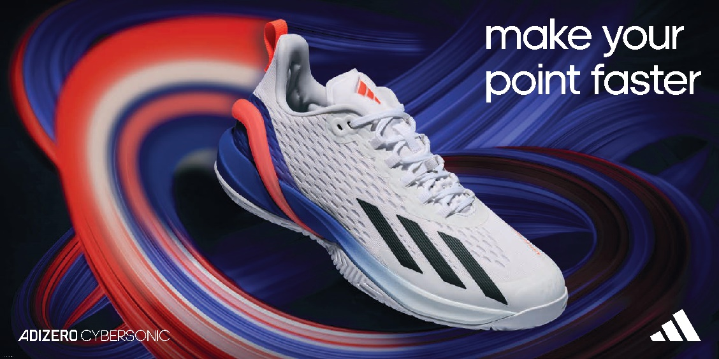

- The adizero Cybersonic, designed for extreme speed, enables tennis players to make their point faster
- ENERGYRODS in the shoe provide lightweight propulsion, whilst the Lightstrike midsole provides a mix of lightweight cushioning and on-court responsiveness
- The adizero Cybersonic will be available at adidas.com and via the adidas app from January 9 2023
Herzogenaurach, December 13 2022 – Today, adidas launches the adizero Cybersonic, a tennis shoe designed to help players make their point faster. With the game of tennis becoming faster and more demanding than ever before, the shoe is created to help athletes push their pace, from the net to the baseline.
DESIGNED FOR SPEED
On its quest to create a tennis shoe designed to deliver unparalleled high-performance for its players, adidas brought together its Advanced Concepts and Future Innovation teams. Ensuring the new shoe’s performance benefits, the prototypes were tested and validated by pro athletes, in collaboration with the University of Freiburg.
Daniel Neuerburg, Director Tennis and Court Sports, adidas, commented: “Our aim with the new adizero Cybersonic was to make the impossible possible when it comes to creating a shoe that’s more efficient, consistent and precise. The stability and burst of pace that the Cybersonic offers enables our players to be laser-focused and respond to their opponent’s next move - faster.”
BUILT FOR SPEED
From helping players stabilize and keep their balance, change direction quickly, or inject energy when accelerating, the adizero Cybersonic keeps athletes moving. In a game won and lost by such small margins, adidas’ new adizero Cybersonic allows players to focus on the point in play and overcome their opponent.
The adizero Cybersonic features a range of technological innovations:
- ENERGYRODS – The ENERGYRODS in the heel provide lightweight propulsion, allowing the athlete to achieve rapid changes of direction. This is the first time ENERGYRODS have been used in an adidas tennis shoe.
- Lightstrike Midsole – The dual-density Lightstrike midsole and adiWEAR rubber compound sole enable players to be more efficient, consistent and precise with their footwork.
- ADITUFF Abrasion Zone – The recycled ADITUFF engineered sport-specific abrasion zone lets athletes push harder whilst keeping balance, letting them get back to position as fast as possible.
THE PRODUCT
The adizero Cybersonic, coming in a blue fusion/solar red colorway for men and a blue fusion/pulse mint colorway for women, will be available at adidas.com and via the adidas app from January 9.
For further information please visit adidas.com or follow @adidasTennis on Instagram to join the conversation, using #adizeroCybersonic, #adidasTennis and #adidas.
- ENDS -
Notes to editors:
About adidas
adidas is a global leader in the sporting goods industry. Headquartered in Herzogenaurach/Germany, the company employs more than 61,000 people across the globe and generated sales of €21.2 billion in 2021.
About adidas Tennis
adidas Tennis is represented by top players such as Garbiñe Muguruza, Angelique Kerber, Maria Sakkari, Karolína Muchová, Dominic Thiem, Stefanos Tsitsipas and Félix Auger-Aliassime.

