ADIDAS CULTIVATE & B.L.O.O.M. PROGRAM ELEVATES BLACK AND LATINX ENTREPRENEURS TO ACCELERATE THEIR GROWTH & IMPACT
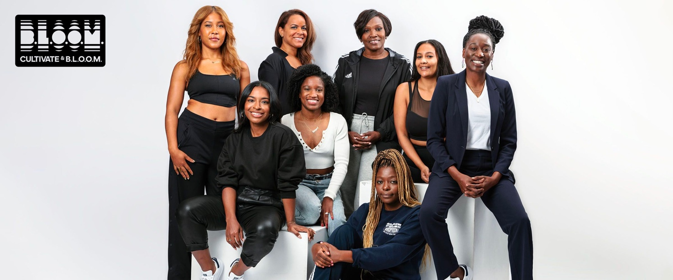
- In Spring 2022, adidas announced its partnership with Impact Hub and Blavity.org to launch a new program called Cultivate & B.L.O.O.M. (Building Legacies Out of Movements), an accelerator program for social entrepreneurs of color.
- Through knowledge sharing and funding, the program cultivates a thriving ecosystem for changemakers to accelerate impact and deliver initiatives at the intersection of sport, equity and creativity for Black and Latinx communities.
Earlier this year, adidas announced its newest program, Cultivate & B.L.O.O.M., designed to equip entrepreneurs of color with tools and resources to enable them to accelerate growth and maximize impact. As part of adidas’ United Against Racism commitments and celebration of boundary-breaking Black women, Cultivate & B.L.O.O.M. is further closing the opportunity gap that exists for Black and Latinx social entrepreneurs by elevating, co-creating with and funding entrepreneurs creating change in their communities.
17% OF BLACK WOMEN ARE IN THE PROCESS OF STARTING OR RUNNING NEW BUSINESSES, COMPARED TO 10% OF WHITE WOMEN, AND 15% OF WHITE MEN. DESPITE THIS EARLY LEAD, ONLY 3% OF BLACK WOMEN ARE RUNNING MATURE BUSINESSES. Harvard Business Review, May 2021
Through an intentional selection process, eight Black women social entrepreneurs were identified to participate in the first-ever Cultivate & B.L.O.O.M. cohort. The first cohort kicked off in July 2022 and will graduate in March 2023.
Throughout their nine months in the program, entrepreneurs have access to a tailored portfolio of resources and opportunities from within and outside of the adidas ecosystems that will serve to accelerate their impact. These resources include funding, access to industry experts, mentorship, workshops, fireside chats and visibility into adidas’ networks.
- Funding: adidas awards each entrepreneur $100,000 to apply to the growth and development of their organization.
- Mentorship: Entrepreneurs are assigned mentors from a talented pool of women of color across adidas who hold positions on its product, retail, marketing, creative and digital teams, and meet with them once a month.
- ‘Office Hours’ Workshops: Each month, entrepreneurs attend workshops led by experts from adidas’ internal and external networks. The workshops cover key topics meant to aid in business development.
- Fireside Chats: Cultivate & B.L.O.O.M. welcomes powerful women of color to hold monthly conversations on topics like innovation, networking and self-care. Speakers have included Black Ambition CEO and author Felecia Hatcher, Parkwoods Philanthropy Director Ivy McGregor, actress, producer, screenwriter Lena Waithe and yoga and healing justice facilitator Alli Simon.
- Tools: Participants are given a one-year subscription to Ureeka, a small business growth engine, and are plugged into the adidas Community platform where they learn from and interact with leaders in business, sport and creative industries. They are also connected to the many resources Impact Hub offer.
After graduating from the program, participants become a partner in the “Innovation Network”, a network of social impact partners that seek to drive forward change within their communities and organizations. This portfolio of partners will enable adidas to continue strengthening the diversity of our partnership network, increase our reach within key markets and deepen our relationships over time.
Ayesha Martin, Senior Director Purpose, Communities & Social Impact at adidas said: “At adidas, we are committed to changing lives through sport, and are excited about the opportunity to– through Cultivate & B.L.O.O.M.– start to address and remove systemic barriers Black & Latinx community change-makers on the rise face. This is just the beginning, with so much more to do.”
Join us in celebrating our first Cultivate & B.L.O.O.M. cohort of powerful women entrepreneurs who are having far-reaching impact on their communities.
- Annya Santana, Hood Health: Hood Health's the first media platform and lifestyle brand at the intersection of health, wellness and culture. A rare space that focuses on inclusive, practical, functional wellness of people of color through thoughtful, educational, entertaining content where nutritional, physical, mindful wellbeing and culture collide. IG: @hood_health
- Briana Thompson, Spiked Spin & Wellness Co: Briana launched Spiked Spin & Wellness Co in 2016 to diversify the state of health and wellness by creating classes and resources for Black women and allies to feel seen and supported. Spiked Spin has since grown its ridership to over 4,000 people in NYC and offers indoor cycling, Pilates, yoga, nutrition guides and monthly group mental check-in sessions with licensed therapists and psychologists. IG: @spikedwellness
- Corinne Milien, WRK: Corinne founded WRK, a talent sourcing firm specializing in connecting sports, media and entertainment companies with a community of qualified talent, to eliminate bias and barriers for those historically excluded from traditional hiring practices. Her infectious energy towards “doing good” for others and ultimately paying it forward is helping to level the playing field for all. IG: @lets.do.wrk
- Elisa Shankle, HealHaus: Elisa merged her passion for integrated mindful and holistic approaches to wellness with her passion for design to create HealHaus, a one stop shop for diverse healing services, available at its Brooklyn flagship location or through an online subscription-based membership or workplace program. IG: @healhaus
- Jasmyne Spencer, The Black Women’s Players Collective: Serving on the executive board of BWPC, a nonprofit created by the Black players in the National Women's Soccer League to advance opportunities for Black girls in sport and beyond, Jasmyne helps elevate the image, value and representation of Black women as athletes and leaders across industries. IG: @blackwplayercollective
- Lauren Spearman, R&B Yoga: Noticing a lack of diversity in the yoga community she was so passionate about, Lauren created R&B Yoga to break down barriers to yoga for those who’ve previously not felt included in the community. By blending upbeat, modern music with beginner-friendly techniques, the classes encourage body positivity and make fitness accessible to all in a welcoming, lighthearted and fun environment. IG: @rnbyoga
- Sinikiwe Dhliwayo, Naaya: Sinikiwe is committed to using wellness as a means to make society more equitable and just, which led her to found Naaya. By highlighting practitioners and instructors of diverse backgrounds and bodies, Naaya is disrupting the status quo of the wellness industry, helping change the wellness narrative from exclusive to inclusive and creating safe spaces for BIPOC folks to exist as the fullest expression of their humanity. IG: @naaya.wellness
- Wanda Jones, The Ahmaud Arbery Foundation: Committed to honoring her son, Ahmaud Arbery, she created the Ahmaud Arbery Foundation to empower, serve and affirm Black boys on their journeys towards mental wellness. IG: @ahmaudarberyfoundation
The next cohort, which will focus on equipping and empowering Black and Latinx social entrepreneurs, will kick off in 2023, with the cohort application opening in June. To participate, entrepreneurs must be at a company or organization:
- Based in Portland, Oregon – home to adidas’ North America head office
- Within early-stage development (first 1-3 years)
- With at least one Black and/or Latinx founder
- Whose purpose is aligned to removing barriers of access to and safety in sport at the intersection of community, equity and creativity.
++++++
About adidas
adidas is a global leader in the sporting goods industry. Headquartered in Herzogenaurach/Germany, the company employs more than 61,000 people across the globe and generated sales of € 21.2 billion in 2021.
About Impact Hub
Impact Hub is a global network catalyzing entrepreneurial action and business for good.
With 108+ locations across 60+ countries and 25,000+ people driving change, they connect
entrepreneurs and innovators to large organizations, investors, and the public sector. Why?
To enable inclusive and sustainable innovation - at scale.

About Blavity.org
Blavity.org is a new racial equity and social impact organization created by the founders of Blavity Inc. Blavity.org Foundation is not-for-profit group to drive Black economic advancement forward through entrepreneurial fellowship programs featuring grants, education, and sponsorship. A groundbreaking social-cause organization, Blavity.org’s Foundation has been created by Blavity Inc., the leading media company for Black culture and millennials. Blavity.org was built to further Blavity Inc.’s social impact through the development of digital programs designed to advance economic progress and racial equity for Black entrepreneurs. Blavity.org understands the need of a foundation to drive, support, and amplify Black economic achievement and mobility.

