Trae 2: Trae Young Debuts His Second Signature Collection

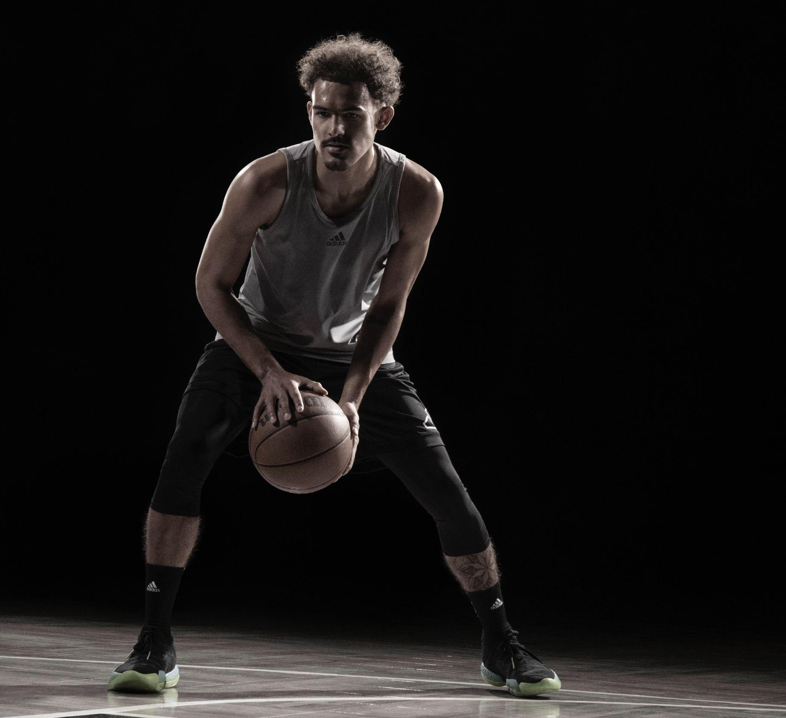

(Los Angeles, Calif.) – adidas Basketball and All-NBA guard Trae Young announce the next chapter in the icon’s footwear legacy with the pre-season debut of the Trae 2. Leading the charge of the game’s next generation, the Trae 2 channels Young’s incomparable ability and is an invitation for all hoopers to lace up and dominate like Trae.

“My childhood dream was to have my own signature basketball shoe and it’s surreal to be announcing my second sneaker with adidas,” Young said. “Through our partnership we aim to inspire future hoopers to dream big and to stay true to themselves. I hope that others can relate to my journey as an example of what is possible through the game.”

The Trae 2 arrives with forefoot branding inspired by the Adilette slide fused with the performance innovations of Boost and Lightstrike technologies to set a new precedent for game-ready energy return and lightweight responsiveness. Highlighting adidas Basketball’s inventive blend of an adaptive knit upper and ultramodern lacing system, built for quick changes of direction and enhanced movement, this iteration combines pinnacle performance footwear with all the comfort of the post-game cool down. For Trae’s game, staying a step ahead of the competition is paramount and is an embodiment of his best between the lines.

As an integral piece of the Three Stripes roster, Young is committed to empowering the next generation of hoopers by delivering premium performance offerings that blend innovative tech with contemporary and future-focused style. The Trae 2 arrives with the lead colorway pairing black with hues of neon green and electric purple reflecting dynamic modern styling. Hoopers across the globe can look forward to an assortment of vibrant and spirited colorways indicative of Trae forging the future of the game.

The Trae 2 retails for $140 USD and will be available on November 1st in select retailers and online at www.adidas.com/us/basketball

