September 29, 2022

D.O.N. ISSUE #4: THE LIGHTEST SIGNATURE SILHOUETTE FROM DONOVAN MITCHELL

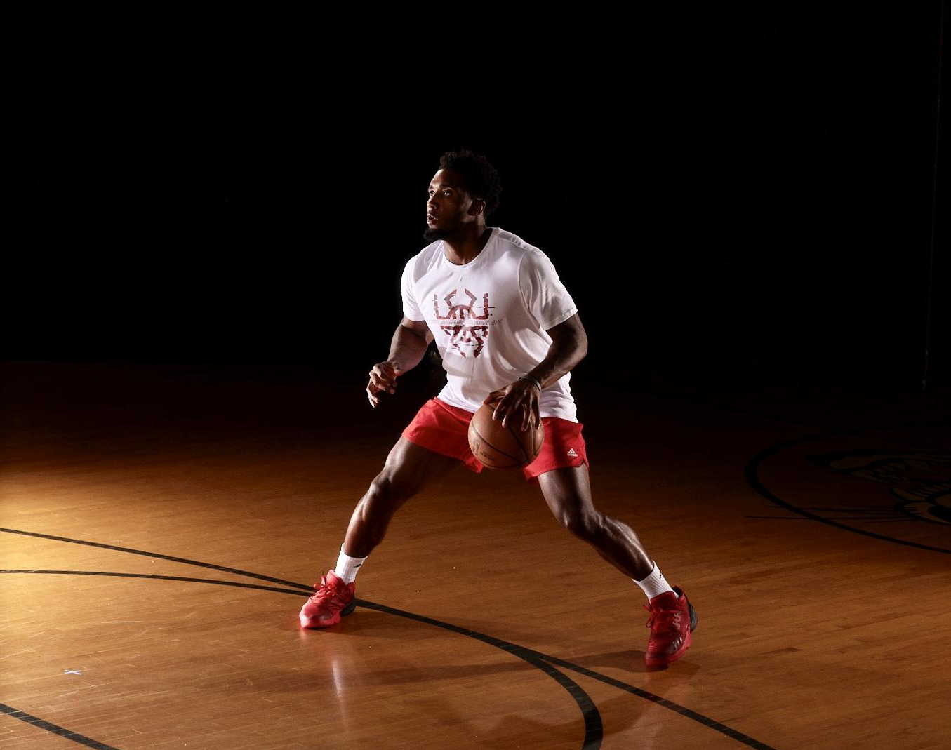

DOWNLOADABLE ASSETS

- The D.O.N. Issue #4 is one of the lightest and most advanced adidas Basketball shoes to date
- The D.O.N. franchise aims to empower and elevate the future of next gen hoopers

(Portland, Ore.) — adidas Basketball and all-star guard Donovan Mitchell ushers in a new era for his signature franchise with the D.O.N. Issue #4 releasing on October 1, 2022. The latest iteration is the lightest and most advanced basketball D.O.N. to date, channeling Mitchell’s superhuman speed and agility.

“I’m thrilled to release my fourth signature sneaker and the lightest D.O.N. to date with adidas,” said Mitchell. “Through our partnership, we’ve been able to spread a positive message with the D.O.N. signature series. This is about sharing my NBA experience with everyone who loves to play hoops and provide them with high-performance footwear that can be worn at any level.”

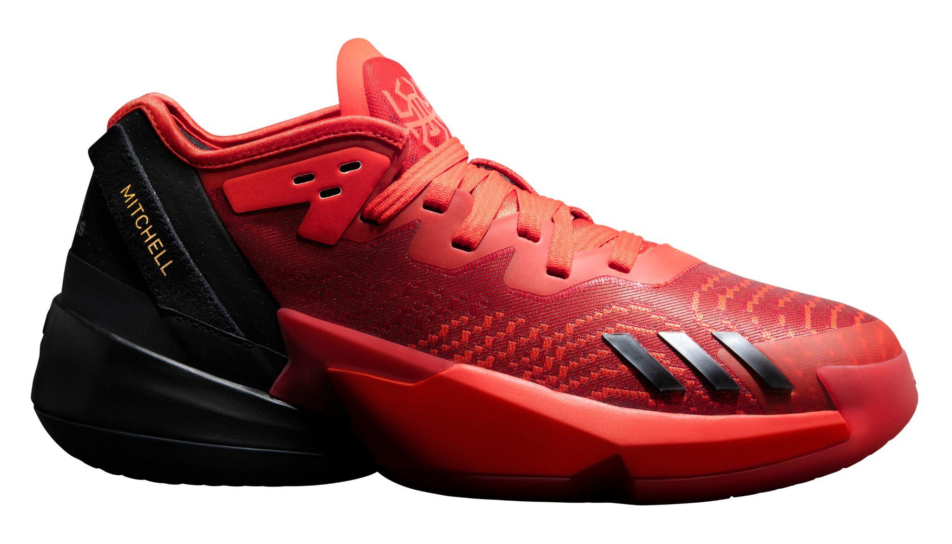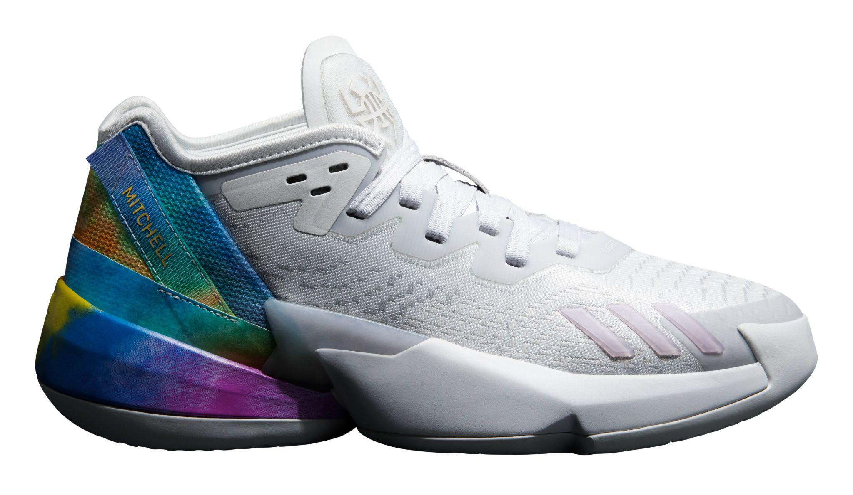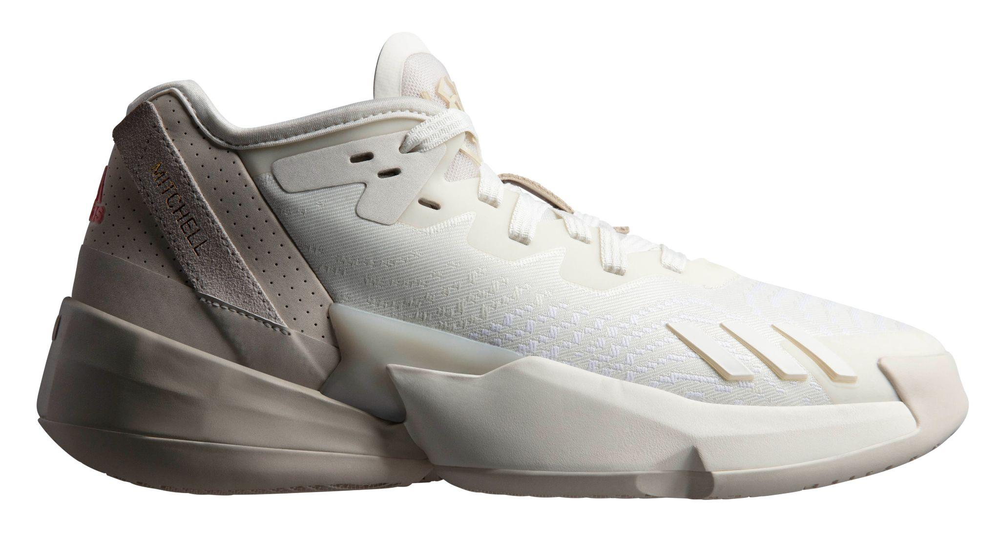

Designed as a blueprint for the future while mirroring Mitchell’s out of this world skills, the D.O.N. Issue #4 receives a new LIGHTLOCK upper with Rubber Outsole allowing for the most efficient energy transition in the game. To maintain a lightweight frame for a quick first step, the sneaker leverages the new adidas Lightstrike Strobel midsole for super-light cushioning, while encased in a next-gen propulsion frame enabling explosive speed for full-court domination.
The D.O.N. franchise embodies Mitchell’s extraordinary feats on and off the court while representing a call to action for the next generation of hoopers to stay positive through adversity and never give up on their dreams. The D.O.N. Issue #4 colorways arrive in core red and team black for “Future of Fast,” dash gray and bliss lilac for ”Dream It”, in core black and carbon for “Lights Out” and in off white for “Achieve It”.

The D.O.N. Issue #4 retails for $110 USD and will be available October 1 in select retailers and online at www.adidas.com/us/basketball.

About adidas
adidas is a global leader in the sporting goods industry. Headquartered in Herzogenaurach/Germany, the company employs more than 62,000 people across the globe and generated sales of € 19.8 billion in 2020.

For more on adidas Basketball & Donovan Mitchell

adidas Basketball:
IG: @adidasbasketball / @adidas
Twitter: @adidashoops / @adidas

Donovan Mitchell
- IG: @spidadmitchell
- TW: @spidadmitchell

Hashtag
#DONISSUE4

FOR MORE INFO:
adidas.com/basketball

###

For general inquiries, please contact:

Matthew Oliver
Matthew@pitchblend.com

Alyssa Ahern
alyssa.ahern@adidas.com

