INTRODUCING THE ADIDAS BREAST CANCER AWARENESS COLLECTION – A SELECTION OF FOOTWEAR AND APPAREL DESIGNED TO RAISE AWARENESS AND FUNDING FOR BREAST CANCER NOW AND NATIONAL BREAST CANCER FOUNDATION, INC.
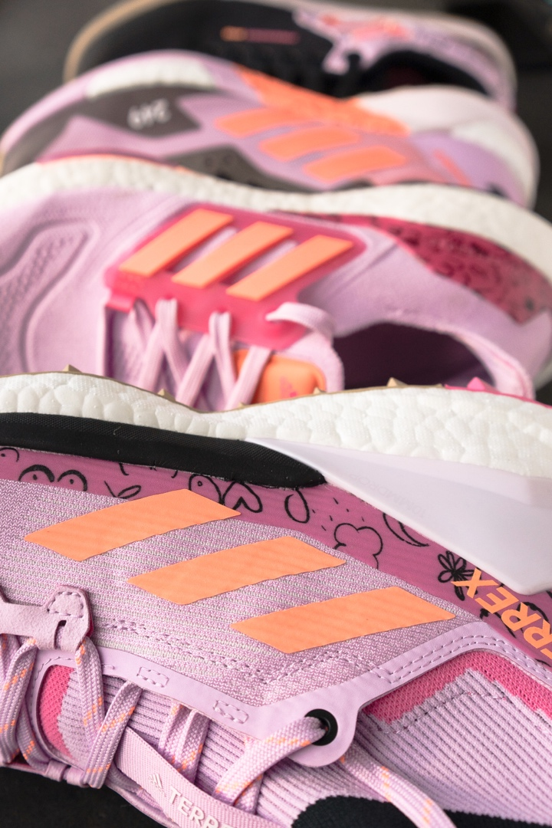

- Launched in partnership with the charities Breast Cancer Now (UK/Europe) and National Breast Cancer Foundation, Inc. (US), the adidas Breast Cancer Awareness Collection brings together a range of footwear and apparel for running, hiking and mountain biking

- £15/€15/$15 from each full-price sale will be donated to Breast Cancer Now (for purchases in the UK and EU) or National Breast Cancer Foundation, Inc. (for purchases in North America)
- The products in the collection feature illustrations by adidas pro mountain biker Veronique Sandler, empathetically designed to represent the comfort that those with breast cancer have experienced in the outdoors

Herzogenaurach, 16th September, 2022: Inspired by the experiences of people and communities around the world, including its own employees and athletes, adidas is launching the Breast Cancer Awareness Collection this October.

Available throughout Breast Cancer Awareness Month, the adidas Breast Cancer Awareness Collection sees adidas partnering with Breast Cancer Now in the UK and Europe, and National Breast Cancer Foundation, Inc. in the US, to help raise awareness of breast cancer and support the vital work both charities do.

The products in the Breast Cancer Awareness Collection have been chosen to help everyone, regardless of physical ability or condition, spend more time in the outdoors.

“My mom had breast cancer,” explains adidas Five Ten Senior Product Manager Bike; Global Brand Comms, Social Media Manager, Luke Hontz. “She is fortunate to have come through it. I’ve wanted to do something to raise awareness of the disease and to help support individuals and their friends and families who are impacted. Working on this collection is a passion project. I'm grateful adidas gave me the chance to get it off the ground. I hope our efforts can make a difference in people's lives."

The collection features a range of footwear for running, hiking and mountain biking. The TERREX Free Hiker is an all-terrain hiking shoe that offers grip and a responsive, padded midsole over long distances, while the adidas TERREX Agravic Ultra trail-running shoe was created with insights from athlete Ekaterina Mityaeva for comfort and energy return over technical trails.

The adidas Ultraboost is a breathable shoe designed for runners who want to pick up the pace, featuring a BOOST™ midsole for cushioned runs. The adidas Five Ten Freerider Pro, meanwhile, provides a grippy MTB ride over almost any terrain.

The collection’s apparel selection includes an adidas Five Ten Flooce Jacket and Jersey designed to aid temperature regulation when mountain biking in variable conditions. Also in the collection is a windproof and water-repellent adidas TERREX Trail Wind Jacket which, on cooler outings, can be layered over the adidas TERREX Agravic T-shirt. Featuring AEROREADY technology, this base-layer T-shirt manages runners’ body sweat to keep them feeling comfortable for longer.

The collection’s focus on functional footwear and apparel that is designed for the outdoors is in keeping with adidas' objective to help broaden access to outdoor sports and help everyone enjoy the benefits of spending time in nature. With United by Summits, adidas TERREX is taking this brand-wise ethos further by encouraging all people, from every background, to realise their own individual goals in the outdoors and enjoy the benefits of adventure, both big and small.

Pro mountain biker and adidas athlete Veronique Sandler has created a series of illustrations for the products in the collection, aimed at representing the strength and comfort that those with breast cancer have experienced in the outdoors.

“A few significant people in my life have had breast cancer. It’s something many of us will be affected by in some way in our lifetime, and it’s so important to spread awareness. I’m so stoked to have had the opportunity to be involved with designing this collection,” says Veronique Sandler. “Speaking to people with the disease, and those who have had it in the past, many of them described to me how spending time in nature or thoughts of nature helped them stay positive through difficult moments. I hope my illustrations help represent their strength and positivity.”

The collection is available for purchase in limited quantities from September 30, 2022 until the end of October 2022 for adiClub members only, and £15/ €15/$15 from each full-price sale of the adidas Breast Cancer Awareness Collection will be donated to Breast Cancer Now (for purchases in the UK and EU) or National Breast Cancer Foundation, Inc. (for purchases in North America). The money raised will contribute to the important work these charities are doing.

With the Breast Cancer Awareness Collection, adidas can support its charity partners in their efforts to help those impacted by breast cancer, while also offering more people a route into the outdoors with the footwear and apparel they need.

To find out more or purchase an item from the adidas Breast Cancer Awareness Collection, head to the adidas website.

ENDS
About adidas
adidas is a global leader in the sporting goods industry. Headquartered in Herzogenaurach, Germany, the company employs more than 61,000 people across the globe and generated sales of €21.2 billion in 2021.
About Breast Cancer Now
Breast Cancer Now is the UK’s first comprehensive breast cancer charity, combining world-class research and life-changing support. Breast Cancer Now’s ambition is that, by 2050, everyone who develops breast cancer will live and be supported to live well.
Breast Cancer Now, the research and support charity, launched in October 2019, created by the merger of specialist support and information charity Breast Cancer Care and leading research charity Breast Cancer Now.
For more information, please visit breastcancernow.org. Anyone looking for support or information can call the free Helpline on 0808 800 6000 to speak to an expert nurse.
Media contact: Sarah Reilly, Senior Press Officer in Fundraising sarah.reilly@breastcancernow.org
About National Breast Cancer Foundation, Inc.®
Recognized as one of the leading breast cancer organizations in the world, National Breast Cancer Foundation, Inc. is Helping Women Now® by providing early detection, education and support services to those affected by breast cancer.
A recipient of Charity Navigator’s highest 4-star rating for 16 years, National Breast Cancer Foundation, Inc. provides support through their National Mammography Program, Patient Navigation, breast health education, and patient support programs.
For more information, please visit https://www.nationalbreastcancer.org/
Media contact: Ashley Miller, Director of Public Relations amiller@nbcf.org

