ADIDAS INTRODUCES LATEST FW22 MADE WITH NATURE CAPSULE COLLECTION, CONTINUING ITS COMMITMENT TO BUILDING A NEW ERA OF SPORTSWEAR
- Designed in balance with the planet, the new capsule collection features a Made with Nature Ultraboost 22 alongside a Made with Nature apparel range
- “Change is not only possible, it’s an urgent necessity” says adidas’ Christopher Wheat, Global Category Director Running Footwear as the sports brand continues its mission to help end plastic waste
- The new Made with Nature Capsule Collection will be available from September 15, 2022, with Early Access from September 8 via https://www.adidas.com/running
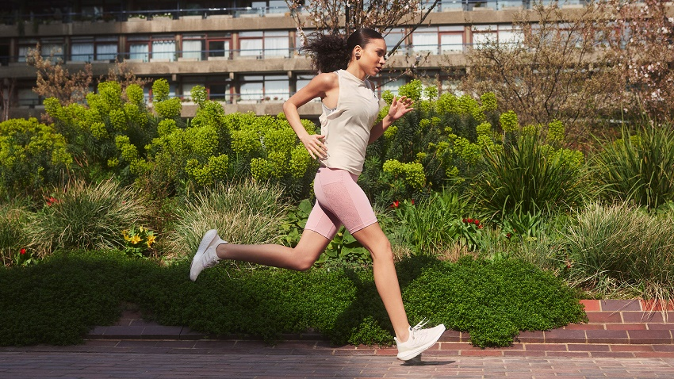

Herzogenaurach, September 8, 2022 – adidas has today unveiled the latest in its Made with Nature Capsule Collection with a new Ultraboost 22 Made with Nature and Made with Nature apparel joining the range as the brand continues its mission to call time on conventional materials and design out finite resources.
adidas understands that there is no tomorrow without changing the way we think today and the launch of the new collection demonstrates this. The Made with Nature Capsule Collection features:
Ultraboost 22 Made with Nature
Designed in balance with the planet, the women’s Ultraboost 22 Made with Nature takes the forward-thinking elements of the Ultraboost 22 and amplifies them with natural materials. The shoe is made in part with natural materials – 40% of the knitted upper is made with lyocell, a material created with cellulosic fibers made from sustainably grown wood.
Inspired by nature and focussing on warmth and escapism, the shoe launches in a Non-Dyed / Zero Met / Chalk White colorway. It will be priced from 180 EUR / $180.
Made with Nature apparel range
Launching alongside the Ultraboost 22 Made with Nature is a new Made with Nature apparel range, including a performance running wear look for men and women. The apparel range is made with at least 50% organic cotton. Visit adidas.com/madewithnature for pricing.
The women’s Made with Nature look features:
- Made with Nature hat
- Made with Nature top
- Made with Nature trousers
- Made with Nature socks
The men’s Made with Nature look features:
- Made with Nature zip-up tracksuit top
- Made with Nature tracksuit bottoms
- Made with Nature top
- Made with Nature hat
- Made with Nature socks
Christopher Wheat, Global Category Director Running Footwear said: “At adidas, we understand that change is not only possible, it’s an urgent necessity. With Made with Nature, we are on a journey to a world beyond plastic. We’re calling time on conventional materials and methods of make. Once depleted, there’s no coming back for fossil resources. But when we design in synergy with natural processes, when we make with nature, we can use materials that regrow or regenerate – and change the way products are made.
“We’re building a new era of sportswear, designed to look for more responsible solutions. To protect the places we run, swim, play and create. From eco-innovation that mimics biology to pioneering plant-based yarns, our material revolution puts our athletes – and our planet – first.”
For more information, visit adidas.com/madewithnature. Join the conversation on Facebook, Twitter and Instagram via #MadeWithNature #EndPlasticWaste.

