LOVE IS WHERE IT ALL BEGINS: ADIDAS X THEBE MAGUGU LAUNCH TENNIS COLLECTION DESIGNED TO CELEBRATE CULTURE, HERITAGE AND INCLUSIVITY

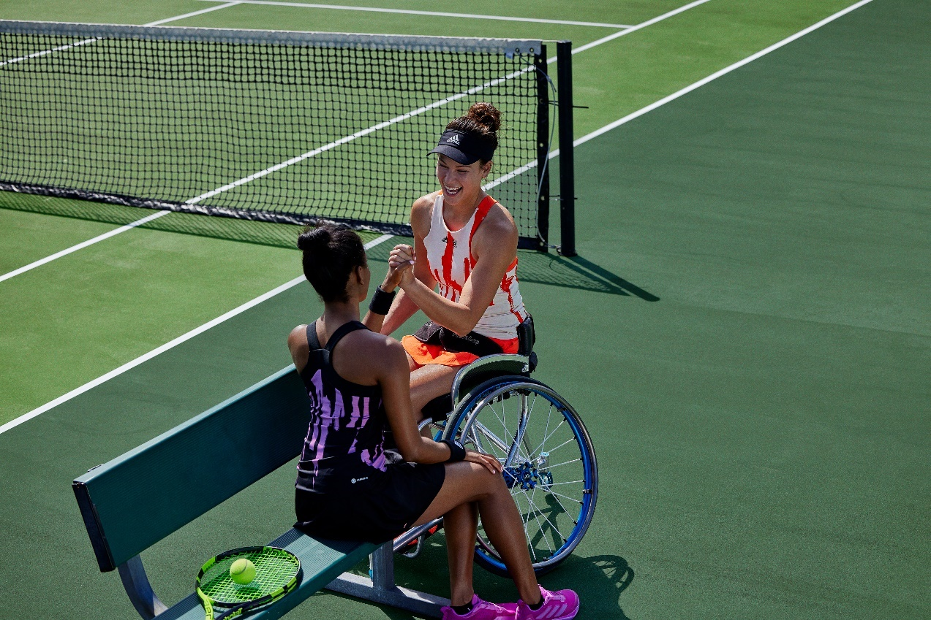
- adidas has collaborated with South African designer Thebe Magugu to create a new Tennis performance collection, which aims to inspire the next generation of tennis players to shape the future of the game and champion diversity and inclusion in the sport
- The collection will be premiered on court during one of the most prominent hardcourt tournaments this summer, by inspirational adidas athletes Dana Mathewson, Felix Auger Aliassime, Daria Kasatkina, Stefanos Tsitsipas, Jessica Pegula, Garbiñe Muguruza and Dominic Thiem
- The high-performance pieces include UNITEFIT technology – a fit system created with a spectrum of sizes, genders and forms for a gender-neutral fit
Herzogenaurach, Aug 15 2022 – Today, adidas launches its latest Tennis collection, created in partnership with contemporary South African designer Thebe Magugu. Following the launch of the mainline collection earlier this month, the new Tennis range, which features apparel in inclusive sizing, is set to celebrate culture, heritage and inclusivity.
While tennis has not always been a place of inclusion, adidas and Thebe Magugu share the belief that it could be, if everyone started from a place of love. This concept of kinship is expressed in adidas and Thebe Magugu’s collaborative collection through designs focusing on unisex styles, gender-neutral pieces and inclusive sizing.
Thebe Magugu, designer, commented: “I firmly believe that sport has the power to bring people together over a shared love for the game. That is why I am thrilled to partner with adidas, a brand that shares my beliefs and hopes for a more inclusive future. This collection was designed as a celebration of culture, heritage and inclusivity, and I cannot wait for some of the most inspirational athletes to wear it on court.”
Key looks of the collection will be premiered during one of the most prominent hardcourt tournaments this summer, by adidas athletes Dana Mathewson, Felix Auger Aliassime, Daria Kasatkina, Stefanos Tsitsipas, Jessica Pegula, Garbiñe Muguruza and Dominic Thiem. These inspirational athletes share a passion for showing support for what matters and encouraging diversity and inclusivity on and off the court.
Felix Auger Aliassime, elite tennis player, commented: “Tennis still has a way to go until it is fully accessible for all, but we all have a role to play in shaping this global community. The adidas x Thebe Magugu Tennis collection features inclusive sizing and celebrates the cultures and communities that make up the sport across the world, and I am excited to play a part in that.”
Daria Kasatkina, elite tennis player, commented: “Hiding who you are and who you love is the hardest thing in the world. Being at peace with yourself and those around you is one of the most important things in life. For this reason, I want to use my platform to inspire positive change in the sport and pave the way for future Tennis athletes to be their true, authentic selves, no matter what challenges they face.”
The collection contains a range of apparel pieces, including the NY Y-DRESS in two colorways (semi pulse lilac and black/grey/impact yellow), the NY 2-IN-1 TIGHTS in white, the MY UNITEFIT SLEEVELESS in two colorways (black/grey/impact yellow and white/black/semi pulse lilac), and the NY Y-TANK TOP in a variety of colors and sizes (semi pulse lilac/white, semi pulse lilac/black and bright orange/white). The collection also features a new iteration of the Avacourt, which launched earlier this year, in a semi pulse lilac colorway.
To ensure athletes of all genders and sizes can enjoy the collection, it features inclusive sizing and UNITEFIT technology. Created and tested on a range of sizes and genders, UNITEFIT technology is designed to offer a comfortable gender-neutral fit.
In terms of sustainability credentials, the apparel collection features the Unisex Tee and Unisex Short in Made with Nature fabrication, and all men’s styles are Made with Nature. The rest of the collection is also made in part with recycled materials, including the new Avacourt shoe.
The prominent colors of the collection are black, semi pulse lilac, impact yellow and bright orange, articulated in vibrant graphics and patterns, inspired by Thebe’s South African heritage and culture.
The Thebe Magugu x adidas Tennis collection will be available on adidas.com and via the adidas app from Aug 15 2022.
For further information please visit adidas.com/us/tennis-clothing or follow @adidasTennis on Instagram to join the conversation, using #adidasxThebeMagugu, #adidasTennis and #adidas.
About adidas
adidas is a global leader in the sporting goods industry. Headquartered in Herzogenaurach/Germany, the company employs more than 61,000 people across the globe and generated sales of €21.2 billion in 2021.
About Thebe Magugu
Thebe Magugu is a South African fashion designer who garnered critical acclaim for his thoughtful and inventive collections that comment on history, culture, and politics. His work and designs focus on social storytelling through traditional graphic language and community work.

