**ADIDAS REVEAL MURALS CELEBRATING STARS OF UEFA WOMEN’S EURO 2022TM AS THE RECORD-BREAKING TOURNAMENT KICKS OFF**

* The murals – and an accompanying series of short-films – celebrate the goals that the players have achieved and continue to pursue both on and off the pitch
* The four murals each feature an adidas-sponsored athlete who is set to light up the tournament: Mapi Leon, Millie Bright, Vivianne Miedema and Wendie Renard
* The murals can be seen across London in Portobello Road, Nine Elms, Shoreditch and Peckham Rye respectively

**Herzogenaurach, July 7, 2022 –** This morning, adidas reveals four murals celebrating stars of UEFA Women’s EURO 2022™, hours before the biggest European women’s sport event in history kicks off.

Created in collaboration with female artists from the UK and revealed in four London locations, the murals celebrate the personal goals and achievements of Mapi Leon, Millie Bright, Vivianne Miedema and Wendie Renard. Each mural features a design that visualises the player’s story, framed by their goals.

The murals are part of adidas’s campaign for UEFA Women’s EURO 2022™, which celebrates the incredible players taking part, with the aim of inspiring young football fans to pursue their own goals. The goal frame design represents the goals that the players have achieved in their lives so far, and the goals they continue to pursue – from world-firsts in football, to working with young people. Each of the murals also features a QR code that links to a short film charting the player’s journey:

Mapi: <https://youtu.be/G4OVELYppiY>

Millie: <https://youtu.be/VZDiUw5Ukvg>

Viv: <https://youtu.be/As2sTN4IIkw>

Wendie: <https://youtu.be/Xa3eb-JXNl8>

*“Our focus for UEFA Women’s EURO 2022*™ *is to ensure the players get the spotlight that their incredible talent deserves. We are so proud to work with a group of players who are inspiring the next generation on and off the pitch. For people who know the players well already, the murals will be a source of great pride, and for those new to the game, we hope this will be an inspiring introduction to some of the modern stars of the game”* said **Claus-Peter Mayer – SVP Brand, adidas Europe.**

**Speaking about her mural, Spain player Mapi Leon said: “***I have loved being part of this campaign. I think it’s a great way to show another side of players outside of football and to be able to help inspire anyone who identifies with me or any of the other players involved. The mural is amazing. I really love art, so putting it on the street where everyone who passes by can see it is overwhelming. It’s all incredible!”*

**Player murals:**

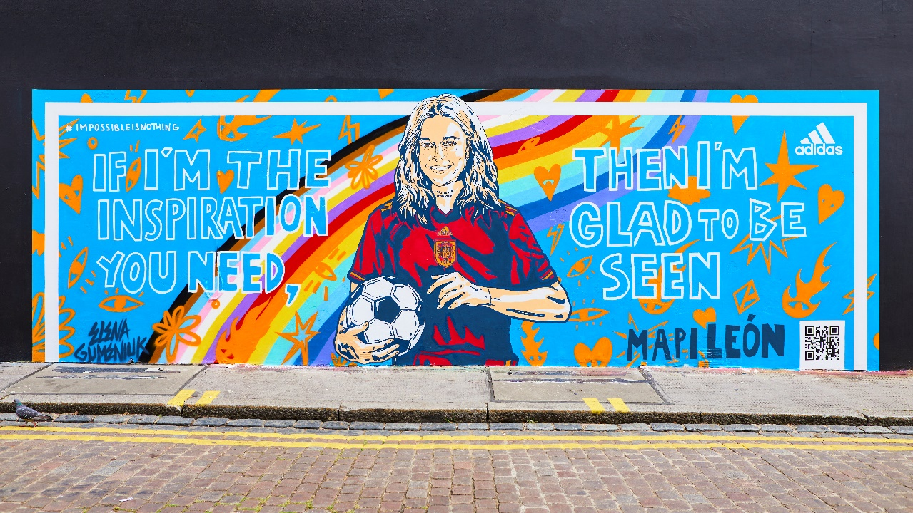

**Mapi Leon – Portobello Road, Notting Hill**

**Artist:** Elena Gumeniuk

*Mapi’s goal is to be the kind of role model that she never had. She’s known for firsts. The first female pro to come out, the first female player to have a transfer fee in Spain and the first player to the ball, obviously.*

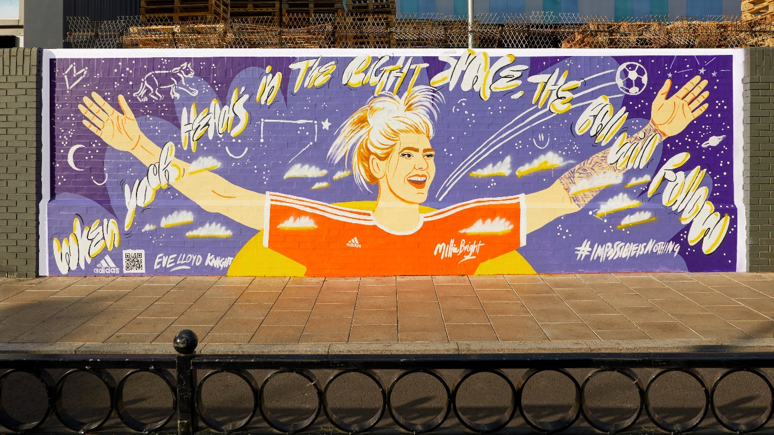

**Millie Bright – Nine Elms**

**Artist:** Eve Lloyd Knight

*Millie’s goal is to use her platform, Daly Brightness to support anyone struggling with mental health and spread positive energy to the next generation. She is known for her strong defensive skills but supporting her team goes way beyond the pitch.*

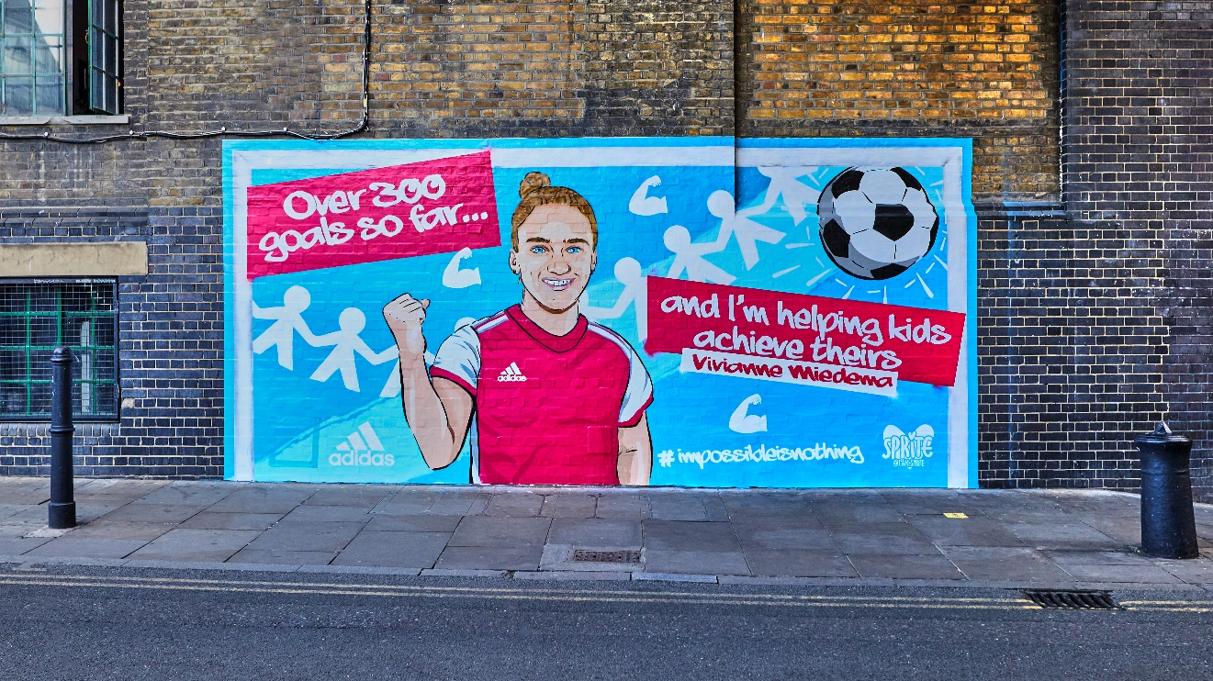

**Vivianne Miedema – Truman Brewery, Shoreditch**

**Artist:** Sprite

*Vivianne’s goal is to use her influence to help young people achieve their goals.*

*Working as an ambassador for War Child, she is committed to helping increase children’s resilience and mental strength.*

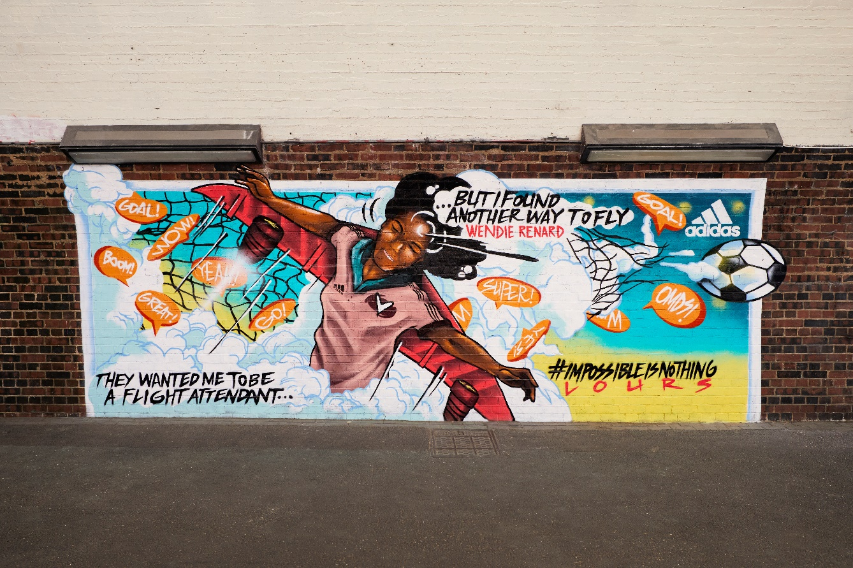

**Wendie Renard – Station Way, Peckham Rye**

**Artist:** Lours

*Wendie was told by her teacher that professional footballer wasn’t a ‘real job’ and she should re-focus on her second option of becoming a flight attendant, but she found another way to fly. Wendie has become one of the most decorated players in European football – winning eight UEFA Women’s Champions League titles.*

**UEFA Women’s EURO 2022™ & UEFA partnership**

On the pitch, adidas has created kits for the national teams of Belgium, Germany, Northern Ireland, Spain and Sweden. Each of the kits has a focus on performance and sustainability, with a consistent design approach that focuses on enabling players to be the best versions of themselves while proudly wearing the colours of their nation.

adidas recently confirmed a significant expansion of its relationship with UEFA which includes an official partnership with UEFA Women’s Football from 2021-2025, where adidas will be the Official Match Ball provider for UEFA Women’s Champions League, UEFA Women’s EURO 2025, Women’s Futsal EURO, Women’s U19 and U17 Championships.

As part of the extension of the partnership, UEFA and the adidas Football Collective will create standout initiatives designed to provide greater access for all, from grassroots players to those at the elite level. The adidas Football Collective is a new movement and unique cooperative of individuals, clubs and communities, united by the belief that through football, a positive change can be created.

Last year adidas also became the exclusive global sponsor of DAZN’s UEFA Women’s Champions League coverage on DAZN and YouTube – providing support for coverage that has, for the first time, allowed fans to follow the entire season of UEFA Women’s Champions League, all around the world, in one single place.

For more information on the campaign and the murals, please visit [@adidasfootball](https://www.instagram.com/adidasfootball/?hl=en) on Instagram. For further details on the artists, please see below.

**- END -**

**For further media information please visit** [**http://news.adidas.com/GLOBAL/PERFORMANCE/FOOTBALL**](http://news.adidas.com/GLOBAL/PERFORMANCE/FOOTBALL) **or contact:** [**adidasglobalfootball@hkstrategies.com**](mailto:adidasglobalfootball@hkstrategies.com)

**About adidas in Football**

adidas is the global leader in football. It is the official supplier of the most important football tournaments in the world, such as the FIFA World Cup™, the UEFA European Championship, the UEFA Champions League & Major League Soccer. adidas also sponsors some of the world’s top clubs including Real Madrid, Manchester United, Arsenal, FC Bayern Munich & Juventus, as well as top Federations such as Germany (DFB), Spain (RFEF), Belgium (RBFA), Argentina (AFA) & (as of January 2023) Italy (FIGC). adidas is also partner to some of the best athletes in the game including Leo Messi, Paul Pogba, Mohamed Salah, Paulo Dybala, Karim Benzema, Catarina Macario, Jude Bellingham, Vivianne Miedema, Trinity Rodman, Jennifer Hermoso, Serge Gnabry, Pedri, Joao Felix, Lindsey Horan & Wendie Renard.

**APPENDIX: Artist biographies**

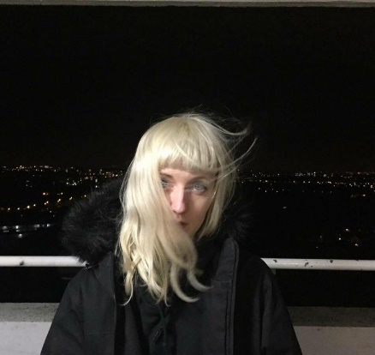

**Elena Gumeniuk (Mapi Leon)**

*Elena Gumeniuk is an illustrator and animator based in London, UK. Working on music videos, short films and animation, alongside her 2D illustration, Elena works hard to create completely unique work through her signature, hard-lined and aggressively coloured style. Innovative and unusual, Elena’s illustrations show the beauty in rawness and grime.*

**Eve Lloyd Knight (Millie Bright)**

*Eve Lloyd Knight is an illustrator based in Margate, UK. Since graduating from Kingston University, she has created work for brands and publishers all over the world, recently winning the Margaret Mallett Picture Book Award for her work in the bestselling book Rebel Voices.*

*Eve’s textural and dreamy work is created with a rich narrative and design led aesthetic, which you can feel in each of her creations.   
When she is not drawing, her interests include equality, culture* *, and empowerment*

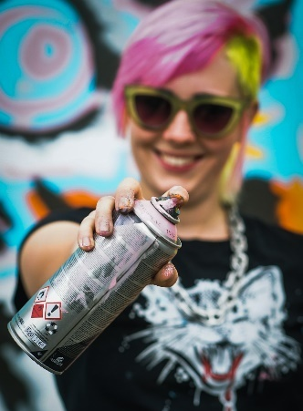

**Sprite (Vivianne Miedema)**

*Sprite is a fun, playful, innovative street artist based in Brighton, England. Not afraid to tackle sensitive subject matter within her graffiti murals, she has a personal passion for animals and positive mental health messaging, as seen in the body of her work. As a multi-discipline street artist, she’s used to working freehand and with stencils in various mediums, often in novel locations and large public focal points.*

**Lours (Wendie Renard)**

**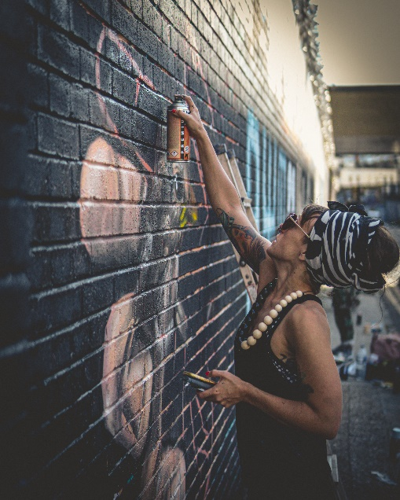***LOURS is a multifaceted urban, digital and studio artist with roots in graffiti muralism and theatrical performance. She shares her inner world with the intention of making people smile and touching the hearts of fellow human beings. Upon moving from Madrid to London, the vibrant British graffiti and street art scene deeply influenced LOURS as an artist, as she discovered new skills, techniques and people that refined her practice. LOURS focused on the surreal-realist style of painting, and is inspired by her experiences, whether they are strongly felt emotions or the contrast of the sky. Subject matter maybe someone whom she appreciates or a reason for complaint. Painting is her method of communication with the world.*