THERE'S ONLY ONE HOME COURT: ADIDAS X PARLEY COLLECTION HIGHLIGHTS COMMITMENT TO HELP END PLASTIC WASTE
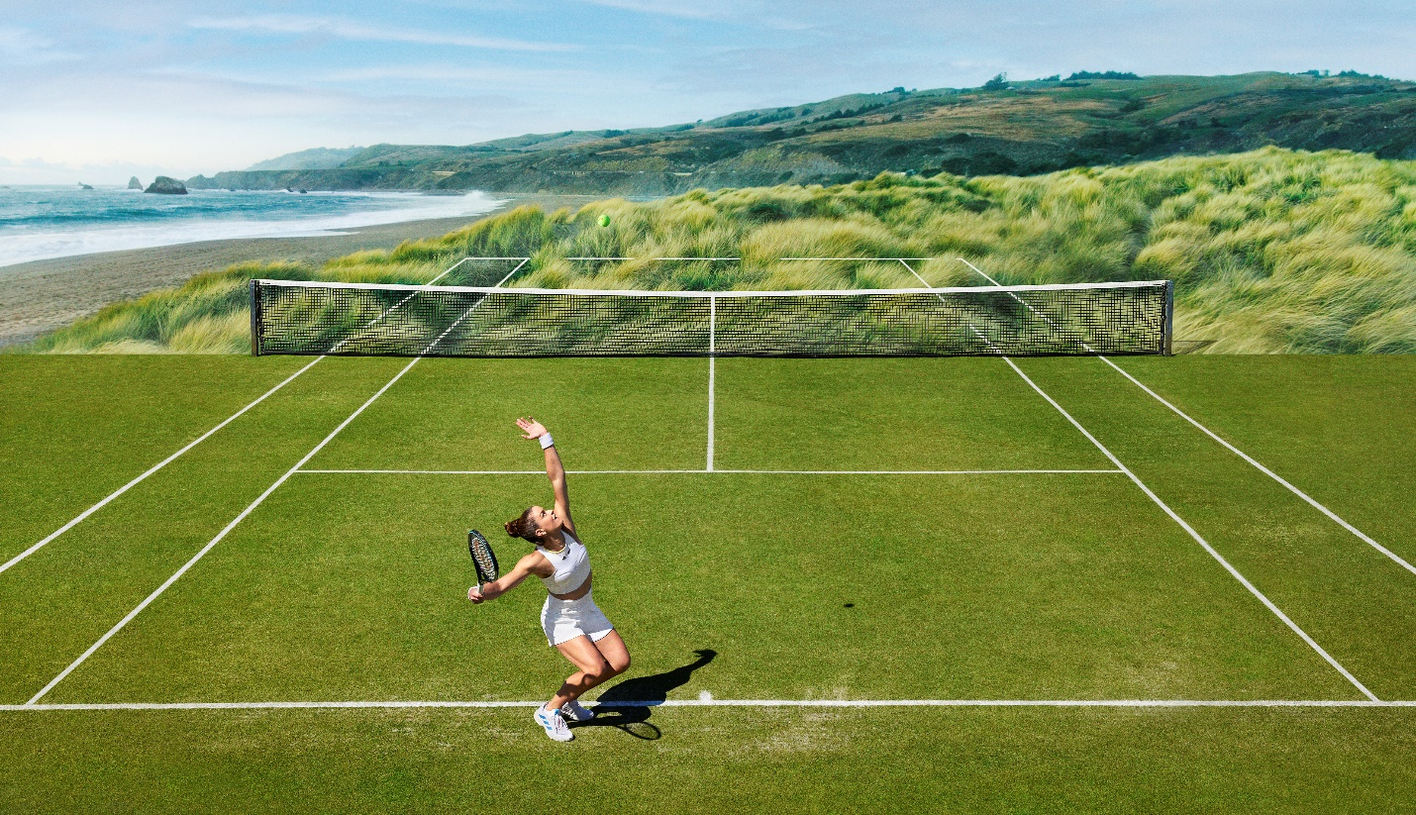
- The adidas x Parley Collection is a performance apparel range featuring morse code engineered patterns and laser-cut executions, inspired by ocean activists.
- Made in collaboration with Parley for the Oceans, all garments in the collection are made in part with Parley Ocean Plastic, continuing adidas’ commitment to help end plastic waste.
- The adidas x Parley Collection will be available at adidas.com and via the adidas app from June 14 2022.

Herzogenaurach, June 14 2022 – Today, adidas launches its adidas x Parley Collection, made in partnership with Parley for the Oceans. A testament to the belief that loving tennis as a sport means loving the earth it is played on, each garment in the collection is made in part with Parley Ocean Plastic intercepted on remote islands, beaches, coastal communities and shorelines, preventing it from polluting our oceans.

WORKING TOGETHER TO HELP END PLASTIC WASTE

At adidas, we see the world not as it is, but as it could be. As such we are continuously searching for solutions and possibilities to work towards helping to end plastic waste. But there is only one way to create true change – through collaboration.
adidas' partnership with Parley for the Oceans, which began as a left-field prototype created with yarn made from thousands of meters of deadly fishing net, is a testament to our mission of helping to end plastic waste through co-creation.
Cyrill Gutsch, CEO and Founder of Parley for the Oceans, commented: “This new collection will be premiered for the first time during one of the most legendary tournaments of the year. And seeing the adidas athletes competing in gear created with Parley Ocean Plastic makes them true symbols of change. But we won’t stop there - in order to turn this global tennis event into powerful impact, Parley pledges to intercept one plastic bottle from islands for every minute they play on court. For the Oceans.”

HELPING FROM THE HOME COURT

Launching ahead of the most prominent grass court tournament of the summer, the adidas x Parley Collection will be premiered on court by adidas athletes, Felix Auger-Aliassime, Elena Rybakina, Maria Sakkari, Dominic Thiem and Stefanos Tsitsipas who all share a passion for working together to help end plastic waste.
For them what they wear on the court is not only performance attire but an expression of their personal beliefs, which includes their commitment to help ending plastic waste. The adidas x Parley Collection is designed to help end plastic waste whilst still being fashionable and fully functional on court. All garments in the collection are made in part with Parley Ocean Plastic and feature engineered patterns and laser-cut executions, enabling players to perform on court with style.
Dominic Thiem, elite tennis player, commented: "I want to use my platform to inspire positive change and looking after the planet should be everyone’s top priority. That is why I am looking forward to wearing the adidas x Parley FW22 collection on court, to help drive awareness that helping end plastic waste is something we need to do together, as a global community.”
Taking its commitment even further, Parley for the Oceans will clean-up one plastic bottle from islands for every minute an adidas athlete plays during the tournament.
THE COLLECTION
The apparel collection features a range of styles for men and women. For female players, the collection features a dress, match tank, crop top, shorts, woven jacket, woven pants and a skort, and for male players, the collection features a, t-shirt , shorts, polo shirt, a 2-in-1 short, jacket, woven tee and woven pants. It is available in a range of styles, with morse code engineered patterns and laser-cut executions, inspired by ocean activists. The prominent color of the collection is white with yellow and black accents.
The adidas x Parley FW22 Tennis Collection will be available for adidas Creators Club Members from May 31 and at adidas.com and via the adidas app from June 14.
For further information please visit https://www.adidas.co.uk/tennis-clothing or follow @adidasTennis on Instagram to join the conversation, using #adidasxParleyCollection, #adidasTennis and #adidas.
- ENDS -
Notes to editors:
About adidas Tennis
adidas Tennis is represented by top players such as Garbiñe Muguruza, Angelique Kerber, Maria Sakkari, Elena Rybakina, Karolína Muchová, Dominic Thiem, Stefanos Tsitsipas and Félix Auger-Aliassime. For more information on adidas Tennis, please visit https://www.adidas.co.uk/tennis-clothing. For additional images please visit our media Newsrooms on news.adidas.com and follow us on Twitter or on Instagram under @adidasTennis.

