DESIGNED FOR SPEED – ADIDAS ANNOUNCES ARRIVAL OF LATEST ADDITION TO RECORD-BREAKING ADIZERO RANGE: THE ADIZERO ADIOS PRO 3
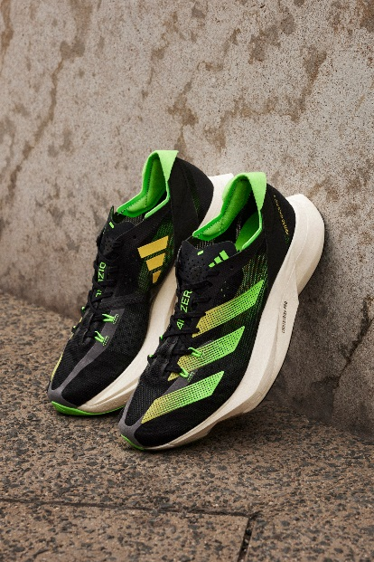
- adidas expands its elite running footwear range with the launch of the new Adizero Adios Pro 3, demonstrating its continued commitment to helping athletes break records
- The Adizero Adios Pro 3 features ENERGYRODS 2.0 embedded in the midsole, to give runners a unique return experience through the toe
- Developed with and for the world’s fastest road runners, the new upper features a lightweight and breathable design ideal for support and speed
- The Adizero Adios Pro 3 will be available from June 1 via adidas.com and in select adidas stores
Herzogenaurach, June 1, 2022 – Today, adidas unveils the latest addition to its record-breaking Adizero franchise* – the Adizero Adios Pro 3.
The newest addition to the iconic Adizero range, the Adizero Adios Pro 3 is a true testament to the brand’s continued dedication to elevate the performance of runners by helping them push the boundaries of what is possible.
What started with Peres Jepchirchir’s world record win – breaking the half marathon world record in the Adizero Adios Pro 1 in Prague in 2020 – continues now with the Adizero Adios Pro 3. adidas´ ultimate long-distance racing shoe, the Adizero Adios Pro 3 is built for runners looking to take their performance to the next level and run after new records.
Launching in a beam yellow / solar green colorway, the Adizero Adios Pro 3 features:
- ENERGYRODS 2.0 - Carbon energy rods which were previously separate, are now a single structure for harmonious stiffness. Embedded in the midsole and running parallel to the metatarsals, to give runners energy return.

- Lightstrike Pro foam – The midsole consists of two levels of resilient Lightstrike Pro foam, providing runners with cushioning and energy return to support them on longer races ranging from half to full marathons.

- New upper - New lightweight upper, designed to be race-ready and provide support for athletes where they need it most.

- Continental rubber outsole – Helping runners stay on track, the silhouette is built with a Continental rubber outsole with traction to help take corners at fast pace.

- Made in part with recycled materials – This product is made in part with a series of recycled materials – just one solution that will help adidas phase out all virgin polyester and help end plastic waste.

Nicholas Roché, Global Project Manager at adidas said: “We’re super excited to be welcoming the Adizero Adios Pro 3 to our record-breaking Adizero range.
“This shoe showcases our ambition to continue working with, and for, the world’s top athletes, as we deliver elite racing footwear to those looking to run faster than ever and improve their running performance.
“We have witnessed the record shattering capabilities of the Adizero range in the past, so we look forward to seeing what times our athletes can achieve in the latest iteration, as we continue to strive to reach unprecedented goals.”
Amanal Petros, adidas athlete said: “It’s an honor to lace-up and train in the newest Adizero shoe. We’re privileged to know first-hand how effective the Adizero can be when it comes to time and performance, so it’s been exciting to try the Adizero Adios Pro 3. I’ve really felt the speed, and the traction of this model. I’m hoping that I can continue to push my performance levels as I continue to train and race in the Adizero Adios Pro 3.”
The Adizero Adios Pro 3 will be available from June 1 at RRP €250 (or equivalent local currency). It will be available via adidas.com and select adidas stores (timing and availability may vary by market). See www.adidas.com/adiospro3 for more details.

ENDS
NOTES TO EDITORS
* Haile Gebrselassie became the first person to break the 2:04hr marathon barrier wearing the Adizero Adios 1 in Berlin on 28, September 2008. Since then, the world's best have continued to smash records wearing the range including Peres Jepchirchir, who made history by becoming the first athlete to win Olympic gold and the New York Marathon in the same year wearing the Adizero Adios Pro 2, and Senbere Teferi, who shattered the 5k world record with the Adizero Takumi Sen 8 at last year's adidas Road to Records.
adidas
adidas is a global leader in the sporting goods industry. Headquartered in Herzogenaurach/Germany, the company employs more than 62,000 people across the globe and generated sales of € 19.8 billion in 2020. adidas’ sustainability mission is to help End Plastic Waste through forging partnerships and developing product innovations that either: use recycled materials, are made to be remade or are made with nature. adidas has set big goals for the coming years: replacing virgin polyester with recycled polyester wherever possible by 2024, (by the end of 2020 already more than 50% of its polyester was recycled), 15% carbon footprint reduction by 2025, 30% carbon footprint reduction by 2030 (compared to 2017) and carbon neutrality by 2050. For more information visit: adidas.com/sustainability.

