ADIDAS COMMITMENT TO HELP END PLASTIC WASTE IS IN FULL BLOOM WITH SS22 TENNIS COLLECTION

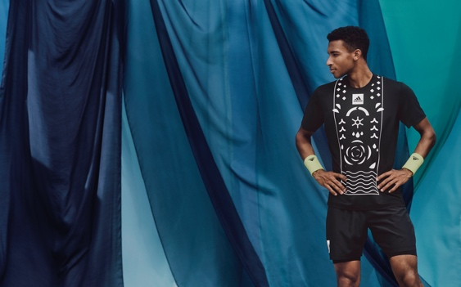
- Taking inspiration from botanical gardens across Paris, the bold graphics featured in the SS22 Tennis collection are a nod to the beautiful gardens and green spaces found throughout the city.
- Garments in the SS22 collection are made either in part with Parley Ocean Plastic or in part with recycled content
- To keep the players feeling cool, dry and confident on court, the pieces in the collection are equipped with our HEAT.RDY technology.
- ​The SS22 Tennis Collection is available to buy now.
Herzogenaurach, May 30 2022 – adidas launches its SS22 Tennis Collection, a high-performance tennis apparel line featuring graphics inspired by Paris’ botanical gardens and green spaces, garments in the collection were made either in part with Parley Ocean Plastic or in part with recycled content.
IT’S IN OUR COURT
Launching ahead of the most prominent clay court tournament of the summer, the SS22 Tennis Collection is being premiered on court by adidas next-gen athletes, Elena Rybakina and Felix Auger-Aliassime, alongside Maria Sakkari, Dominic Thiem and Stefanos Tsitsipas who all share a passion for championing sustainability and working together towards a better future for our planet.
Dominic Thiem, elite tennis player, commented: "I think it's important to use my position as a tennis player to raise awareness for our planet and what we can do to protect it. That's why I look forward to wearing the new adidas SS22 collection made in part with Parley Ocean Plastic or in part with recycled materials. The collection is an example of what we can create when we're inspired to help end plastic waste."
FROM INSIGHT TO ACTION
The SS22 Tennis Collection is another step adidas is taking on its journey to help end plastic waste, and its athletes are sharing this commitment. For adidas athletes, what they wear on the court is not only performance attire but an expression of their personal style and beliefs.
Elena Rybakina, elite tennis player, commented: "As part of the next generation of tennis players, I see a possibility for tennis to be more than a sport, but a platform for change. Our sport reaches and inspires so many, so I think it’s important to stand up for what we believe in. Wearing the SS22 collection by adidas on court is one way of showing that helping end plastic waste is something we need to address together, as an international community.”
Felix Auger-Aliassime, elite tennis player, commented: "I'm part of a generation of players who care about having an impact on and off the court. When I think about the future, it's not just about my future as a tennis player, but also about the future of the planet. . That's why I wear the new adidas SS22 collection made in part with Parley Ocean Plastic or in part with recycled materials – to send a message that we can all do our part by helping to end plastic waste.“
FASHION-FORWARD PERFORMANCE
The SS22 Tennis Collection is designed to be bold yet fully functional on court. Each garment features HEAT.RDY technology which is designed to keep players feeling cool, dry and confident as they take on their next challenge.
The Collection features two dresses, tank tops, long sleeve tees and a match skirt for female players. For male players, the collection consists of two tees, a sleeveless tee, a polo tee, a TECHFIT long sleeve top and two different types of shorts.
It is available in a number of different bold graphic prints, all inspired by the Serres d'Auteuil botanical garden. The prominent colors of the collection are black and white.

The SS22 Tennis Collection is available to buy now.
For further information please visit https://www.adidas.fr/tennis-tous_produits_eco_responsables or follow @adidasTennis on Instagram to join the conversation, using #SS22TennisCollection, #adidasTennis and #adidas.
- ENDS -
Notes to editors:
About adidas Tennis
adidas Tennis is represented by top players such as Garbiñe Muguruza, Angelique Kerber, Maria Sakkari, Elena Rybakina, Karolína Muchová, Dominic Thiem, Stefanos Tsitsipas and Félix Auger-Aliassime. For more information on adidas Tennis, please visit https://www.adidas.fr/tennis-tous_produits_eco_responsables . For additional images please visit our media Newsrooms on news.adidas.com and follow us on Twitter or on Instagram under @adidasTennis.

