ADIDAS AND ALLBIRDS SCALE UP
RELEASING FOUR NEW COLORWAYS OF THEIR
LOWEST CARBON RUNNING SHOE

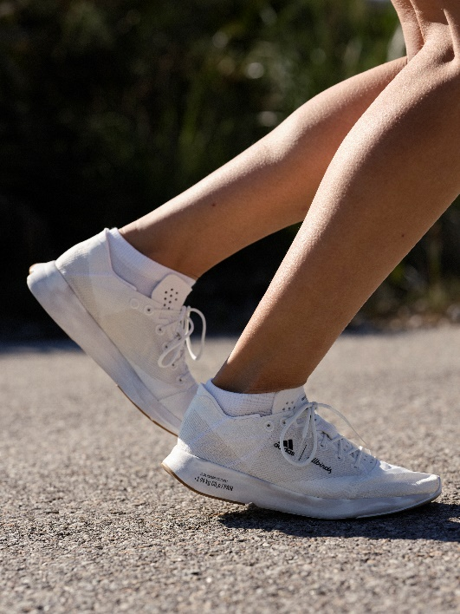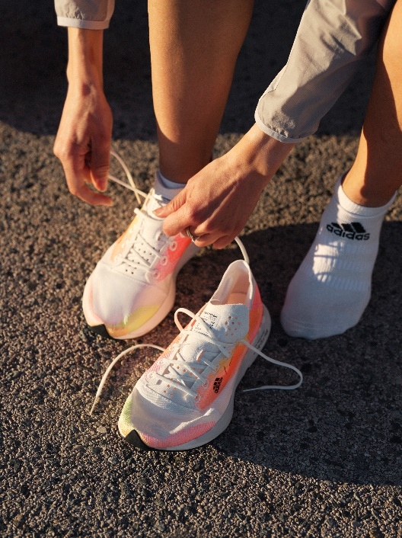

- adidas and Allbirds expand their collaboration with the ADIZERO X ALLBIRDS 2.94 KG CO2E
- An evolution of the FUTURECRAFT.FOOTPRINT, this new iteration continues to be the lowest carbon performance shoe adidas or Allbirds have ever created
- The shoe, which will launch in four exciting new colorways, will be the most widely available drop yet from the adidas x Allbirds collaboration
- ADIZERO X ALLBIRDS 2.94 KG CO2E will be available from April 12 via adidas.com, allbirds.com, the adidas and Allbirds apps and select adidas and Allbirds stores
Herzogenaurach, April 12, 2022 – Today marks another important milestone in the adidas x Allbirds’ collaboration – the launch of the ADIZERO X ALLBIRDS 2.94 KG CO2E.
An evolution of the FUTURECRAFT.FOOTPRINT, which launched last year, this drop seeks to demonstrate that low-carbon running shoes can be delivered at scale. Each of the ADIZERO X ALLBIRDS 2.94 KG CO2E shoes equate to just 2.94 kg CO2e per pair, meaning it remains the only adidas and Allbirds performance model to go below 3 kg CO2e.
With more pairs available than ever before, the launch represents a personal best for both brands, highlighting how quickly innovation can advance when two market leaders work together. Doing more with less, adidas and Allbirds combined their expertise to maximize performance benefits with minimal materials and smart solutions, to give every runner a shoe for performance and planet.
With each pair having a carbon footprint of just 2.94 kg CO2e and created with 63% less emissions*, the ADIZERO X ALLBIRDS 2.94 KG CO2E showcases a new approach to design and an alternative method of manufacturing that drastically reduces carbon impact.

The ADIZERO X ALLBIRDS 2.94 KG CO2E will come in four new colorways including Core Black/ Bliss, Cloud White/ Carbon, Core Black/ Acid Red and Allbirds’ exclusive colorway. Each shoe has been colored with no dye - a method that uses the material’s natural color to help reduce water consumption.
Kimia Yaraghchian, Product Manager at adidas said: “By continuing this progressive partnership, we’re hoping to pave the way for others to break new ground in footwear and clothing. We can take further steps towards zero carbon waste by working together, and we also want to show that drastic changes and solutions are possible within a very short time. As we are already in the midst of climate change, it is important to show people that industries can turn the switch now, and that there is still hope to contribute to not exceeding the 1.5° target.
“Importantly, the launch of the ADIZERO X ALLBIRDS 2.94 KG CO2E proves that like-minded ambition can help deliver low-carbon running shoes at scale. This project has laid the foundation for the decarbonisation goal. All the learnings from this project have subsequently and immediately been incorporated into the creation of further running shoes in order to achieve our footprint reductions more quickly. So stay tuned for more inspiring running shoes that will shake up the market.”
Hana Kajimura, Head of Sustainability at Allbirds said: “The adidas x Allbirds partnership has been an amazing journey, and we’re incredibly excited to get this innovative product into the hands of more consumers around the world. Expanding our collaboration to offer products in new colorways and at greater scales is a testament to how far we can move forward if we choose to work together with a partner that shares our vision.
“Climate change presents a formidable challenge, but the success of this project is an example of how two teams can work together to create a shoe fit for performance and the planet. Our overarching ambition with this shoe is to inspire others to open up their development processes and cooperate with others to create the most carbon efficient designs possible.”

The ADIZERO X ALLBIRDS 2.94 KG CO2E features:

- Bio-based EVA – The midsole is made with 17% plant-based content derived from sugarcane offering a low-carbon component, developed in part with natural materials. The sockliner uses 46% bio-based sugarcane content and the tongue + heel foam uses 17%.

- Outsole innovation – The outsole, which is made with 10% recycled rubber, is extremely lightweight and minimalistic. With a thickness of 1-1.2mm, it is designed to reduce the CO2 footprint compared to conventional outsoles.

- Removal of the torsion bar – Removing the torsion bar completely has saved material and resulted in a higher flexibility during the transition phase while on the run.

- Tangram design creation – Both the upper and the outsole construction are inspired by the Tangram Principle – a design method that creates the visual impression that the upper material and the outsoles have been put together like a puzzle of individual parts. This means that all individual parts in their entirety should achieve as little scrap as possible in production in order to reduce waste.

- Upper material – The upper is made with 77% recycled polyester and 23% natural lyocell—a fiber made from sustainably grown wood—designed to create a smooth, lightweight upper that lives up to performance expectations with a reduced carbon impact.

- Features with 100% recycled polyester – The lining, laces and embroidery all feature 100% recycled polyester.

- Carbon footprint callout for transparency – A nutrition list on the tongue reflects the carbon footprint of each lifecycle stage, including the total carbon footprint of the entire project from cradle to grave.

The ADIZERO X ALLBIRDS 2.94 KG CO2E will be available from April 12 at RRP $120 (or equivalent local currency). The four colors will have availability via adidas or Allbirds, including adidas.com, allbirds.com the adidas and Allbirds apps and select adidas and Allbirds stores (timing and availability may vary by market).
ENDS
NOTES TO EDITORS
*Measured against a comparable running shoe - Adizero RC3 at 7.86 kg CO2e.
adidas
adidas is a global leader in the sporting goods industry. Headquartered in Herzogenaurach/Germany, the company employs more than 62,000 people across the globe and generated sales of € 19.8 billion in 2020. adidas’ sustainability mission is to help End Plastic Waste through forging partnerships and developing product innovations that either: use recycled materials, are made to be remade or are made with nature. adidas has set big goals for the coming years: replacing virgin polyester with recycled polyester wherever possible by 2024, (by the end of 2020 already more than 50% of its polyester was recycled), 15% carbon footprint reduction by 2025, 30% carbon footprint reduction by 2030 (compared to 2017) and carbon neutrality by 2050. For more information visit: adidas.com/sustainability.
Allbirds
Allbirds believes in making better things in a better way. As a certified B Corp and public benefit corporation, the environment is a key business stakeholder. Since inception, the brand has been laser focused on combating the proliferation of petroleum-based materials in apparel and footwear. Allbirds’s story began with superfine New Zealand merino wool, and has since evolved to include a eucalyptus tree fiber knit fabric and a sugarcane-based EVA foam (SweetFoam®). In 2019, Allbirds became 100% carbon neutral through a self-imposed carbon tax, and in 2020, the brand began labeling all products with a carbon footprint. Allbirds firmly believes that business can accelerate a shift away from high-polluting practices and help protect the planet for future generations.

