IN NEW CHILDREN'S BOOK TRINITY RODMAN X ADIDAS TEAM UP TO INSPIRE KIDS TO STAY POSITIVE AND PASSIONATE ABOUT SPORT

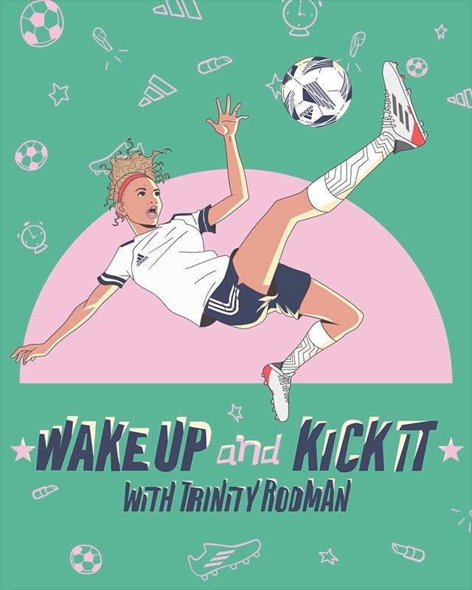

Following a monumental rookie year as professional, Rodman has no signs of slowing down. On top of an already impressive career most athletes only dream about, she has quickly moved onto another area she is passionate about – creative arts – with the debut of her first book in collaboration with adidas.

Impossible is Nothing: Reflecting on her rookie year
In 2021, Rodman was drafted #2 overall, moving to Washington D.C, despite never having played a collegiate soccer match because of the COVID-19 pandemic. The risk of forgoing a collegiate career and jumping straight into professional soccer paid off tremendously, with Rodman becoming the highest paid and youngest female professional soccer player ever drafted. As a self-described “beast” on the field, impossible really is nothing for Rodman.

“Wake Up and Kick It with Trinity Rodman”: Rodman unveils her first book
Leaning into her passion for the arts, Trinity is partnering with adidas on a children’s book about the resilience, perseverance and optimism that helped her achieve the unprecedented success she’s had in her career thus far. As “Wake Up and Kick It” reveals, there were many early mornings and late nights, and internal and external obstacles to overcome, but Trinity didn’t let those hinder her from seeing the incredible opportunities in each and every moment, on and off the field.

The book seeks to inspire kids from all walks of life and backgrounds to get out there and pursue whatever their passions are, in spite of what others may say or what obstacles they might see in their path.

“Paving my own, unique path has never been easy, but I have always had unmatchable work ethic, been able to ignore outside noise and wake up and tackle each day as it comes,” said Rodman. “I’m excited for this book to inspire the next generation to go out and achieve their goals and dreams, proving that nothing is out of reach if you are willing to work for it.”

“Wake Up and Kick It” and the larger partnership with Trinity is part of adidas’ continued commitment to championing girls and women, particularly in sport. Sport has the power to change lives, and by amplifying stories of women’s success across local and global communities, young girls and women alike can confidently tackle whatever obstacles stand in the way of their goals.

“Trinity is one of those individuals whose story of success makes you want to get out there and chase after your own goals, whether that’s on the field, in the workplace, or in your communities and homes,” said Skate Noftsinger, Director of Sports Marketing, Soccer North America at adidas. “We are proud to support strong, driven women like Trinity who believe that impossible is nothing, and we can’t wait to see all the amazing accomplishments other young women and children will make after reading “Wake Up and Kick It”’.

As part of the book release, adidas in partnership with the U.S. Soccer Foundation’s Soccer For Success program will donate over 5,000 copies to youth across social-impact and soccer partner communities. The book donations are part of a larger effort to help ensure children are not just inspired but equipped with resources to follow their passions.

As part of Women's History Month, adidas brand concept retail doors will offer adiClub members a free copy of “Wake Up and Kick It" in-store beginning March 25-31 while supplies last. Check here for store locator information https://www.adidas.com/us/storefinder.

SUPPORTING IMAGERY
