adidas and Parley for the Oceans celebrate the 5th anniversary of their partnership and renew their commitment to ending the global plastic crisis

- Partners re-confirm their vision of bringing change to the industry and expanding their collaboration to drive the Material Revolution.

- adidas becomes founding partner of the Parley Institute for Material Science, which identifies, evaluates and funds material replacements for plastic.

- To celebrate the anniversary, partners release the special edition adidas Parley UltraBOOST DNA - inspired by the prototype which launched the movement in 2015. For every pair of this special edition shoe purchased between June 26th - 29th, adidas will contribute 30 USD / EUR to support Parley.

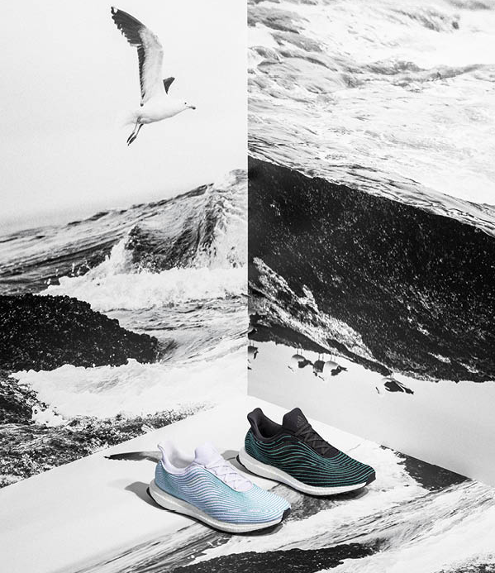

JUNE 29, 2020 (New York, Herzogenaurach) - On the day that marks the fifth anniversary of their partnership, adidas and Parley for the Oceans are renewing their commitment to their mutual mission of helping to end the global plastic crisis, bringing eco-innovation and change to the industry, and driving the Material Revolution to replace plastic altogether.

The partnership was originally announced at the 2015 Parley ‘Oceans. Climate. Life.’ event at the United Nations in New York, where Cyrill Gutsch, the founder and CEO of Parley, introduced an ambitious vision: to end marine plastic pollution with the strategy called Parley AIR. This approach is based on three pillars of action: Avoid plastic where possible. Intercept plastic debris from the environment and turn it into Ocean Plastic, when plastic can’t be avoided. Redesign plastic by inventing new materials.

It was on that occasion that the adidas and Parley unveiled a concept shoe with an upper made of yarns and filaments reclaimed and recycled from ocean waste and illegal deep-sea fishing nets – a first for the industry.

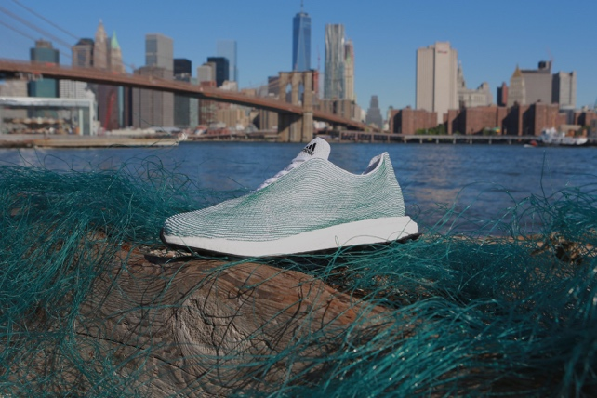

Since then, the partnership has driven eco-innovation within the industry, creating a global ocean movement through the power of sport.

“We are not just focused on changing how we do business; we are dedicated to changing how our industry does business”, says James Carnes, adidas VP Brand Strategy.

In the last five years, adidas has gradually eliminated virgin polyester from its products and by the end of 2020 more than 50% of all the polyester used in the company’s products will be recycled. These achievements put adidas well on track to achieve its goal of phasing out virgin polyester in its products by 2024.

With Primeblue, the partners jointly developed a high-performance yarn for the sports industry, made with Parley Ocean Plastic. By the end of 2020, adidas will have made more than 30 million pairs of shoes with Parley Ocean Plastic.

“Today is the day to look back and evaluate, to dive deep into our consciousness and ask ourselves if we did enough, if we used the time wisely, if we lived up to what we promised ourselves, what we promised our network and the general public. With the scale of the problems we’re up against, it never feels like we’re doing enough, or moving fast enough. Looking back, what we’ve achieved together with adidas feels like a miracle. In the last five years we delivered the proof of concept for our Parley AIR Strategy. Now is the time to drive the Material Revolution like never before. We have 10 years left to end the Toxic Age we created. The path to survival is to unite as a species and collaborate with nature”- says Cyrill Gutsch, CEO and Founder of Parley.

Moving forward, adidas and Parley will work on developing, testing and implementing new materials to replace plastic for good. Adidas joins the Parley Institute for Material Science as a founding Partner; the Institute identifies, evaluates and funds material replacements for plastic and other harmful, toxic or exploitative materials.

To celebrate the anniversary of the partnership, adidas and Parley released the adidas Parley UltraBOOST DNA, a shoe that is inspired by the historic prototype presented in 2015. For every pair of this limited-edition shoe purchased between June 26th and 29th, adidas will contribute 30 USD / EUR to support Parley.

ASSETS:

- Find images HERE
- Adidas Creator U with James Carnes, adidas VP Brand Strategy
- Adidas Creator U with Cyrill Gutsch, CEO and Founder of Parley.

NOTES TO EDITORS

Other highlights achieved over the last five years include:

BUSINESS PRACTICES

Avoided plastic wherever possible and increased the use of recycled plastic instead of virgin plastic.

- Adidas ended the use of plastic microbeads across all body care products.
- In 2016, adidas removed plastic shopping bags from its own retail stores globally. This move eliminated approximately 70 million plastic shopping bags per year.
- Adidas eliminated single use plastic from all of its offices globally.

PRODUCT

Scaling up the use of Parley Ocean Plastic

- Beginning in the Maldives, the sourcing of plastic waste for the making of Parley Ocean Plastic has expanded into areas such as the Philippines and the Dominican Republic.
- Scaled up the production of products made using Parley Ocean Plastic from 1 million pairs of shoes 2017; to 5 million in 2018; to 11 million in 2019; and now planning for around 15 million in 2020 – meaning less virgin plastic, reduced CO2 emissions and more awareness of the issue.
- To further accelerate the use of recycled materials, adidas and Parley have developed Primeblue, a high-performance yarn made with Parley Ocean Plastic.
- The use of Primeblue will help adidas achieve its goal of phasing out virgin polyester in its products by 2024; by the end of 2020 more than 50% of all the polyester used in products will be recycled.
- New applications of Parley Ocean Plastic for sport have been developed when adidas and Parley unveiled a brand-new turf field at South Florida’s Miami Edison High School in January 2020, which was composed of approximately 1.8 million plastic bottles, or 40,000 pounds of plastic waste collected on beaches and coastal communities.
- Parley’s Global Cleanup Network has gradually evolved and is now operating in up to 28 countries on every continent except Antarctica.

THE MOVEMENT

Beyond product.

- More than 3 million people across the globe have joined the movement and Run for the Oceans. Cancelled in 2020 due to COVID-19, the event will return in 2021.
- Through the power of sport, adidas and Parley have turned the ocean cause into a global movement – involving partners like Real Madrid, the MLS, Manchester United, Bayern Munich, NHL hockey and countless athletes, influencers and artists.

EDUCATION

Inspired the next generation of Ocean activists.

- Run for the Oceans funds raised in 2018 and 2019 were used to develop Parley’s youth education program, aimed at inspiring and empowering youth to join the ocean movement and to establish schools as local hubs in the fight against marine plastic pollution.
- The in-school program started in the Maldives, where in 2019, 92 schools were enrolled in the programme and they are now education hubs as well as plastic interception points for the local community.
- Additionally, in collaboration with the Ministry of Education, schools and NGOs, Parley Ocean School in the Maldives has helped more than 100,000 youth and their parents went snorkeling to experience the world beneath the blue surface, many for the very first time.
- In 2019, Parley also organised its first Ocean Uprise Youth Leadership Camp, on the island of Oahu in Hawaii.
- Additional Ocean Schools were organised in the Maldives, Europe and North America.

About Parley for the Oceans
Parley for the Oceans is the global network where creators, thinkers and leaders from the creative industries, brands, governments and environmental groups come together to raise awareness for the beauty and fragility of the oceans and collaborate on projects that can end their destruction. The organization has formed alliances with major partners including adidas, Anheuser Busch InBev (Corona), American Express; the World Bank, SACEP, Afghanistan, Bangladesh, Bhutan, India, Maldives, Nepal, Pakistan and Sri Lanka and collaborators spanning the worlds of science, art, fashion, design, entertainment, sports, space and ocean exploration. Learn more and join the movement at www.parley.tv

