adidas launches new FC Bayern Munich 2020/21 home jersey – a classic look for the record-breaking German club

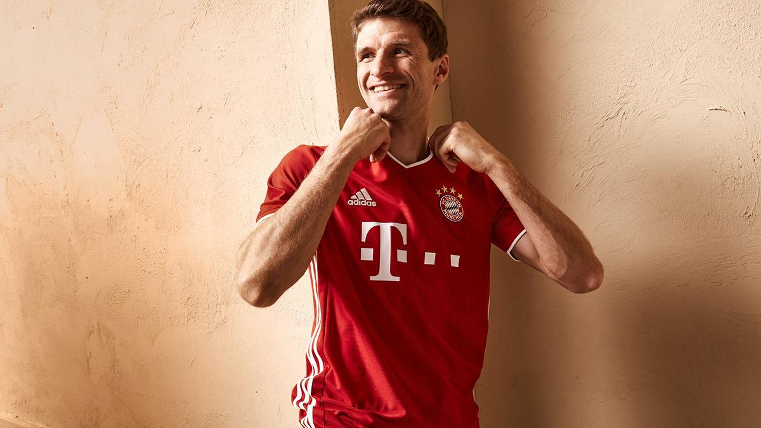

- Traditional club colors of red and white are complimented by fresh design details for a distinctly modern look
- Special details include “Mia San Mia” lettering on the neck and stripe details worked into the fabric
- The new kit will debut on-pitch this evening, and will be available exclusively at adidas.com/football and FCbayern.com/shop/en from today

Herzogenaurach, June 10th 2020: adidas and FC Bayern Munich today present the new 2020/21 season home kit for the reigning German champions.

The jersey is designed in classic club colors of ‘FC Bayern true red’ and white. The familiar look unites the club's sense of tradition and the bond with the entire FC Bayern Munich family, through the club mantra, "Mia san mia" lettering - meaning ‘we are who we are’ - emblazoned on the neck. Stripe details worked into the fabric give the red shirt a fresh look, while fine white edges on the collar and sleeves compliment this design element. Red shorts and socks complete the players' home kit for the 20/21 season, whilst the goalkeepers will play in a blue-green jersey.

The new home design will be seen on-pitch for the first time this evening (June 10th), as the club look to finish the remainder of the 2019/20 season with further domestic success. The 2020/21 home kit is available as of today exclusively at adidas.com/football, in the FC Bayern Online Store as well as in selected adidas and all FC Bayern Stores, and from June 17th at retail partners.

The pitch-version features a functional fit and adidas HEAT.RDY technology and is available for 129.95 EUR. A stadium version is also available at EUR 89.95.

- END -
For further media information please visit http://news.adidas.com/GLOBAL/PERFORMANCE/FOOTBALL or contact:

Max McLaren
Senior Global PR & Publishing Manager, adidas Football
Email: max.mclaren@adidas.com
Tel: +4915116955143

Notes to editors:

About adidas in Football
adidas is the global leader in football. It is the official supplier of the most important football tournaments in the world, such as the FIFA World Cup™, the UEFA European Championship & the UEFA Champions League. adidas also sponsors some of the world’s top clubs including Real Madrid, Manchester United, Arsenal, FC Bayern Munich & Juventus. adidas is also partner to some of the best athletes in the game including Leo Messi, Paul Pogba, Mohamed Salah, Paulo Dybala, Gabriel Jesus, Roberto Firmino, Joao Felix, Serge Gnabry, Isco, Dele Alli, Karim Benzema, Vivianne Miedema, Lindsey Horan & Wendie Renard.

