ADIDAS AND ALL BLACKS CONTINUE THE FIGHT AGAINST MARINE PLASTIC POLLUTION WITH THE RELEASE OF NEW TRAINING RANGE MADE WITH PRIMEBLUE: MADE WITH PARLEY OCEAN PLASTIC

- Featuring adidas PRIMEBLUE: Made With Parley Ocean Plastic performance fabric, a more sustainable technology where 100% of the polyester used is recycled
- Design inspired by the oceans that surround New Zealand
- Training collection available now on adidas.com
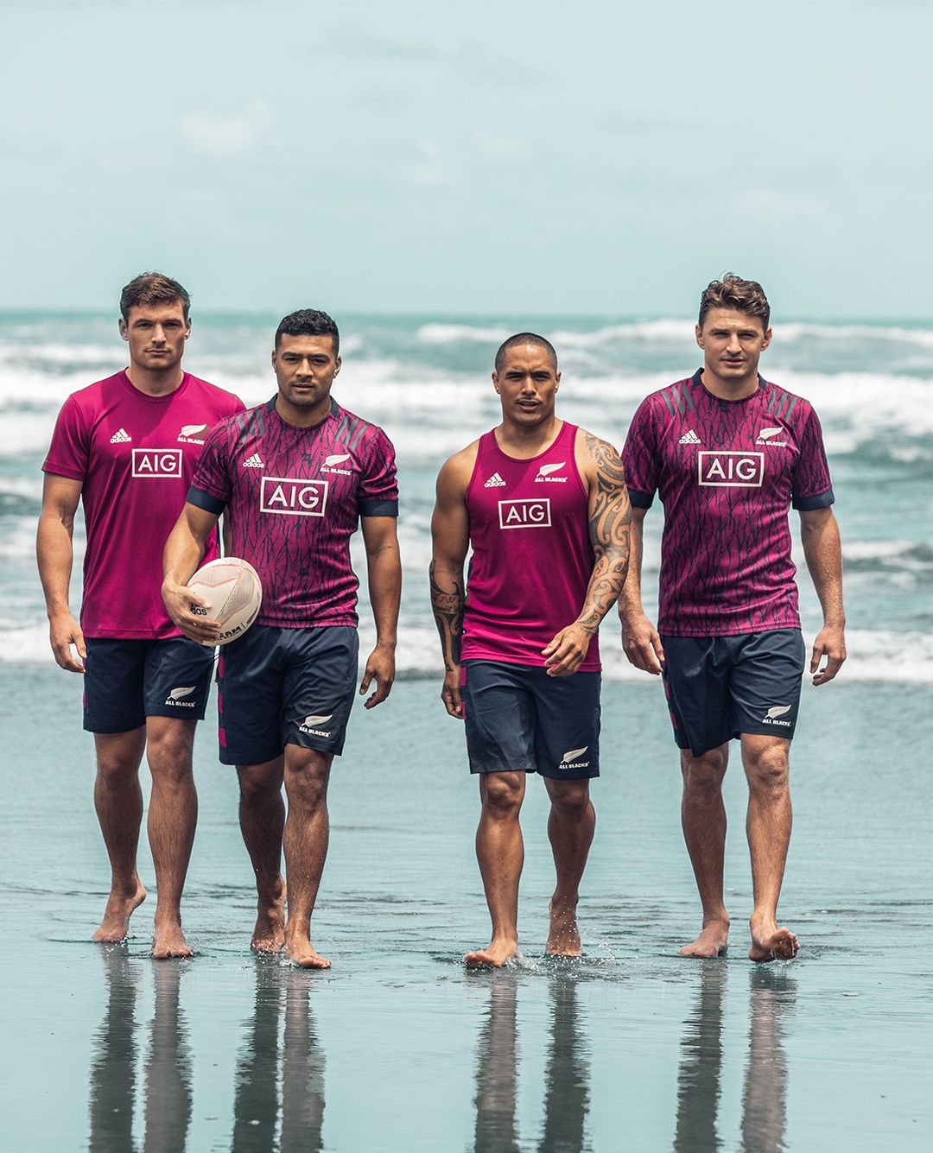

Herzogenaurach, 1st June 2020 – adidas and the All Blacks continue the fight against marine plastic pollution with the release of the All Blacks training range, featuring PRIMEBLUE: Made With Parley Ocean Plastic performance fabric. PRIMEBLUE: Made With Parley Ocean Plastic is made from recycled plastic waste and intercepted from beaches and coastal communities before it reaches the ocean.

The new training range includes the All Blacks training jersey and shorts, as well as items such as tees, hoodies and shorts. All are made from PRIMEBLUE: Made With Parley Ocean Plastic, a more sustainable technology where 100% of the polyester used is recycled. This recycled high-performance material is just part of our commitment to continue to innovate in the area of sustainability until we reach our goal of being completely off of virgin polyester by 2024. The training collection aims to highlight the environmental impact plastic waste has on our oceans and looks to harness the power of collaboration, eco-innovation and sport to drive solutions.

The training jersey features a more sustainable design, inspired by the oceans of New Zealand. In keeping with the importance of the Fern to the All Blacks, the training jersey features a more sustainable design and takes its inspiration from the movement of New Zealand marine flora. The new training apparel will be worn by the All Blacks later this year, and available for fans to buy from 1 June.

Matthew Fielding, adidas Category Director said: “After launching two more sustainable adidas rugby collections in 2019, for the All Blacks and the Super Rugby away jerseys, we wanted to ensure we continued that story in the 2020 season and our new PRIMEBLUE: Made With Parley Ocean Plastic technology provided an excellent opportunity to do so. The introduction of this fabric to ranges across our categories is helping to combat marine plastic pollution, raise awareness and champion eco-innovative solutions to one of today’s most pressing environmental issues. The All Blacks have a global platform in sport to spread our message of change and we hope to inspire rugby fans to join the movement.”

All Blacks inside back Beauden Barrett says: “The whole team are really proud to be wearing the new training range made from PRIMEBLUE: Made With Parley Ocean Plastic and we are all excited to get behind the cause. It’s good to know that we are playing a small part in highlighting the devastation that plastic is causing the oceans.”

The All Blacks training collection will be available for fans to purchase from 1st June. Jerseys will be stocked at all adidas stores, major sporting goods retailers, rugby retailers throughout New Zealand and the world, and online at www.adidas.com.

- END -
Press office enquiries
Daniel Messias – Hill + Knowlton Strategies
Email: Daniel.Messias@hkstrategies.com
Tel: +44 (0)2074133221

Notes to Editors:

About adidas
adidas is a global leader in the sporting goods industry with the core brands adidas and Reebok. Headquartered in Herzogenaurach/Germany, the company employs 57,000 people across the globe and generated sales of around €22 billion in 2018.

