adidas brings together creative worlds of art & football with new UNIFORIA boot pack

- Abstract art & self-expression inspire new Predator, COPA, Nemeziz and X designs
- Vivid colour palette & brush stroke design of the collection celebrate shared spirit of flair and ingenuity
- The pack will be available at adidas.com from May 26 ready for the return of football
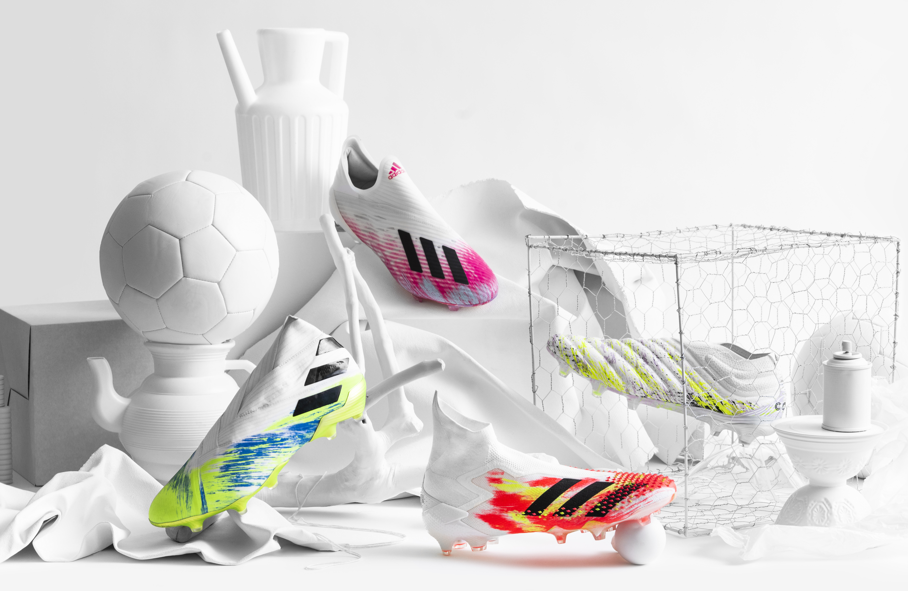

Herzogenaurach, May 26, 2020: adidas today reveals striking new colour designs across its Predator, Nemeziz, Copa and X franchises with the release of the UNIFORIA pack.

Designed at the intersection of art & football, the UNIFORIA boot pack celebrates the unity & euphoria-inspiring power of the two, possessing a shared ability to evoke creativity & self-expression.

The starting point for each design was a bold white base, mirroring an artist’s blank canvas. Each canvas is brought to life with a luminous colour palette, with brush stroke design sparingly applied in the style of abstract artistry methods for an impactful & handcrafted aesthetic.

The UNIFORIA pack sees Predator Mutator 20+ – complete with its DEMONSKIN innovation for an enhanced level of touch, control & spin on the ball – re-imagined with Pop and Signal Green brushstroke-style detailing, contrasted against the boot’s white backdrop.

The new COPA 20+ meanwhile mixes Purple Tint & Black, making for an equally bold design aesthetic. This features upon the boot’s leather outer & knitted collar, enabling clean ball contact for the wearer.

A similar palette is used for the updated Nemeziz 19+, combining Signal Green with Team Royal Blue for the intricate design, featuring on its Tension Tape composition designed for a fully adaptive fit.

The collection is rounded off with the X 19+, with lively Shock Pink detailing solely utilised across the boot’s low-cut silhouette & 3D moulded heel, giving it a sleek, minimalist look.

The UNIFORIA pack will be available at adidas.com & selected retailers from May 26, 2020 & will be worn by the best as play returns.

For further information, please visit adidas.com/football or follow @adidasfootball on Instagram or Twitter to join the conversation.

- END -
For further media information please visit http://news.adidas.com/GLOBAL/PERFORMANCE/FOOTBALL or contact:

Max McLaren
Senior Global PR & Publishing Manager, adidas Football
Email: max.mclaren@adidas.com
Tel: +4915116955143

Notes to editors:

About adidas in Football
adidas is the global leader in football. It is the official supplier of the most important football tournaments in the world, such as the FIFA World Cup™, the UEFA European Championship & the UEFA Champions League. adidas also sponsors some of the world’s top clubs including Real Madrid, Manchester United, Arsenal, FC Bayern Munich & Juventus. adidas is also partner to some of the best athletes in the game including Leo Messi, Paul Pogba, Mohamed Salah, Paulo Dybala, Gabriel Jesus, Roberto Firmino, Joao Felix, Serge Gnabry, Isco, Dele Alli, Karim Benzema, Vivianne Miedema, Lindsey Horan & Wendie Renard.

