adidas Originals and Girls Are Awesome Collaborate on Top-to-Toe Capsule Collection
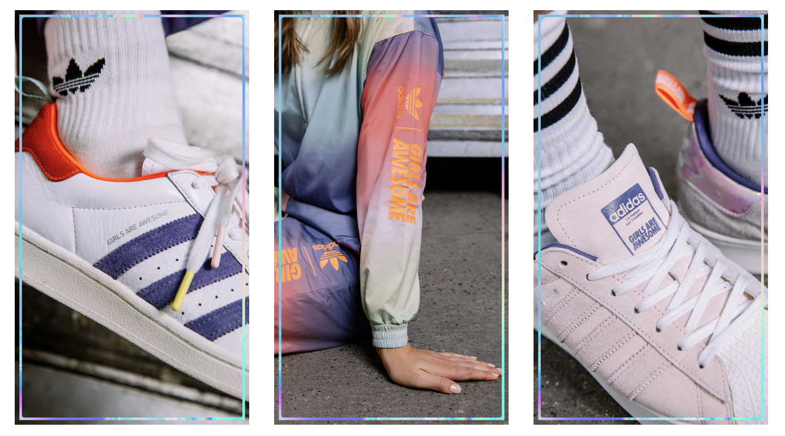

Herzogenaurach, April 15th, 2020 - adidas Originals has teamed up with the purpose driven
brand and emerging media platform, Girls Are Awesome, for a versatile top to toe capsule
collection that champions the importance of creators. Including a range of women’s, unisex, and kids’ apparel and footwear options, the collection is presented by a striking visual campaign featuring a range of role models from the Girls Are Awesome family.

Having previously worked together on a number of projects, including the elaborate Future
Studio in Berlin, the collection marks the beginning of a new series of collaborations between
the German sportswear brand and the forward thinking creative collective. With a strong belief in the importance of role models as cultural facilitators, Girls Are Awesome strive to increase
female representation by inspiring, elevating, and empowering girls and women around the
world. Together with the platform’s growing community, and through social initiatives and
partnerships, Girls Are Awesome create enabling conditions for change through culture, governance and practical tools.

Speaking on the collection, Brand Director Søs Bondo explained “Creating this collection
together is a natural progression from the three years of work Girls Are Awesome has done with adidas Originals in Central Europe, and allows us to spread our message further as we look to create more impact in the future. It’s been a fun challenge to create an eclectic range that aims to reflect the multi-faceted lives we lead in 2020, and to spotlight some of the role models from the Girls Are Awesome family.”

Let’s look at the collection. Starting with apparel, adidas Originals and Girls Are Awesome have
merged evocative palettes with forward thinking cuts to produce a number of striking clothing
pieces. The apparel capsule features a co-branded unisex t-shirt, sweatshirt and coach jacket,
with a women’s tracksuit and overalls in faded pink, navy, and iridescent colourways.

So, what about the footwear? The collaborative collection features four unique makeups of the
iconic Superstar silhouette. First, the Superstar Up “Girls Are Awesome” features a split icey
pink and light grey colored upper, an exaggerated sole, an iridescent heel patch, and two pairs of matching laces. Next, the Unisex Superstar EL I, Superstar C, and Superstar J are all offered from kid’s to adult sizing and feature a classic white leather upper with coral accents, matching laces, and asymmetric tech-purple and white three-stripes branding. Finally, the Superstar 360 I features a wrap-around one piece iridescent upper with contrasting coral stripes and is offered in infant sizing. Each sneaker in the capsule then comes replete with a custom co-branded insole and “Girls Are Awesome” heel pull.

The launch of the collaborative collection is accompanied by a campaign highlighting 9 role models from across the worlds of music, art and sport. Members of the extended Girls Are Awesome family, the campaign spotlights illustrator and tattoo artist Simone Klimmeck, skateboarder and photographer Laura Kaczmarek, musician Kinck, freestyle footballer Maymi Asgari, rappers and music coaches Silhouette and Q.Marzi, wheelchair basketballer Nagwa Brown, actor May Simon and soul singer Melissa Inya.

Where can you get it? The adidas Originals and Girls Are Awesome collaborative capsule
launches globally on April 22nd and it is available at adidas.com/girlsareawesome and girlsareawesome.com.

www.adidas.com
@adidasOriginals

About Girls Are Awesome:

Girls Are Awesome is a purpose-driven brand and emerging media platform.
Girls Are Awesome creates and collaborates on projects that increase female representation.

Their work focuses on elevating role models, through creating media exposure, hosting events, producing podcasts and videos, developing programs and product and working with their partners to constantly push for diversity, inclusion and equality! Together with their growing community, and through social initiatives and partnerships, they create enabling conditions for change through culture, governance and practical tools.

