ADIDAS GMR UNVEILED, THE ALL-NEW TECHNOLOGY MADE BY ADIDAS, POWERED BY JACQUARD™ BY GOOGLE AND EXPERIENCED THROUGH EA SPORTS™ FIFA MOBILE

The first of its kind gaming technology enables players to impact virtual performance with real-world play in EA SPORTS™ FIFA Mobile, merging physical football and digital gaming

adidas GMR measures a player’s kicks, shot power, distance and speed on-pitch, to unlock exclusive in-game rewards, improve their Team OVR and compete in leaderboards

Costing only €34.99, adidas GMR will be available to buy online at adidas.com and select adidas stores from today

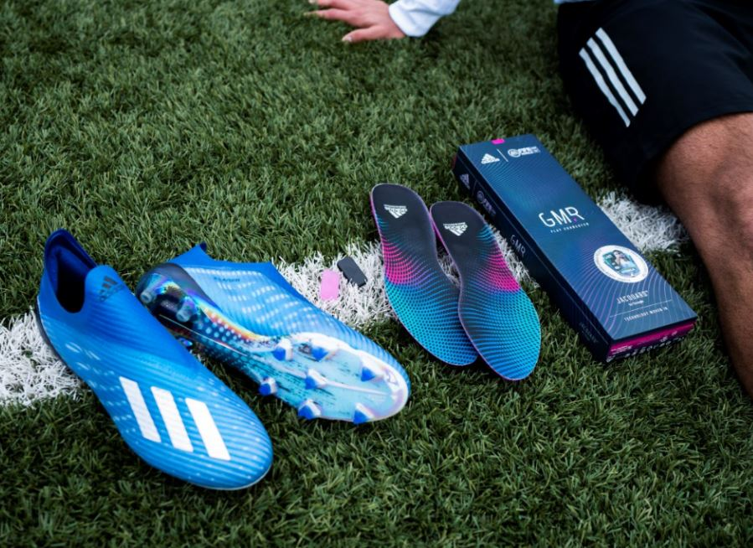

Herzogenaurach, 10th March 2020 – Together with EA SPORTS™ FIFA Mobile and Jacquard™ by Google, adidas today launches adidas GMR – an innovation that merges physical football and digital gaming, giving players the power to play connected by improving their FIFA Mobile Ultimate Team™ overall rating (OVR) through real-world play using the Jacquard by Google Tag.

The adidas GMR insole can be placed within any type of footwear. Once in place, the innovation will empower players to complete challenges on the street or pitch to unlock in-game rewards, improve their Team OVR and compete in leaderboards.

Powered by the Jacquard Tag’s advanced machine-learning algorithms, adidas GMR recognises the actual physical movements footballers make on-pitch - measuring kicks, shot power, distance and speed. By completing different challenges and hitting longer-term milestones, users will earn rewards and improve their Ultimate Team, powering their players in-game with real-world achievements.

One of the first challenges is Master Finisher, which sees players tasked with taking 40 powerful shots in the penalty box within a week to earn coins and skill boosts in their FIFA Mobile game. A player’s hardest shot will even be ranked on different leaderboards, giving them the chance to earn bragging rights over their friends.

Following the previous signing of Ninja as part of its Time In campaign, the launch of adidas GMR signals a move from adidas to enter the phygital gaming space – the latest step on its mission to become the number one sports brand influencing gaming culture.

Speaking on behalf of adidas, Moritz Kloetzner, Director of Business Development for adidas Football, said: "adidas is committed to innovation that enables an athlete’s game, regardless of the game they play. adidas GMR lives at the intersection of gaming and the material world because that’s where the audience is. By exploring and challenging traditional approaches to product development, alongside Jacquard by Google and EA SPORTS FIFA Mobile, we have been able to equip players with a whole new way to use their creativity for the betterment of sport.”

Matt Lafreniere, EA SPORTS FIFA Mobile Producer, commented; "We are always looking at how we can bring new experiences to our players that bridge the real-world of football with our virtual world in FIFA Mobile. With adidas GMR, we are debuting a new way to progress in the game, enabling players to grow their Ultimate Team in FIFA Mobile through the game they love, both on and off the pitch.”

Google’s Ivan Poupyrev said: “Jacquard by Google integrates interactivity, connectivity and A.I. into ordinary everyday things to make them more helpful and enjoyable, like the adidas GMR insole. Using advanced machine learning algorithms, we trained the Jacquard Tag, which is placed within your shoe, to recognize moves that you make on the pitch and reward you with a unique one-of-a-kind gaming experience in EA SPORTS FIFA Mobile. I am excited that Jacquard technology can enable a whole new range of experiences for gamers. The opportunities are endless."

Christian Volk, Director FIFA eFootball & Gaming, added: “We are excited to be supporting the GMR project, an innovation that will enhance the experience for players of FIFA Mobile around the world. Innovations that leverage technology to improve the experience of football fans are an important part of FIFA’s strategy.”

adidas GMR will be available to purchase online at adidas.com/gmr and in select adidas stores. FIFA Mobile is available to download in the App Store (iOS) and Google Play Store (Android) and enables players to connect directly to adidas GMR. adidas GMR will have an RRP of £29.95 / €34.99 / $35.

For further information please follow @adidasfootball on Instagram or Twitter to join the conversation.

- END -

For further media information please visit http://news.adidas.com/GLOBAL/PERFORMANCE/FOOTBALL or contact:

Max McLaren
Senior Global PR & Publishing Manager, adidas Football
Email: max.mclaren@adidas.com
Tel: +4915116955143

About adidas Football
adidas is the global leader in football. It is the official supplier of the most important football tournaments in the world, such as the FIFA World Cup™, UEFA EURO 2020™ and the UEFA Champions League. adidas also sponsors some of the world’s top clubs including Real Madrid, Manchester United, Arsenal, FC Bayern Munich and Juventus. adidas is also partner to some of the best athletes in the game including Leo Messi, Paul Pogba, Mohamed Salah, Paulo Dybala, Gabriel Jesus, Roberto Firmino, Joao Felix, Serge Gnabry, Isco, Dele Alli, Karim Benzema, Vivianne Miedema, Lindsey Horan and Wendie Renard.

About Electronic Arts
Electronic Arts (NASDAQ: EA) is a global leader in digital interactive entertainment. The Company develops and delivers games, content and online services for Internet-connected consoles, mobile devices and personal computers.

In fiscal year 2019, EA posted GAAP net revenue of $4.95 billion. Headquartered in Redwood City, California, EA is recognized for a portfolio of critically acclaimed, high-quality brands such as EA SPORTS™ FIFA, Battlefield™, Apex Legends™, The Sims™, Madden NFL, Need for Speed™, Titanfall™ and Plants vs. Zombies™. More information about EA is available at www.ea.com/news.

EA SPORTS, Battlefield, Apex Legends, The Sims, Need for Speed, Titanfall and Plants vs. Zombies are trademarks of Electronic Arts Inc. ©FIFA and FIFA’s Official Licensed Product Logo are copyrights and/or trademarks of FIFA. All rights reserved. Manufactured under license by Electronic Arts Inc. John Madden and NFL are property of their respective owners and used with permission.

About Jacquard™ by Google
Jacquard™ by Google is an advanced technology that seamlessly integrates new digital services and experiences into everyday things. With Jacquard Technology, familiar objects can become interfaces to bridge the physical and digital worlds. Brands are now able to enhance their products with a layer of interactivity, creating a new generation of connected products.

The Jacquard by Google Tag is small, discreet, yet robust and powerful. It's a tiny computer that enables connectivity to a mobile device, and translates interactions and actions into digital experiences. Whether it's a jacket, a backpack, or a shoe, the Jacquard Tag can be embedded seamlessly into the design of the product so it feels like a part of it.

Going beyond fitness tracking or motion detection, the Jacquard Tag uses advanced machine learning algorithms to recognize the actual football moves players make on-pitch -- measuring kicks, shot power, distance and speed. All this technology is stored in a Jacquard Tag that players insert into adidas GMR and place into their shoe. More information is available at www.jacquard.com.

