adidas reveals the Official Match Ball of the UEFA Champions League 2020 knockout stages, inspired by the host city of the final – Istanbul
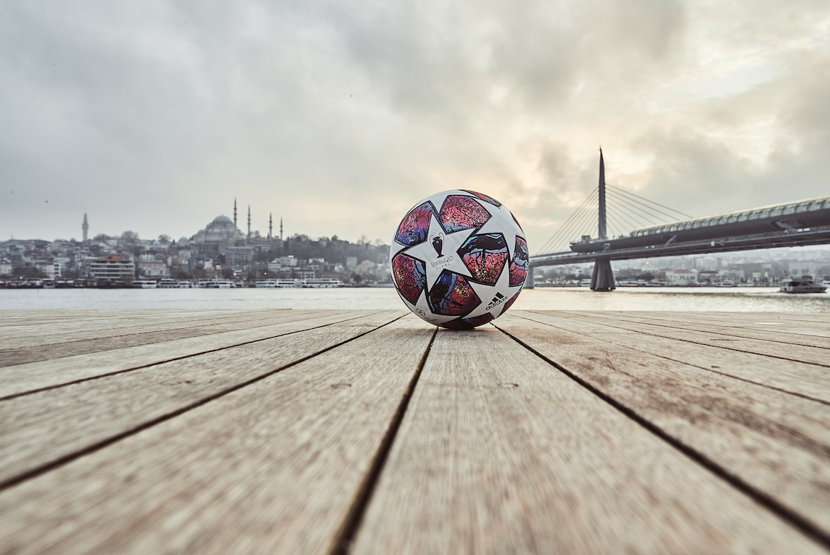
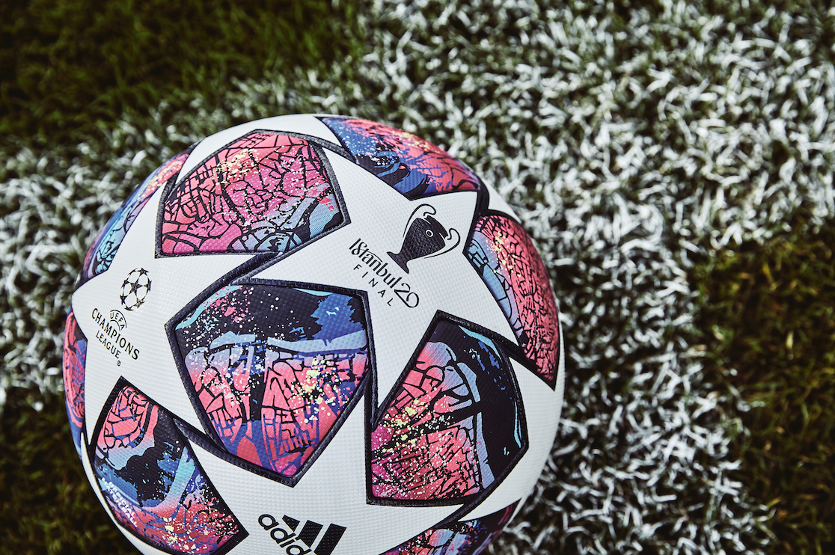

Herzogenaurach 18th February 2020: adidas today reveals Finale Istanbul, the Official Match Ball for the 2019/20 UEFA Champions League knockout stages. Drawing its inspiration from the host city, where East and West merge, the intricate design features a hand drawn artistic interpretation of a map of Istanbul, which uniquely bridges the two continents of Europe and Asia.

The Official Match Ball of the final has been designed to highlight the famous stars of the UEFA Champions League. Nodding to Istanbul’s deep culture of art, the carefully placed white stars contrast to a hand printed artwork of a map of the city which can be followed and adorns the rest of the ball. At the centre of this is the Bosporus narrow, a natural waterway that flows through the country and city itself to merge East and West.

Fusing art and football, adidas designers looked to more traditional methods to bring the map pattern to life, first crafting it by carving in wood, before printing with lino to blend heritage and innovation. The striking purple colour palette is inspired by the hues of the setting sun over the river from East to West.

The ball features the latest adidas performance technology to help ensure Europe’s top can perform at their best during the UEFA Champions League Final. Offering the same high-performance structure and panels as recent iterations of the iconic star ball, an outer texture coating gives a secure grip and complete control while the panels are thermally bonded, with more sustainable glue, to provide a seamless surface for an improved first touch. Equally distributed colour and the star formation are arranged across the ball to ensure peak performance and enhance aerobatic stability.

The 2019/20 UEFA Champions League Final takes place in Istanbul 30th May 2020. The adidas Finale Istanbul Pro will be available to purchase online, in adidas retail stores and selected retailers from today.

For further information please visit adidas.com/football or follow @adidasfootball on Instagram or twitter to join the conversation.

- END -

For further media information please visit http://news.adidas.com/GLOBAL/PERFORMANCE/FOOTBALL or contact:

Max McLaren
Senior Global PR & Publishing Manager, adidas Football
Email: max.mclaren@adidas.com
Tel: +4915116955143

Notes to editors:
About adidas in Football
adidas is the global leader in football. It is the official supplier of the most important football tournaments in the world, such as the FIFA World Cup™, the UEFA EURO 2020™ and the UEFA Champions League. adidas also sponsors some of the world’s top clubs including Real Madrid, Manchester United, Arsenal, FC Bayern Munich and Juventus. adidas is also partner to some of the best athletes in the game including Leo Messi, Paul Pogba, Mohamed Salah, Paulo Dybala, Gabriel Jesus, Roberto Firmino, Joao Felix, Serge Gnabry, Isco, Dele Alli, Karim Benzema, Vivianne Miedema, Lindsey Horan and Wendie Renard.

