ADIDAS OUTDOOR’S MYSHELTER COLLECTION RETURNS FOR SS20 WITH LAUNCH OF MYSHELTER RAIN.RDY PARKA

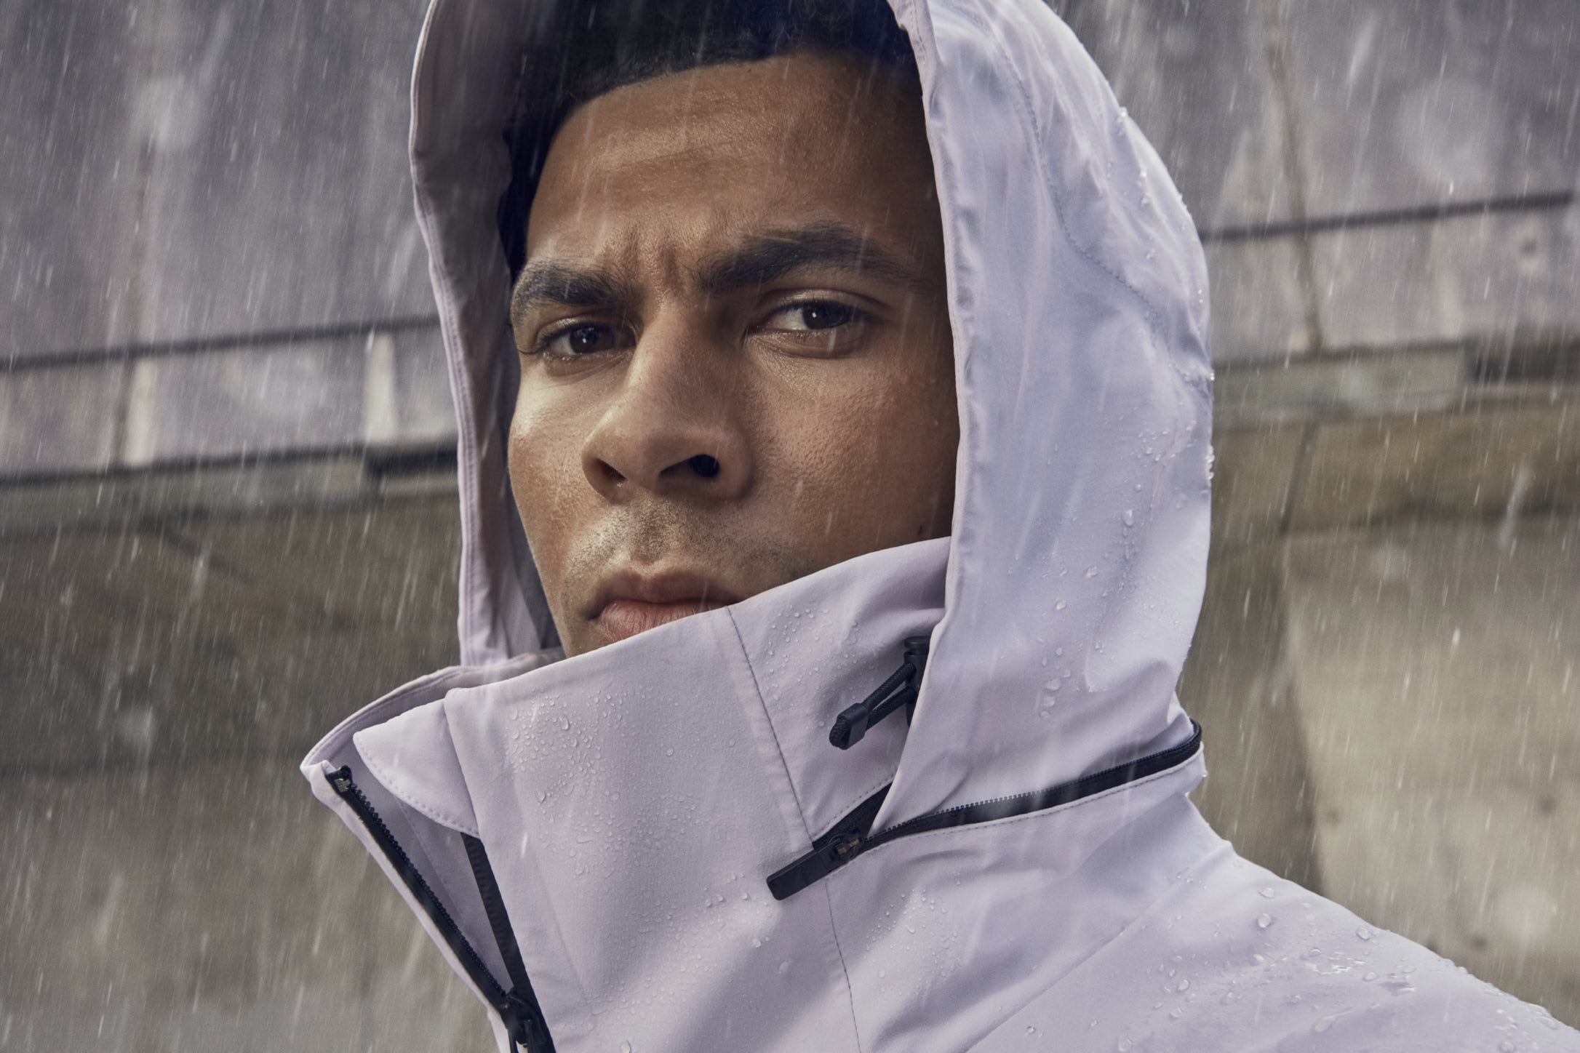

- Designed with the full weight of adidas Outdoor expertise The MYSHELTER RAIN.RDY Parka is the latest release from the MYSHELTER collection
- The Parka’s design was inspired by insights gathered from consumers living in London
- The trench inspired Parka has been designed to help the city-dweller to lead their lifestyle despite the city’s rainy climate

Today, adidas Outdoor launches the latest from the MYSHELTER range, the MYSHELTER RAIN.RDY Parka. Designed with insights from one of the world’s rainiest cities, London, the Parka has been created to defy the elements and allow the wearer to live their city lifestyle no matter the weather.

Inspired by the classic trench coat, the MYSHELTER RAIN.RDY Parka keeps you dry and comfortable as you navigate rainy days in the city. The long length offers extra coverage for when the wind blows the rain sideways, whilst ventilation zips, detachable carry straps and a stow-away hood offers much needed versatility when on the move.

As any Londoner will know, the varying temperature of public transport can provide a challenge in itself, and to negate this, the Parka contains a three-layer fabric that provides easy ventilation when on the move. The RAIN.RDY Parka is created from an outdoor inspired waterproof material that blocks the wind and rain while keeping the wearer dry inside. Coupled with a robust protective collar, the Parka offers both style and substance when in the London rain.

Tim Janaway, General Manager adidas Outdoor says “As we enter the second season of MYSHELTER, we’re keen to show how the collection can be hyper-localised and designed specifically to cities around the world. The weather often created a barrier to spending time outdoors, but through this collection, we’re enabling people to do just that. Thanks to the latest in outdoor technology, the MYSHELTER RAIN.RDY Parka allows our creators to live their lives, no matter the weather. MYSHELTER encourages them to explore and keeps them protected and comfortable.”

Launched in SS19, MYSHELTER is a collection of urban jackets created with outdoor technology and expertise to provide the perfect blend of function and style, allowing the wearer to feel dressed and protected at the same time.

Launching February, 1st 2020 for a retail price of €280.

Follow the conversation on Instagram and Facebook and using #adidasMYSHELTER and @adidasterrex

ABOUT ADIDAS OUTDOOR
Too much of life now happens indoors, affecting health, happiness, and creativity.
That's why, as the creator brand in the outdoors, we believe the solution is to get out there.

In body, the outdoors is our space to play. In mind, it's our place to think differently.
Adidas outdoor brings people to the outdoors and brings the outdoors to the cities.
Because through sport, we have the power to change lives.

