adidas Originals Jumps into the New Year With the
CNY: Mickey Mouse Pack

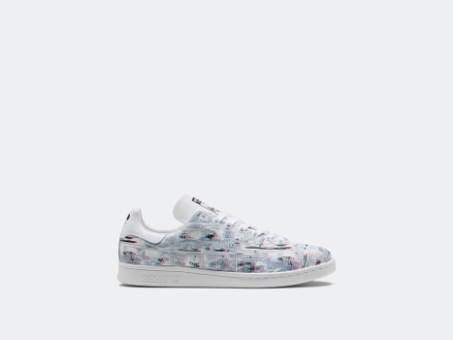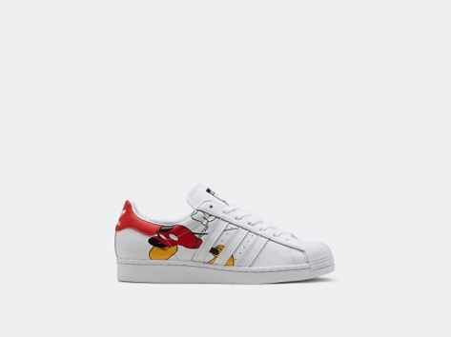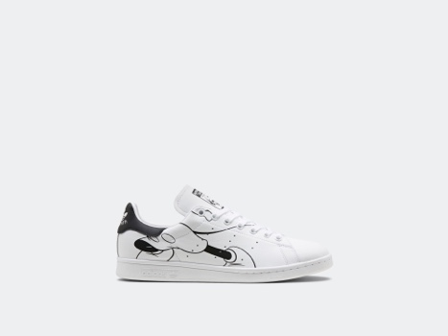

Herzogenaurach, January 14, 2020 - adidas Originals ushers in the Year of the Rat in playfully eccentric style with the CNY: Mickey Mouse Pack. Bringing one of the world’s most iconic animated characters, Disney’s Mickey Mouse, together with two of sportswear’s most revered footwear silhouettes, the Stan Smith and Superstar, the pack celebrates tradition, pop-culture, and design heritage.

Let’s break down the drop. Serving as a subtle nod to important numbers in Chinese tradition, the pack is comprised of 3 distinct sneakers - the “CNY Mickey Mouse Stan Smith 3D”, the “CNY Mickey Mouse - Out of Office Stan Smith”, and the “CNY Mickey Mouse - Out of Office Superstar”.

Perfectly merging aesthetic heritage with modern style, the “CNY Mickey Mouse Stan Smith 3D” features an all over 3 dimensional graphic upper and printed insoles. The striking sneaker is capped off with a pair of 3D glasses, allowing the wearer to experience their pair in an innovative new way, turning the striking designs into a fully readable comic strip.

Meanwhile, the “CNY Mickey Mouse Out of Office” Stan Smith and Superstar shine a light of the original style of two adidas archival icons while offering an energetic update. Each sneaker is made up in a full grain leather upper which features bold Mickey Mouse graphics. In fittingly whimsical style, the two “Out of Office” sneakers are finished off with a handwritten printed message declaring that Mickey is taking a trip away for the Lunar New Year.

So where can you get them? The CNY: Mickey Mouse pack releases globally on January 18th, and is available at adidas.com.

