ADIDAS FOCUSBREATHEIN DESIGNED FOR RUNNING REMEDY AND RE-ENERGIZING A PERSONAL BEST MINDSET
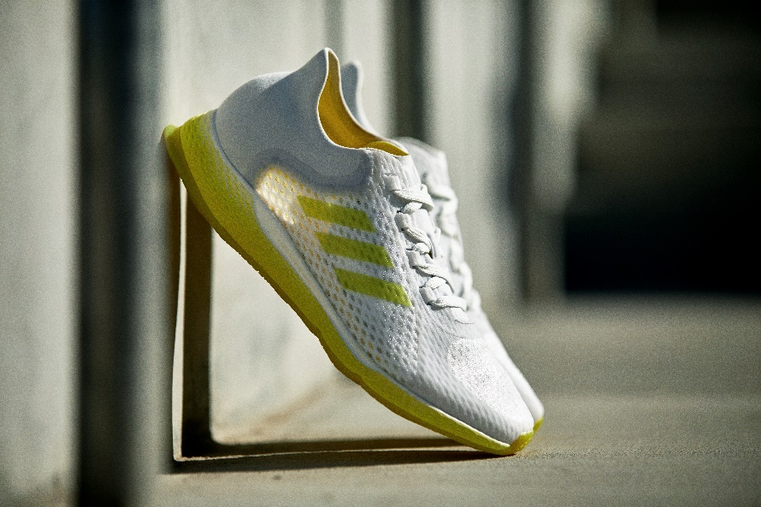
- Runners in New York, Shanghai and Europe shared insights that informed the open source design of the new adidas FOCUSBREATHEIN lightweight shoe, created for runners who run to reset and rejuvenate
- The shoe’s unique upper features a range of layered, transparent textures to create a ‘glowing from within’ effect, mirroring the positive benefits of exercise on a runner’s own internal energy
- The three colorways of the shoe – Root Chakra Red, Solar Plexus Yellow and Third Eye Blue – are all inspired by the different ‘chakra points’ in the human body through which energies flow
- adidas FOCUSBREATHEIN will be available to buy instore and at adidas.com from January 30, 2020

Herzogenaurach, January 20, 2020: Today, adidas reveals FOCUSBREATHEIN – a new running shoe that offers smooth movement and provides lightweight comfort and performance for those who use running as a way to re-energize and establish their personal best mindset. Ready. Set. Glow!
Inspired by the restorative effects of exercise on a person’s wellbeing, adidas FOCUSBREATHEIN combines a translucent upper with a BOUNCELITE EVA midsole, blending iconic adidas performance DNA with modern underfoot comfort. adidas FOCUSBREATHEIN is created for runners looking to reap the holistic benefits of being able to fully reset and rejuvenate when it comes to their all-important workout time.
The design inspiration behind adidas FOCUSBREATHEIN centers on a ‘glowing from within’ concept, with a range of transparent, soft textures utilized in the shoe’s design – both in the upper material and in the distinctive outsole – to create a glowing effect that mirrors the positive benefits of exercise on a person’s own internal energy and aura.
adidas FOCUSBREATHEIN has been specially developed to offer unrivaled natural comfort, with lightweight compounds used to offer a featherlight, aerodynamic performance. The inclusion of a progressive tongue and upper construction ensures the wearer can enjoy fluid, boundless movement when running in the shoe.
The key technical features of adidas FOCUSBREATHEIN are as follows:
FIT – 3D molded heel construction offers lightweight comfort and support, while the inclusion of a progressive and breathable upper with padded tongue ensures a full range of movement and minimal distraction
FEEL – BOUNCELITE midsole technology offers lightweight energy return performance

FLUID MOVEMENT – The outsole centers on an undulated wave design, combining macro undulations with micro textures, to ensure the shoe offers a consistently smooth performance with a quiet and cushioned transition

The three colorways of adidas FOCUSBREATHEIN all take inspiration from the ‘chakras’ – the points in the body through which energies flow – as a further celebration of these different types of energy and the qualities they inspire. These include:
- Root Chakra Red, which is linked to life force and stability
- Solar Plexus Yellow, which is linked to happiness and optimism
- Third Eye Blue, which is linked to intuition and peace of mind
Matthew Van Wyen at adidas said: “Talking to runners around the world, we understand the impact running has on improving people’s personal best mindset and taking them away from the stresses of the everyday. Taking cues from the restorative and rejuvenating effects of exercise, adidas FOCUSBREATHEIN will enable the wearer to forget about everything else going on around them and zone in on themselves during their run and workout, through the lightweight comfort and no-distraction fit”.
adidas FOCUSBREATHEIN will be available to buy instore and online at adidas.com, the adidas app and select retailers from January 30, 2020, alongside an accompanying running apparel range.
As part of the adidas FOCUSBREATHEIN campaign, adidas has captured the stories of a number of female runners, whose motivation for running reflects the inspiration behind the new shoe.
adidas will also be marking the launch of adidas FOCUSBREATHEIN with digital runs also available for runners to try via the adidas Running app.
To find out more, please visit: adidas.com. Follow the conversation on Instagram, Facebook and Twitter at @adidasrunning.

