ADIDAS LAUNCHES NEW LINE IN
COLLABORATION WITH POKÉMON
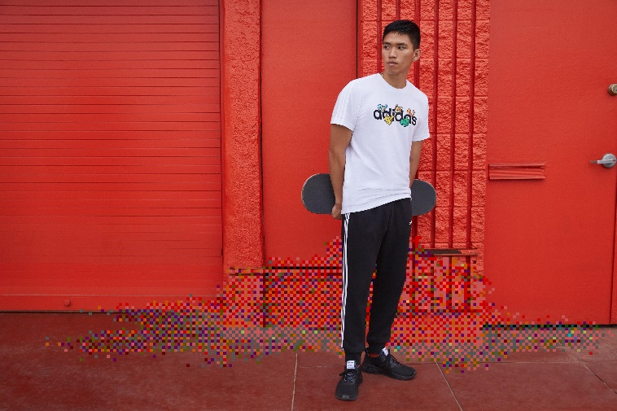

- adidas collaborates with Pokémon to launch unique new line inspired by the game’s iconic Pokémon and retro 8-bit graphics
- Featuring both adult and youth styles, the collaboration sees classic adidas tracksuits, t-shirts, pants, shorts, and three types of shoe given a classic gaming refresh
- The collection will be available to purchase instore and online at adidas.com from today
Herzogenaurach, January 2 2020: Today, adidas announces its collaboration with The Pokémon Company International for a collection celebrating the iconic video game franchise through a stylish new line.
Featuring both adult and youth styles, much of the design aesthetic of the collection is inspired by classic lo-fi 8-bit graphics, reminiscent of Pokémon as they were seen when the first games launched. The collection sees the game’s array of effects - using patterns of pixels to create colours, gradients and textures – combine with some of adidas’s most celebrated retro staples for fans who want to take their love of the game to the next level.
Footwear in the youth collection includes adidas Advantage and Hoops Mid 2.0 shoes – both of which have seen their retro adidas style given a refresh, through the addition of pixelated Pokémon uppers. The youth apparel line-up includes an adidas Pokémon trainer tee and classic black tracksuit, featuring Pokémon inspired graphics as part of its updated look.
The adult footwear collection features a new take on the running-style adidas Phosphere shoes – combining lasting comfort with eye-catching style through the inclusion of contemporary Pokémon illustrations on the tongue. The apparel range includes a pixelated Pokémon tee, in addition to tapered cuff pants, that offer a worthy nod to the gaming icon’s heritage.
Bernhard Serr, VP Product Core Apparel / Accessories at adidas, said: “Streetwear is about making statements – wearing the newest and freshest pieces to show your style and to get yourself noticed. We’re delighted to collaborate with Pokémon to create this unique new sport-inspired line that takes cues from the prolific gaming franchise. The collection is sure to be a must-have for Pokémon Trainers across the globe, young and old.”
Colin Palmer, Vice President of Marketing at The Pokémon Company International said: “This collaboration between Pokémon and adidas sees two of the world’s biggest brands combine to create a unique clothing capsule for Pokémon Trainers. Together, we’ve reimagined timeless adidas staples, giving them a classic but distinctly Pokémon refresh to create a stylish new line that will enable fans to look the part while levelling-up their love of Pokémon games.”
The adidas x Pokémon collection will be available to buy at adidas.com, the adidas app and select retailers from January 1 2020.

ENDS
About Pokémon
The Pokémon Company International, a subsidiary of The Pokémon Company in Japan, manages the property outside of Asia and is responsible for brand management, licensing and marketing, the Pokémon Trading Card Game, the animated TV series, home entertainment, and the official Pokémon website. Pokémon was launched in Japan in 1996 and today is one of the most popular children’s entertainment properties in the world. For more information, visit www.pokemon.com.

