ADIDAS ANNOUNCES THE 2019 STAR WARS™ COLLECTION

10-28-2019 / PORTLAND, ORE.

• The footwear and apparel collaboration features three packs across adidas Basketball, Running and Originals

• Each of the three packs celebrate an element of Star Wars including lightsabers, starships and classic Star Wars characters.

• The Lightsaber-themed pack from adidas x Star Wars will be available at adidas stores and on adidas.com beginning November 1

• For more information on the collection’s upcoming releases, fans can sign up for alerts at www.adidas.com/star_wars.

CAMPAIGN IMAGE
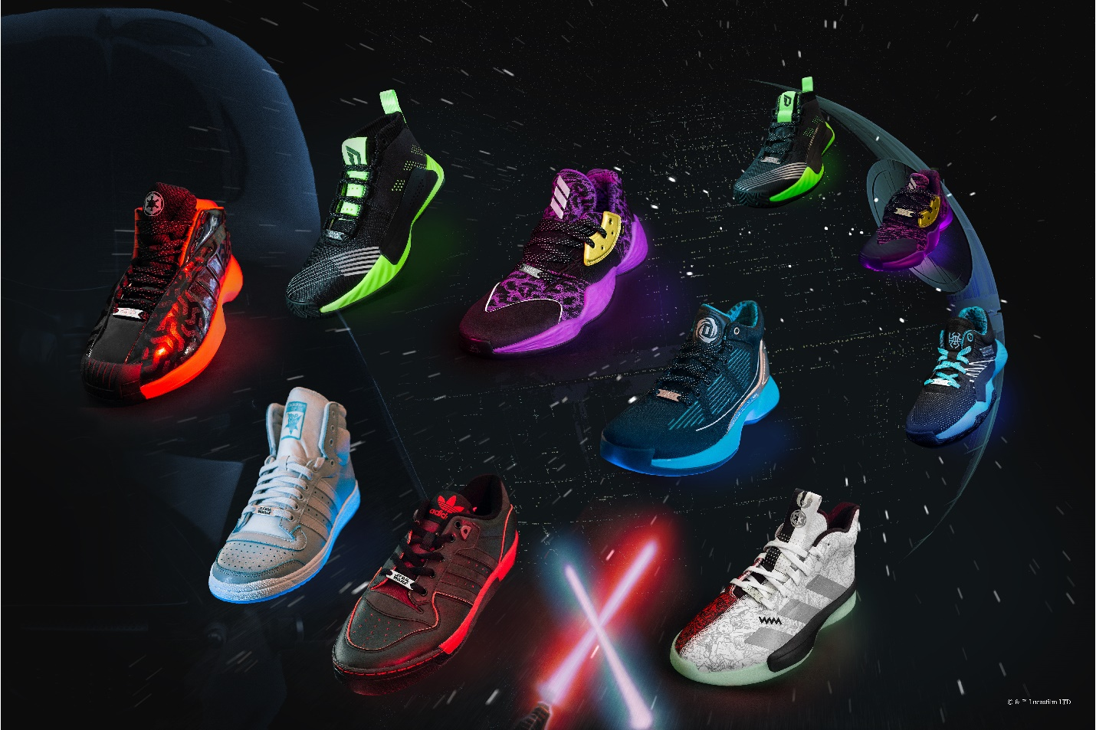
DOWNLOAD MEDIA HERE

adidas, in collaboration with Lucasfilm, unveils the adidas x Star Wars 2019 collection. The capsule collection debuts on Nov. 1 with the Lightsaber-themed pack, followed by the Space Battle pack launching Nov. 21 and the Characters pack launching Nov 29. Each of the three capsules celebrates an iconic element of Star Wars.

The Lightsaber-themed pack is designed for the players who wear them. Inspired by the unbreakable bond between a Jedi and their lightsaber, the design is highlighted by kyber crystal-themed elements that are featured on each silhouette’s UV midsole. The pack features eight custom basketball iterations: The Harden Vol. 4 is designed with purple accents and pays homage to Mace Windu, while the Dame 5 takes inspiration from Luke Skywalker’s green lightsaber. Crazy 1 and Rivalry Lo designs shed light on Darth Vader and the dark side, while the classic Top Ten design is dedicated to the legendary Jedi hero, Obi-Wan Kenobi.

The collection also includes the D Rose 10 and a juniors’ edition of D.O.N. Issue #1, in addition to Pro Next which features characters from both the light side and dark side of the Force. Unique Star Wars detailing is featured throughout all silhouettes including Aurebesh callouts, stamping the footwear with the official written system of the galaxy. To complement the Lightsaber-themed pack, the apparel capsule includes hoodies, crewnecks and sweatpants.

ON-WHITE IMAGERY

The Lightsaber-themed pack releases on November 1 at adidas.com and select adidas stores, with price points between $70-$140 USD. For more information on the collection’s upcoming releases, fans can sign up for alerts at www.adidas.com/star_wars.

STAR WARS and related properties are trademarks and/or copyrights in the United States and other countries, of Lucasfilm Ltd. and/or its affiliates. © & TM Lucasfilm Ltd.

About adidas

adidas is a global designer and developer of athletic and lifestyle footwear, apparel and accessories with the mission to be the best sports brand in the world. As an innovation and design leader, adidas engineers the best in high-performance products to make athletes better, faster and stronger and creates a range of classic and fresh lifestyle and high-fashion lines.

###

For general inquiries, please contact:

Paige Bradford
paige@pitchblend.com

Mimi Chang
mimi@pitchblend.com

