adidas Football reveals Encryption Pack

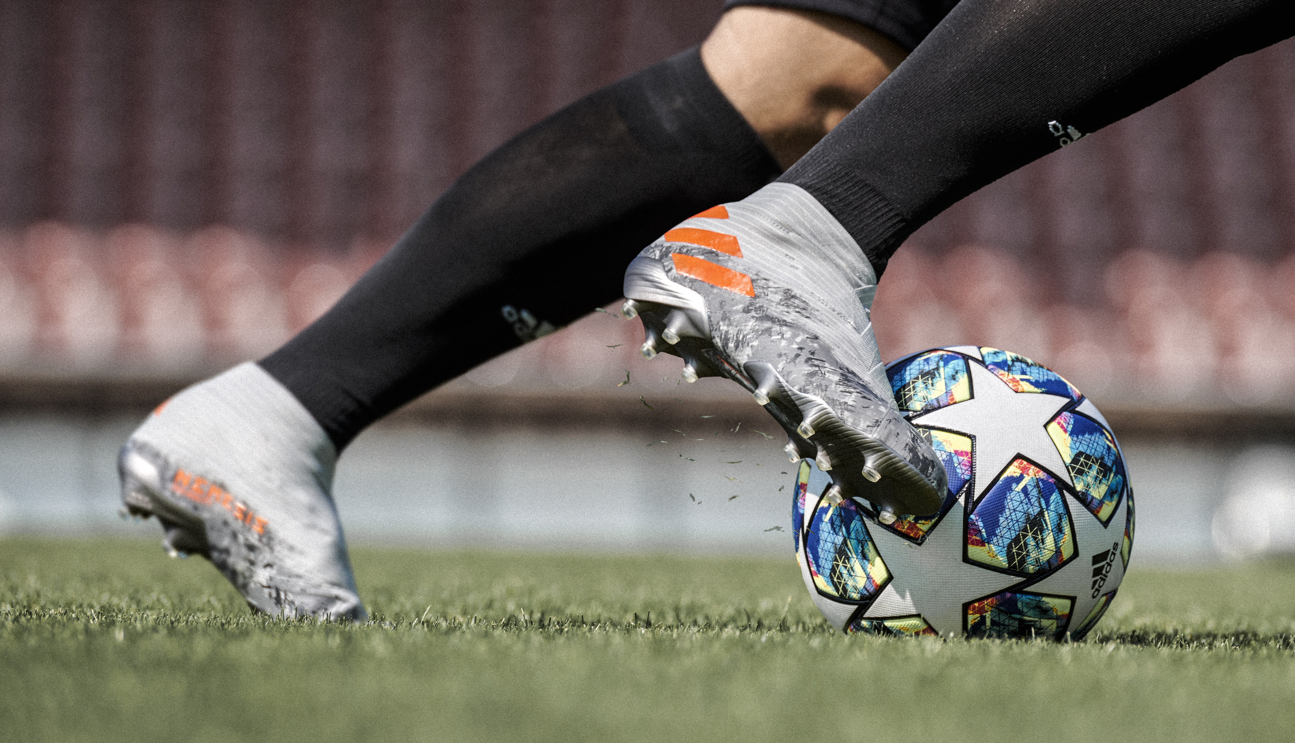

Herzogenaurach, 26th October 2019 – adidas today reveals Encryption Pack – an understated grey and green colour up for Predator, NEMEZIZ, X and COPA. Individual camouflage designs have been crafted for each boot, juxtaposed against a matte finish to create a sleek and unique pattern for each silo:

- NEMEZIZ 19 features a matte grey colouring with an all over camouflage pattern on the boot; made up of a variety of light and dark grey shades, with the three stripes in a solar orange to pop against the muted background.

- X 19 has received a traditional camouflage colouring of dark greens primarily on the collar and heel of the boot. This is blended with a matte green finish, with solar orange accents adding a bold twist.

- Predator 19 has the full camouflage effect with lighter greens than the X19. This colourway and pattern are highlighted against a sock upper in a darker green. White accents standout against the greens of the design.

- COPA 19 features a more muted camouflage design, in a variety of dark greys running along the heel and sole plate. The space grey upper contrasts against the camouflage pattern and accents have been created in a sollar yellow for a colour pop against the greys of the boot.

Encryption Pack will be worn on pitch from tomorrow by some of the world’s top players including Leo Messi, Paul Pogba, Gabriel Jesus, Mohamed Salah, Roberto Firmino, Paulo Dybala, Thomas Müller, James Rodríguez, Diego Costa and Mesut Özil. The pack will be available to purchase online and instore from the 26th October.

- END -

For further media information please visit http://news.adidas.com/GLOBAL/PERFORMANCE/FOOTBALL or contact:

Max Mclaren
Senior Global PR & Publishing Manager, adidas Football
Email: max.maclaren@adidas.com
Tel: +4915116955143

Notes to editors:

About adidas Football
adidas is the global leader in football. It is the official sponsor / official supplier partner of the most important football tournaments in the world, such as the FIFA World Cup™, the FIFA Confederations Cup and the UEFA Champions League. adidas also sponsors some of the world’s top clubs including Manchester United, Arsenal, Real Madrid, FC Bayern Munich and Juventus. Some of the world’s best players also on the adidas roster are Leo Messi, Paul Pogba, Gabriel Jesus, Mohamed Salah, Roberto Firmino, Thomas Müller, Luis Suárez, James Rodríguez, Diego Costa and Mesut Özil.

