**adidas launches celebratory ’MESSI 15 YEARS’ NEMEZIZ pack**

**- adidas releases exclusive 'MESSI 15 YEARS' NEMEZIZ pack, celebrating the 15-year anniversary of Lionel Messi's professional debut in football -**

**- Special issue design of the NEMEZIZ 19+ draws inspiration from the triumphs Messi has achieved throughout his decorated career -**

**- Features of the boot include a 'five dot' detail representing his five Ballon D'Ors, and his personal 'M' logo -**

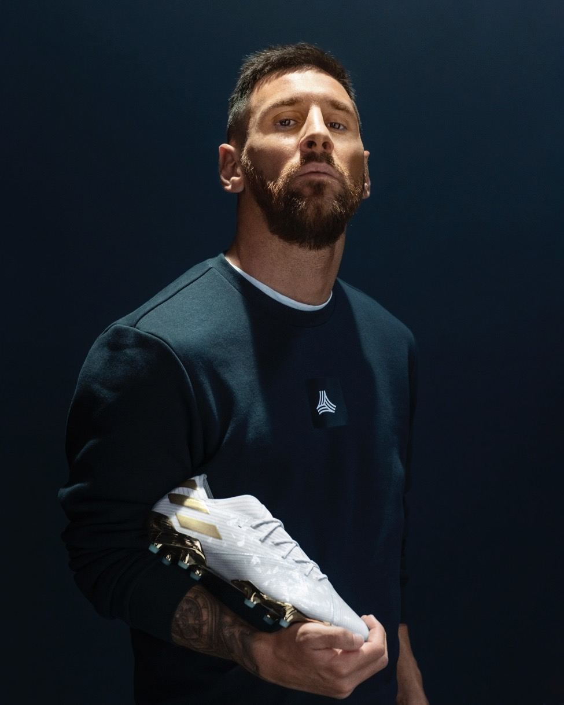

**Herzogenaurach, 16th October 2019 –** adidas has today released an exclusive ‘MESSI 15 YEARS’ NEMEZIZ pack, celebrating the 15-year anniversary of Lionel Messi’s professional debut in football.

The special issue design of the NEMEZIZ 19+ boot takes cues from some of the many remarkable moments in the career of this icon of the game.

The boot’s colourway features Argentina white and blue – celebrating his South American roots – with touches of gold as a nod to the many trophies he has won over the course of his illustrious playing career.

In addition, the boot's design features a range of stylised symbols that represent some of Messi's best loved and most celebrated moments on pitch. This includes a ‘five dot’ detail on the left foot, representing his five Ballon d’Ors and his personal ‘M’ logo on the right. There is also a ’15 AÑOS’ print on the arch to highlight his 15 years as a professional player.

In honour of it being his preferred foot, the boot’s left sock liner is emblazoned with a ’10’ – Messi’s favoured shirt number. Meanwhile, the right boot features the words ‘82nd min – 16-10-2004’ on the forefront in honour of the date and time that Messi stepped onto a professional football pitch for the first time.

NEMEZIZ 19+ is built for the most agile and multidirectional players. Created specifically for those who play unpredictably and with spectacular flair, footwork and movement, the revolutionary upper construction of the NEMEZIZ synergises the function and visual of tension, torsion and compression.

The ‘MESSI 15 YEARS’ NEMEZIZ pack will be available to purchase at adidas.com, as well as selected retail partners from 19th October.

For further information please visit adidas.com/football or follow **@adidasfootball** on Instagram or twitter to join the conversation.

**- END -**

**For further media information please visit**[**http://news.adidas.com/GLOBAL/PERFORMANCE/FOOTBALL**](https://urldefense.proofpoint.com/v2/url?u=http-3A__news.adidas.com_GLOBAL_PERFORMANCE_FOOTBALL&d=DwMFAw&c=5oszCido4egZ9x-32Pvn-g&r=ejfi0Fp458JEXSYrr1445YyHXJxypjLWyRQ3-waFQwo4OQK8Xs-9lZP4U6BFu65G&m=Kpj9LSUphr34BayZUwDzHCmebyCDw5GGlsw2UYgwbBs&s=vumAeWfgX683DIz7hy8uI3dHjfn94g-AgQLdI7ZRjxI&e=)**or contact:**

Max McLaren

Senior Global PR & Publishing Manager, adidas Football

Email: [Max.McLaren@adidas.com](mailto:Max.McLaren@adidas.com)

Tel: +49151/169/55143

**Notes to editors:**

About adidas Football

adidas is the global leader in football. It is the official sponsor / official supplier partner of the most important football tournaments in the world, such as the FIFA World Cup™, the FIFA Confederations Cup and the UEFA Champions League. adidas also sponsors some of the world’s top clubs including Real Madrid, Manchester United, Arsenal, FC Bayern Munich and Juventus. Some of the world’s best players also on the adidas roster are Leo Messi, Paul Pogba, Gabriel Jesus, Mohamed Salah, Roberto Firmino, Paulo Dybala, Thomas Müller, James Rodríguez, Diego Costa and Mesut Özil.