ADIDAS OUTDOOR LAUNCHES MYSHELTER WITH THE RELEASE OF THE ULTIMATE COMMUTER JACKET FOR THE RAINY CITY

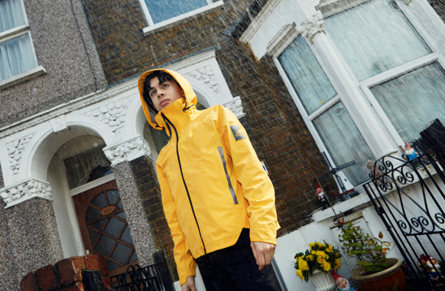

- adidas Outdoor launches MYSHELTER - the first adidas Jackets Franchise, built on insights from consumers living in cities around the globe.
- This launch includes the release of the MYSHELTER RAIN JACKET, featuring the latest adidas Outdoor technology to keep you dry and comfortable
- Designed with the full weight of adidas Outdoor expertise, MYSHELTER is a second skin for moving through the city in the elements

Today, adidas Outdoor launches MYSHELTER, a new range of jackets that combines outdoor expertise and technology with urban style. Through a collection of weather protective jackets, MYSHELTER is based on research and insights from consumers living in cities with specific weather conditions like London, New York, Shanghai and Tokyo. The jackets combine over fifty years of expertise in highly technical apparel, with modern-day innovation. The first jacket to launch will be the MYSHELTER RAIN JACKET set for September 2019. The MYSHELTER RAIN JACKET is for everyday life, empowering young urban creators to leave the indoors behind and explore their city in any weather.

Built for protection against the elements, adidas Outdoor has developed a jacket using technical expertise to provide comfort and dryness on any trip outside. A fully seam sealed construction keeps the wearer dry from the moment they leave the house, whilst a breathable membrane avoids trapping heat when on the move.

Tim Janaway, General Manager adidas Outdoor says “with MYSHELTER we want to empower people to spend time outdoors. Not just in the great outdoors, but in urban environments. Thanks to the latest in outdoor technology, the MYSHELTER RAIN JACKET allows our creators to be creative outdoors living their lives, no matter the weather. MYSHELTER encourages them to explore and keeps them protected and comfortable.

Lightweight and robust, the MYSHELTER RAIN JACKET offers weather protection you can wear, carry, or easily stow whilst travelling – perfect for the inner-city commute. A unique carry strap design allows hands-free commuting and optimum heat management. A high collar with adjustable stow-away hood, accompanied by back-yoke overlay construction, offering that all-important extra layer for added water protection.

The MYSHELTER RAIN JACKET also displays a black reflective logo and branding on a statement yellow base for better visibility in urban environments.

Staying true to the MYSHELTER design ethos, MYSHELTER will continue to create and expand its range of urban jackets, creating a collection of weather specific, technical outerwear that seamlessly blends function with style.

Launching September, 2nd 2019 for a retail price of €200.

Follow the conversation on Instagram and Facebook and using #MYSHELTER and @adidasterrex

ABOUT ADIDAS OUTDOOR
Too much of life now happens indoors, affecting health, happiness, and creativity.
That's why, as the creator brand in the outdoors, we believe the solution is to get out there.
In body, the outdoors is our space to play. In mind, it's our place to think differently.
Adidas outdoor brings people to the outdoors and brings the outdoors to the cities.
Because through sport, we have the power to change lives.

