adidas Unveils NY Collection For US Open

- Alexander Zverev and Angelique Kerber among line up of adidas players to unveil collection on court -
- Designed in collaboration with the adidas Brooklyn Creator Farm -
- Inspired by urban tennis culture and the streets of New York City –
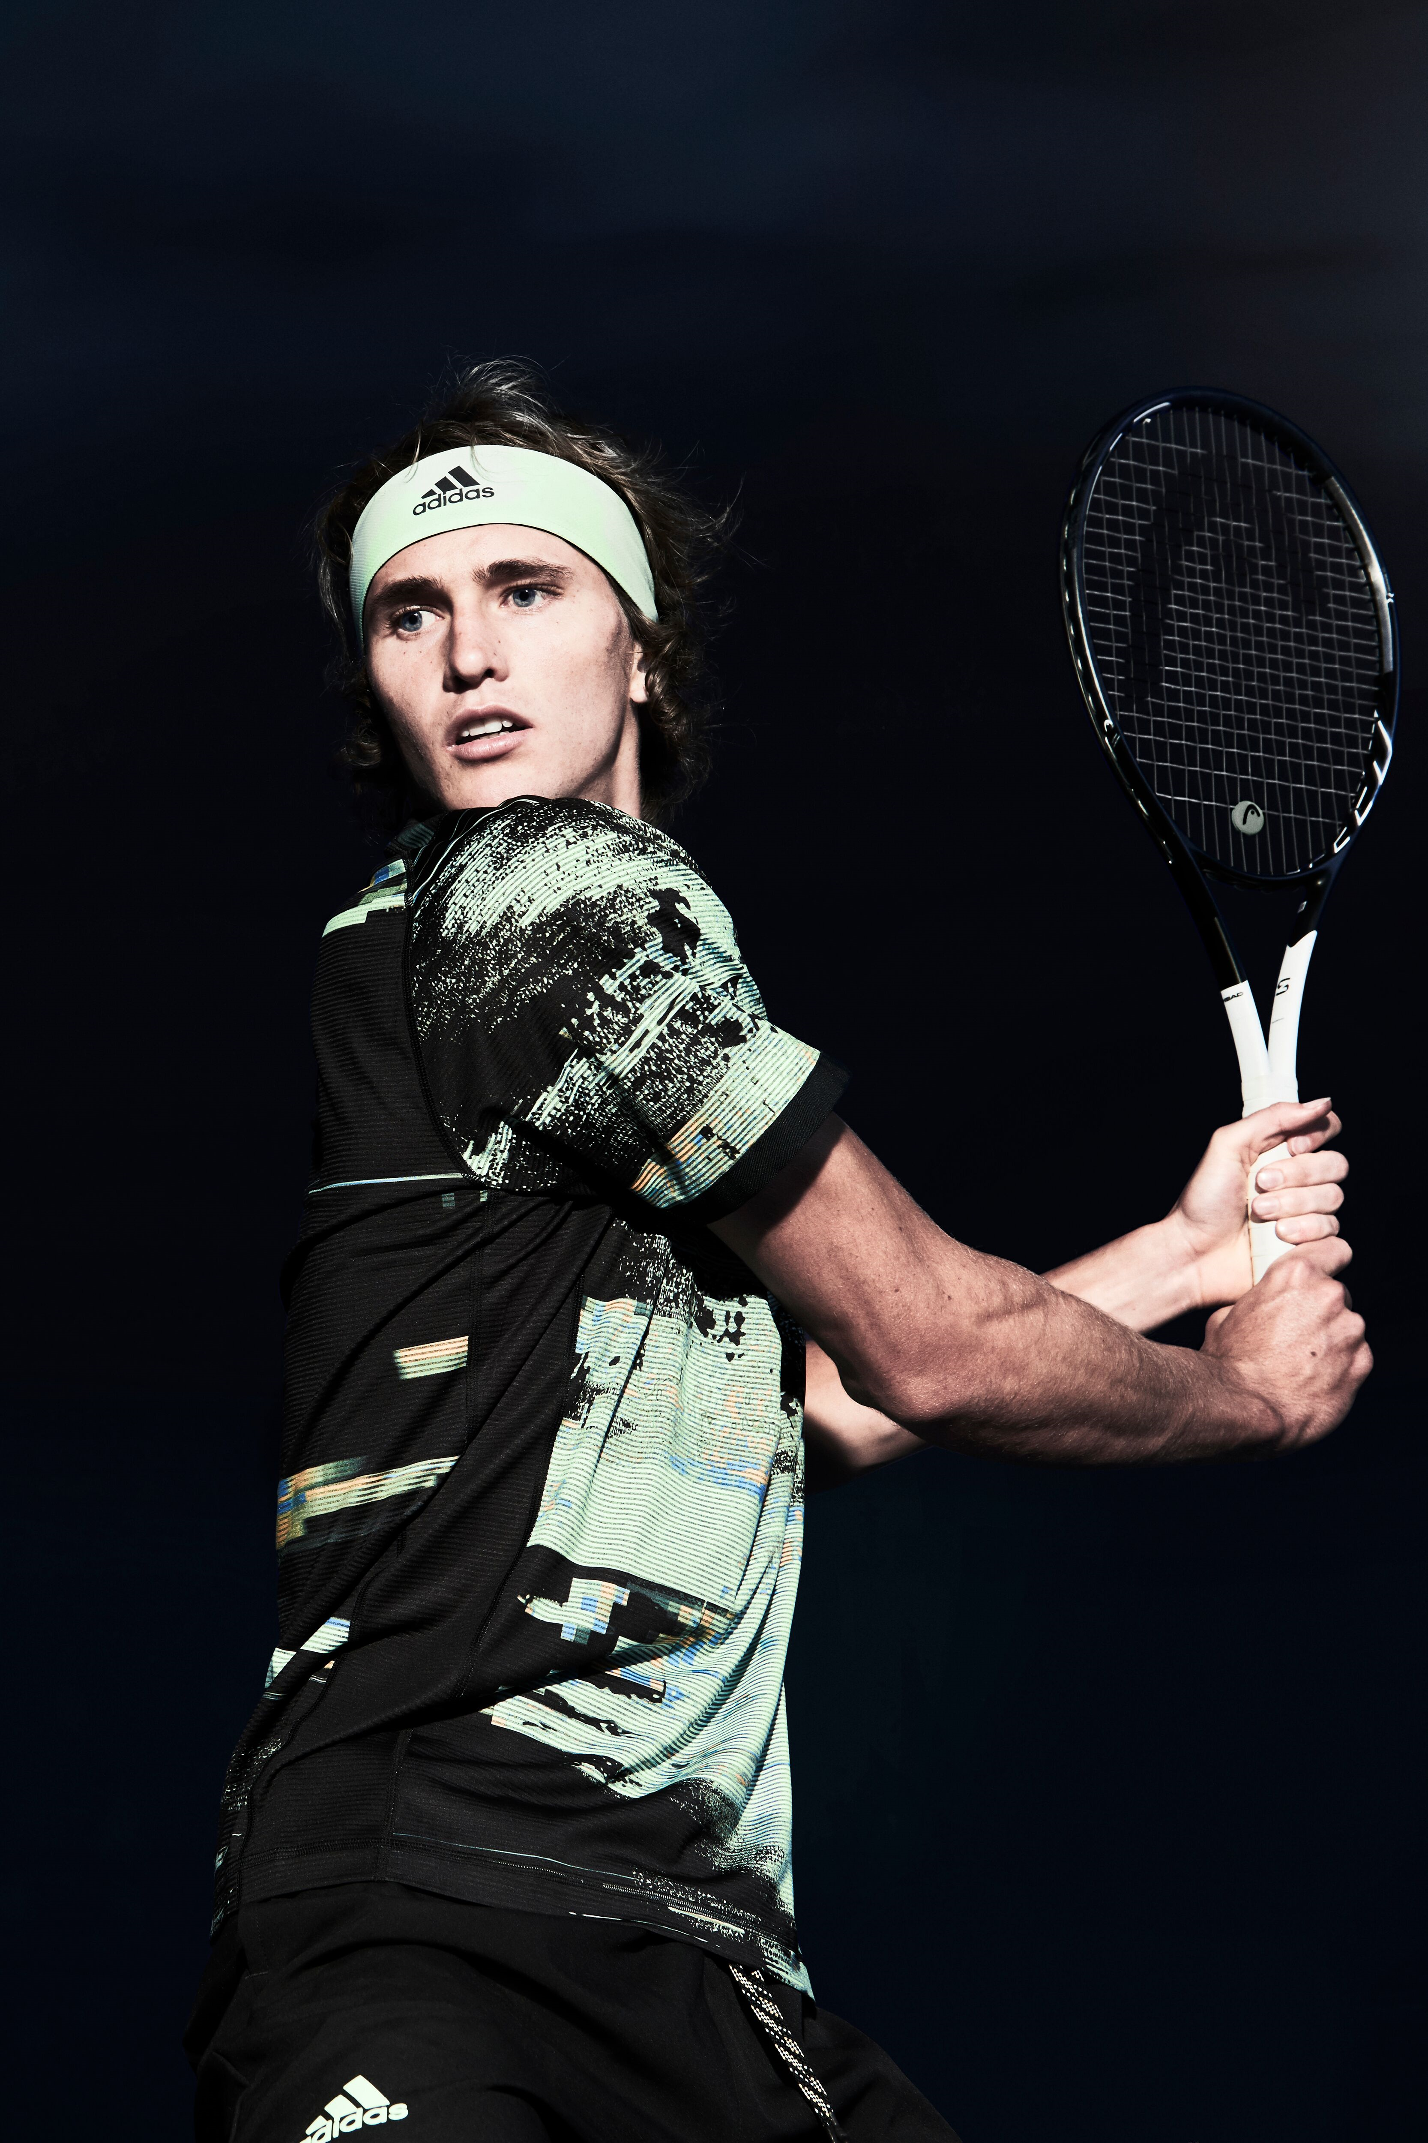
Herzogenaurach, Germany 7th August 2019: adidas unveils its latest collection of high-performance wear to be worn on Grand Slam courts - the NY collection for the final Grand Slam of the season. Designed in collaboration with the Brooklyn Creator Farm, the NY collection is inspired by the streets of New York City and urban tennis culture. The collection will be debuted on court by leading players including Angelique Kerber, Garbine Muguruza, Caroline Wozniacki, Stefanos Tsitsipas and Alexander Zverev.

The US Open collection has been designed to make a statement on the court. Preparing athletes for the famous hard courts of Flushing Meadows, the collection is equipped with adidas’ leading and innovative Clima technologies – including Climalite, which uses ultra-breathable moisture-wicking fabrics to keep athletes cool and dry in even the most intense heat. adidas is also continuing its commitment to sustainability by creating the collection out of recycled polyester.

In the men’s collection, Lucas Pouille, Stefanos Tsitsipas and Alexander Zverev will wear the NY Printed Tee, featuring a stand-out glitch style print inspired by the streets of NYC. Dominic Thiem will wear the NY Polo with a modern 3 button placket and a flat knit collar in the vibrant glow green colourway. Alexander Zverev will wear the NY Solid Short, which has an ergonomic construction for greater freedom of movement. Other male athletes will wear the NY Melange Short which has a premium elasticated waistband and an exposed drawcord for adjustability.

The women’s collection also draws from the urban NYC aesthetic - with the NY Dress, to be worn by Garbine Muguruza and Kiki Mladenovic. The dress features a Climalite engineered fabric with the Streets of NYC inspiration knitted into the pattern. The NY Tank will be worn by Caroline Wozniacki, which features an open hole mesh overlay for a stylish layering look. Both athletes will also wear the NY Skirt which is pleated and features the Streets of NYC inspired print. Angelique Kerber will wear the NY Women’s Tee, featuring open hole mesh zoning at the back to provide optimal ventilation. All of our other female athletes will wear the NY Women’s Short with open hole mesh zoning at the back for additional ventilation and a fresh aesthetic.

The collection will also feature the SoleCourt shoe, offering BOOST cushioning, lightweight materials, comfort, stability and durability. The SoleCourt is adidas’ ultimate technical performance footwear.

The 2019 adidas US Open line will be available online at http://www.adidas.com/tennis from August 7th.

ENDS

For further media information please contact:
Lindsey Rossell
lindsey.rossell@hkstrategies.com
+44 (0) 207 413 3163

