NEW ULTRABOOST 19 COLORWAYS COMING WITH LAUNCH OF ‘FEEL THE BOOST’ CAMPAIGN, A GLOBAL CELEBRATION OF THE ICONIC ADIDAS INNOVATION

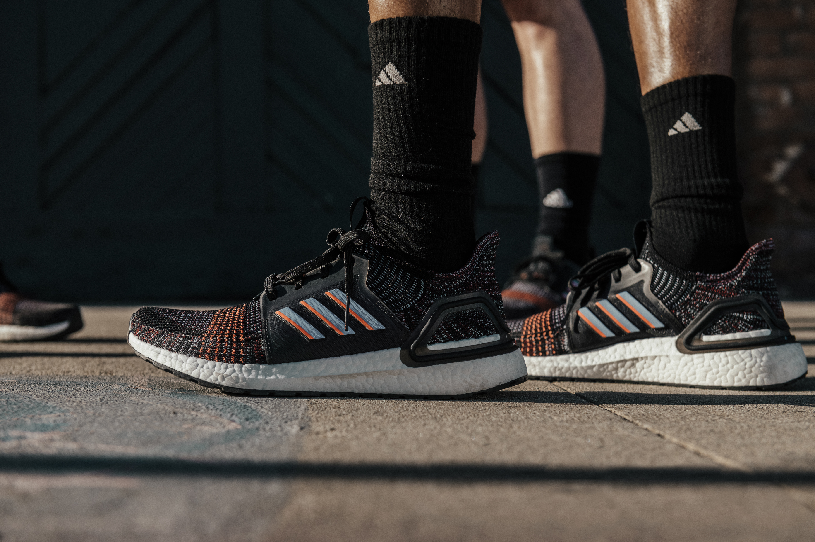

- adidas launches all-new Ultraboost 19 colorways, available worldwide from 18 July
- Silhouette updates launched alongside kick-off of ‘Feel The Boost’, a global campaign celebrating the impact of Boost technology on sport culture
- Since launch in 2013, around the world Creators choose Boost every two seconds
Today, adidas announces new colourways of Ultraboost 19 as cities and Creators around the world celebrate the performance and cultural impact of Boost technology. Consumers are invited to ‘Feel the Boost’ and fall in love all over again with the feeling only Boost on your feet can give you.

This latest Ultraboost 19 update offers the continued benefits of the revolutionised silhouette that was inspired by, and redesigned for, a new era of running and fitness.

Sam Handy, VP Design, adidas Running, said, “Boost is our great running midsole technology, providing the best in comfort and energy return in all conditions. We continue to evolve the material to create different cushioning experiences for different runners. For Ultraboost 19, we added 20% more Boost to a completely streamlined upper construction and Torsion design, giving runners more energy return in every stride. That comes with both a physical and emotional feeling of confidence you can only get with Boost.

adidas designers and product developers worked with thousands of runners worldwide to totally reinvent the running shoe. Together, they simplified the original adidas Ultraboost from 17 pieces to just 4 performance-driven components, creating a lighter reimagined silhouette with more energy return for a new running experience. Product benefits include:

- Optimized midsole with 20% more Boost to inject more energy into each step.
- The brand-new Torsion Spring propels you forward effortlessly. The result of this high-tech configuration is a shoe that blasts back more energy and moves with you.
- The 3D Heel Frame cradles the foot on impact, providing enhanced support and stability for a more confident run.
- The pioneering one-piece Primeknit 360 upper snugly wraps the foot for enhanced support and lightweight comfort.

Since its 2013 launch Boost has proceeded to set new standards for comfort and design, helping athletes across multiple sport categories including running, basketball, tennis, golf, skateboarding and baseball. Boost will continue to be part of the most forward-thinking product innovations from adidas, including the recently unveiled FUTURECRAFT.LOOP – a 100% recyclable performance running shoe.

adidas will be celebrating the technology’s impact on sport culture with its ‘Feel the Boost’ campaign that will continue to rollout throughout the season.

Sign up for more information at adidas.com/feeltheboost. Follow the conversation on Instagram, Facebook and Twitter and using #Boost and @adidasrunning.

