Adidas Soccer and Marvel reveal Marvel NEMEZIZ boot and AlphaBOOST shoe

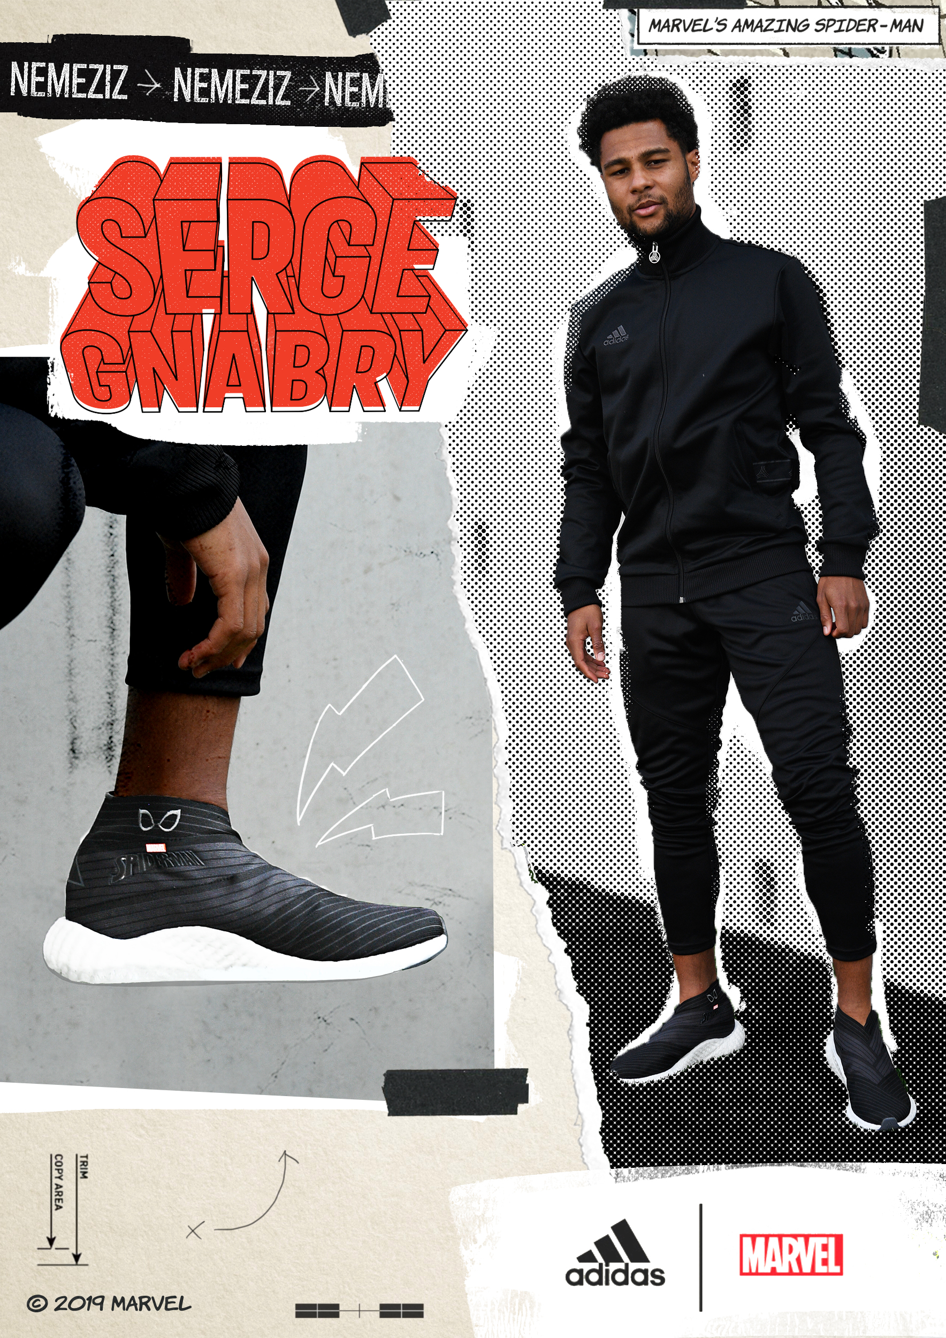

-A boot designed for the most agile players, the new NEMEZIZ design is inspired by Spider-Man, a Super Hero with next level agility

- FC Bayern Munich’s winger Serge Gnabry will wear the new NEMEZIZ boot on field

-The latest NEMEZIZ iteration features iconic Spider-Man red and blue colors and multi-directional web prints

-adidas x Marvel collection has limited availability

Portland, OR July 9 – adidas Soccer today reveal a partnership with Marvel to celebrate Marvel’s Spider-Man. The two-piece collection is led by the Marvel NEMEZIZ, a boot crafted for players with maximum agility and created with design inspiration from the most agile Super Hero, along with an all-black AlphaBOOST trainer.

The coloring and detailing of the collection mirror the iconic suits of Spider-Man. The Marvel NEMEZIZ feature the red and blue colors of his classic suit, and includes the famous web print on the upper, stripes and sockliner. The bold pattern is multi-directional and unpredictable, just like a NEMEZIZ player. Spider-Man’s distinctive, reflective eyes are embroidered on the side of the boot to complete the synergy.

NEMEZIZ is a boot built for the most agile and multidirectional players on the field – created specifically for those who play unpredictably and beat all opposition with spectacular flair, footwork and movement. The stretchy upper is weaved using different widths and tensions of tape for a personalized, locked-down fit that provides stability and direct touch with every twist and turn.

The Marvel AlphaBOOST footwear takes its inspiration from the Super Hero’s brand-new stealth suit, with an all-black colorway. Intricate design details include the web printing on its sockliner as well as reflective eyes embroidered on its side.

The Marvel NEMEZIZ boot will be worn on field by FC Bayern winger Serge Gnabry.

The Marvel NEMEZIZ and AlphaBOOST are complimented by a special-edition box also mirroring his suits, with the familiar red color adorning the outside and the newly added black within.

The adidas Marvel x NEMEZIZ will be available for purchase on July 9 in stores and online.

For further information please visit adidas.com/us/soccer or follow @adidasfootball on Instagram or Twitter to join the conversation.
- END -

