April 15, 2019

adidas Originals Draws Thousands To Sport Club For Weekend One
- Three stripes brand debuts adidas Sport Club, bringing athletes, artists, and entertainers together through a spirit of creative collaboration
- Weekend 1 featured programming included events hosted by athletes and creative partners with an extensive portfolio of adidas ambassadors in attendance
- Talent and guests included Kerwin Frost, Cuco, Kaytranada, Cobra Snake, Mr. Miami, Mo Beatz, A-Trak, Diplo, Beija Velez, Von Miller, Keenan Allen, Derwin James, Josh Rosen, Luke Tadashi, Sophie Simmons, Reggie Bullock, and more

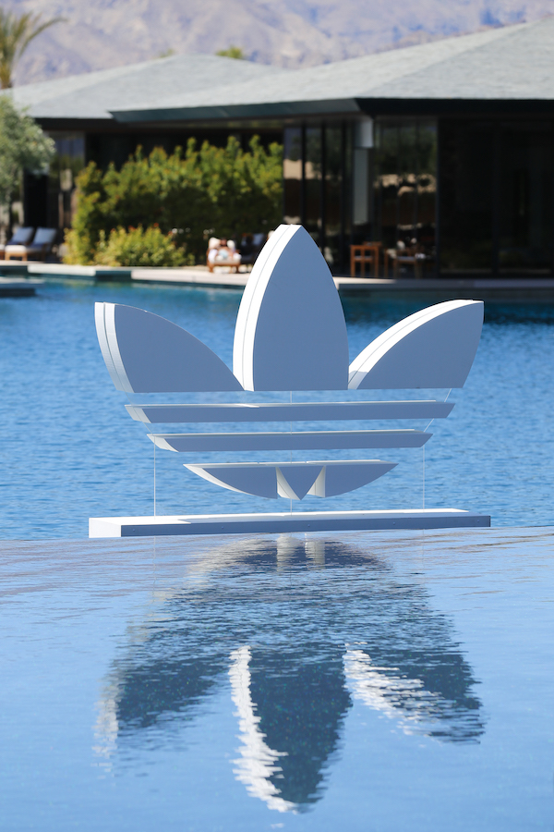

To download imagery, please click HERE

(Indio, CA)—adidas Originals united the best in sports and culture with adidas Sport Club, a modern day revival of Adi Dassler’s original Sport Hotel. The hub was the premier destination over the weekend congregating top athletes and creators in the spirit of collaboration and community elevation. Taking up residence at the opulent Zenyara Estate in the Coachella Valley, adidas Sport Club represented the brand’s Creators Unite mentality, bridging the diverse worlds of sport and culture through groundbreaking experiences and unifying programming.

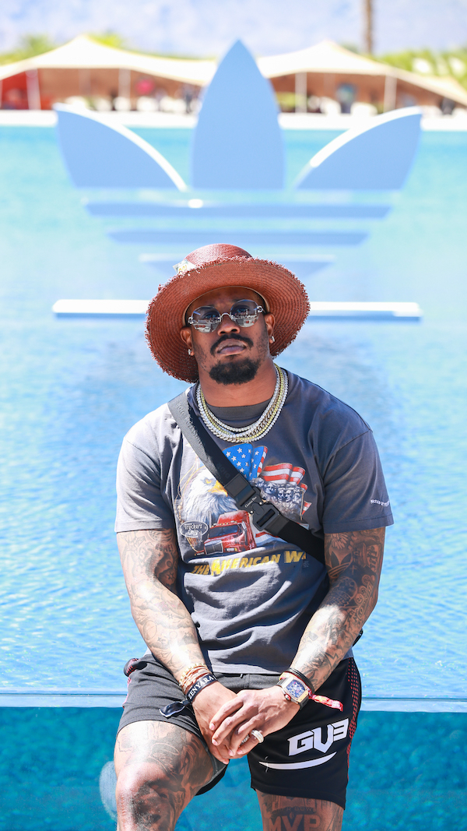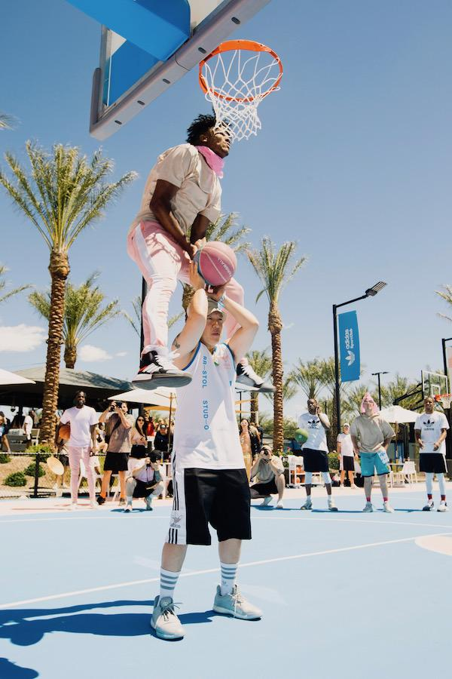

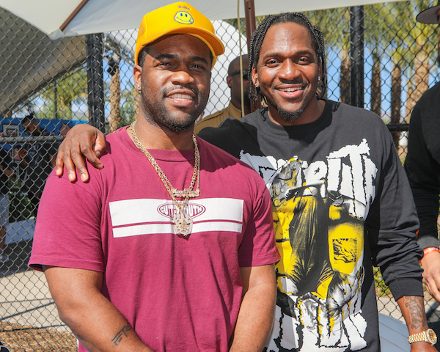

Across two unforgettable days, adidas Originals gathered athletes and talent to a BBQ & Basketball kick-off party hosted by Eddie Huang and Von Miller. Nick “Swaggy P” Young, A$AP Ferg, Candace Parker, Trae Young, and Liz Cambage participated in a wild Three-Point Shoot-Out while rap legend Pusha-T shut down the court with a surprise performance. The following day, guests were treated to an exclusive day festival, You Had To Be There, curated by adidas and Irv Benitez and hosted by DJs, A-Trak and Diplo.

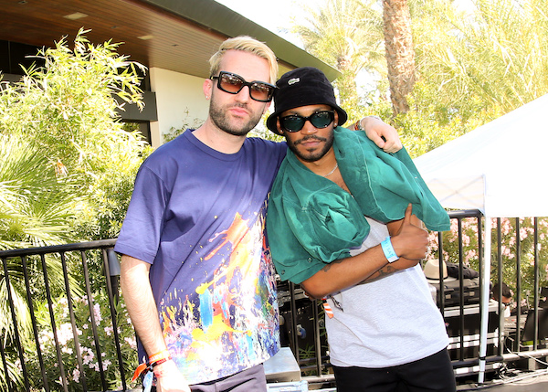
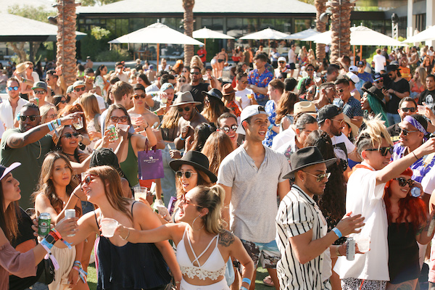

Original artwork by Alexa Meade was featured showcasing a real-time art installation incorporating guests and talent into her canvas. Bristol Studio was also on-site dressing players for the basketball tournament and giving away custom Bristol x adidas Sport Club jerseys to guests.

Maintaining tradition, adidas Originals and The Do Over overtook the Ace Hotel and Swim Club in Palm Springs for another iteration of Desert Sundays. Jams at the pool party were provided by Sosupersam, Noodles, and Just Blaze.

The weekend also saw Donald Glover surprising and delighting festival goers with pairs of his collaborative adidas Originals Nizza shoe through a covert AirDrop announcement where attendees were gifted product on-site.

###
www.adidas.com/originals
@adidasOriginals

For further enquiries, please contact:

Candice Han
candice@pitchblend.com

Paige Bradford
paige@pitchblend.com

