adidas Unveils New Escouade Collection

- Sascha Zverev and Angelique Kerber are among the line-up of adidas players to unveil the collection on court-
- Escouade Collection offers a distinctive streetwear inspired design as well as technical performance features -

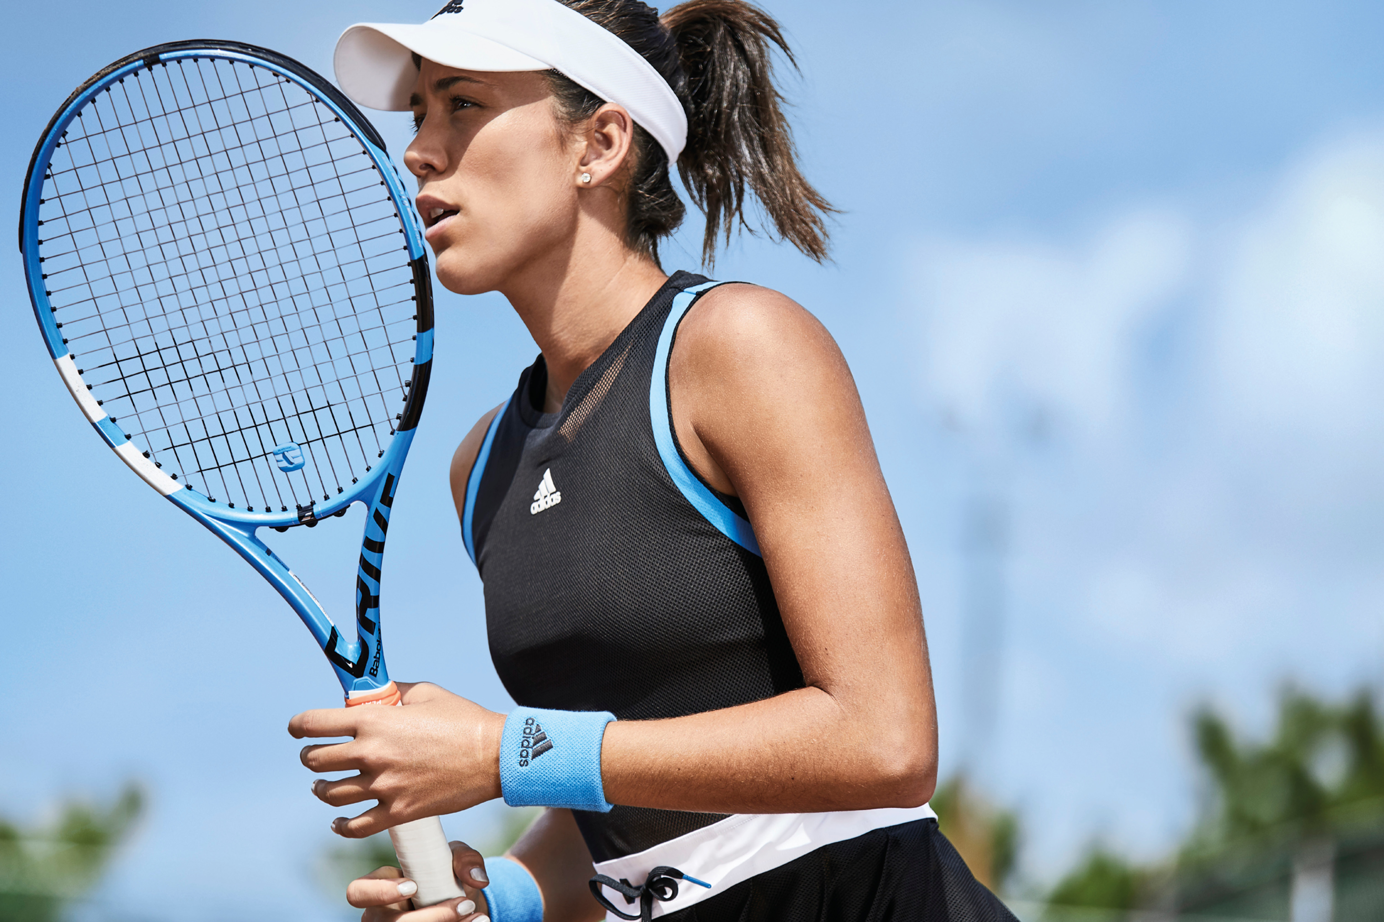

Herzogenaurach, Germany 3rd April 2019: adidas unveils its latest collection of high-performance wear to be worn on Grand Slam courts - the new Escouade Collection for men and women. The range features bold designs and graphics, daring silhouettes and contrast colour blocking; it will be launched with the start of the outdoor season and Roland Garros. The collection will be worn on court by leading players including Sascha Zverev, Stefanos Tsitsipas, Angelique Kerber, Garbine Muguruza and Dominic Thiem.

The Escouade Collection has been designed to make a statement on the European clay courts with bold graphics and two distinct colourways – a light blue, black and white colour story for Roland Garros, and vibrant red, light grey and dark purple for Spring Masters events. Available for men and women, this lightweight apparel range incorporates mesh layering and micro perforated fabrics for additional breathability and adidas’ industry leading performance technologies – including Climalite and Climacool to keep athletes cool and dry while on court. The men’s collection offers a versatile and casual look with street style font graphics incorporated into each piece, while the women’s includes daring silhouettes for a standout look.

The collection will also feature the SoleCourt BOOST shoe, now available for clay – offering maximum stability due to a new chassis construction using TPU material.

The 2019 adidas Escouade Collection will be available online from 3rd April at http://www.adidas.com/tennis.

ENDS

