ADIDAS TENNIS JOINS THE FIGHT AGAINST MARINE PLASTIC POLLUTION WITH THE RELEASE OF THE FIRST-EVER ADIDAS TENNIS PARLEY COLLECTION AT THE AUSTRALIAN OPEN

- adidas and Parley for the Oceans collaborate to help end marine plastic pollution and create the future of sport -
- The adidas Australian Open collection made with Parley Ocean Plastic™ will be debuted on court by the world’s leading tennis players including Sascha Zverev and returning AO champion Caroline Wozniacki -
- Available online at adidas.com now -
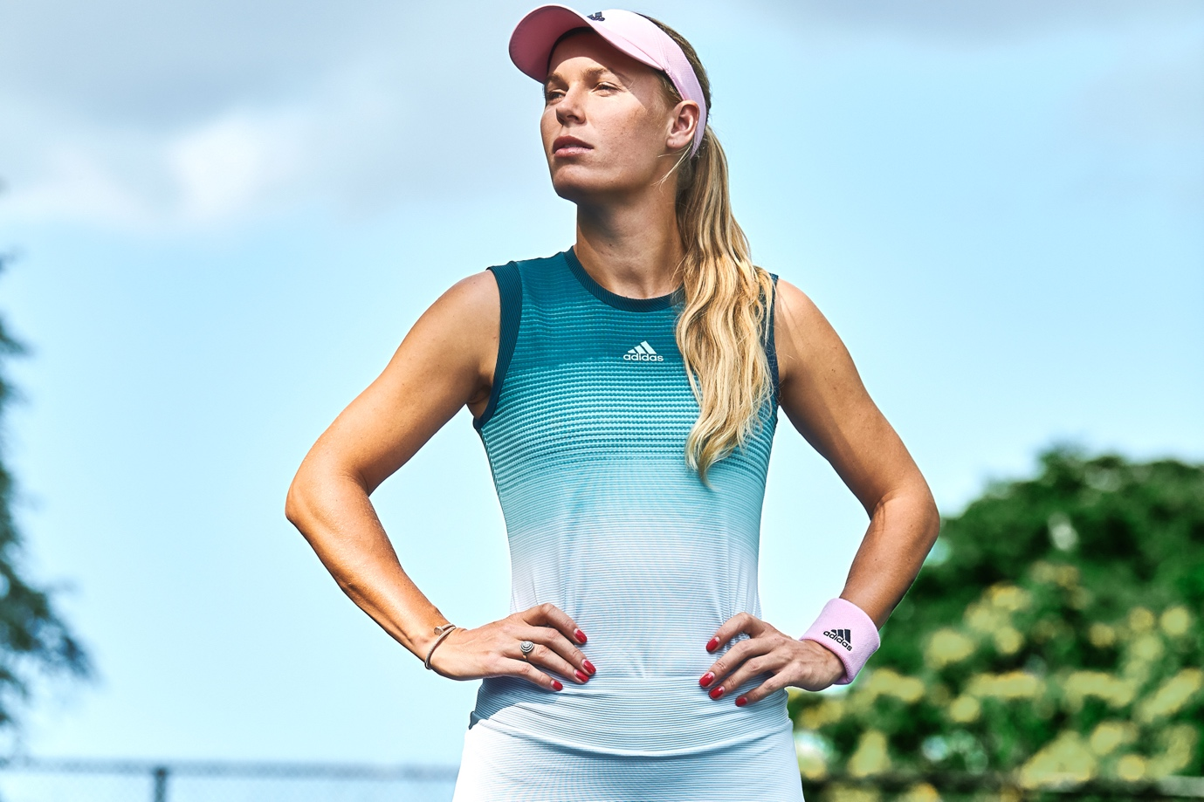

Herzogenaurach, Germany, January 10th Today, adidas Tennis joined the fight against marine plastic pollution by releasing the first ever Parley tennis collection made from Parley Ocean Plastic™. The collection for the Australian Open will be debuted on court by leading players including ATP Finals winner Sascha Zverev and reigning Australian Open champion Caroline Wozniacki. With the tournament and city, Melbourne, known for its iconic coast meets city landscape, the collection aims to create change and inspire the industry, athletes, spectators and fans to better protect the Oceans.
True to the ethos of the adidas x Parley partnership, the adidas Australian Open collection has been designed to create change. Apparel and footwear are made with Parley Ocean Plastic™ — Parley’s material created from up-cycled plastic waste intercepted on beaches and in coastal communities— helping to combat marine plastic pollution, raise awareness and champion eco-innovative solutions to one of today’s most pressing environmental issues.
The Australian Open Parley collection has been designed to make a statement on the court. In the women’s collection, athletes including the defending champion Caroline Wozniacki and Angelique Kerber and Jelena Ostapenko will wear the Parley Tank; a slim fit tank with a design inspired by the different sea levels in the ocean which features a breathable 3D structured Climalite fabric that keeps you cool even in the Australian heat and Garbine Muguruza will wear the Parley dress. The collection also includes the Parley tee; which also features a breathable 3D structured Climalite fabric.
In the men’s collection, Sascha Zverev will wear the Parley printed tee, Lucas Pouille will wear the Parley striped tee and the Parley Polo will be worn by Dominic Thiem and Jo-Wilfried Tsonga. All three tops include an underarm gusset for freedom of movement, a ForTheOceans elastic back neck tape and a 3D structure on the inside of the fabric for reduced cling. All athletes will wear Parley shorts which have stretch woven material with a mesh elasticated waistband for additional ventilation.
The Australian Open also sees the on-court introduction of adidas tennis’ latest footwear franchise – the SoleCourt BOOST, which has been made from Parley Ocean Plastic™ for this collection. The SoleCourt BOOST is a combination of premium materials, state-of-the-art innovation and proven craftsmanship creating a comfortable, lightweight, stable and durable tennis shoe on the court for the all-around player.
Ivan Meija-Devora, apparel designer at adidas Tennis explains: “This is a really exciting collection for us and it made total sense to introduce our first ever adidas tennis and Parley for the Oceans collection at the Australian Open – given the coastal landscape of Melbourne. We always look to the city of the Grand Slam for inspiration when designing our tournament collections, choosing colours and styles that align to the style of the area – but with this collection we’ve been able to take it one step further, using Parley Ocean Plastic™ to create eco-innovative apparel and footwear to inspire positive change and help raise awareness to better protect the oceans.”
Sascha Zverev comments: “Melbourne is one of my favourite cities, I love playing here and being close to the ocean. That’s why I’m excited by this collaboration between adidas and Parley for The Oceans – this collection looks great and has all of the technical features to support my performance on court, but is also part of a movement to create change and protect the oceans.”
The 2019 adidas Australian Open x Parley collection is available online from Wednesday 2nd January 2019 at http://www.adidas.com/tennis.

ENDS

For further media information please contact:
Lindsey Rossell
lindsey.rossell@hkstrategies.com
+44 (0) 207 413 3163

Notes to editors:

About adidas Tennis
adidas Tennis is represented by top players such as Angelique Kerber, Jelena Ostapenko, Kristina Mladenovic, Garbiñe Muguruza, Caroline Wozniacki, Lucas Pouille, Dominic Thiem, Stefanos Tsitsipas, Jo-Wilfried Tsonga and Sascha Zverev. For more information on adidas Tennis, please visit www.adidas.com/tennis. For additional images please visit our media news room on news.adidas.com and follow us on Twitter or on Instagram under @adidasTennis.

About adidas
The adidas Group is a global leader in the sporting goods industry, offering a broad portfolio of footwear, apparel and hardware for sport and lifestyle around the core brands adidas and Reebok. Headquartered in Herzogenaurach, Germany, the Group employs more than 56,888 people across the globe and generated sales of around € 21.2 billion in 2017.

About Parley for the Oceans
Parley for the Oceans is the global network where creators, thinkers and leaders from the creative industries, brands, governments and environmental groups come together to raise awareness for the beauty and fragility of the oceans and collaborate on projects that can end their destruction. The organization has formed alliances with major corporations including adidas, Anheuser Busch InBev (Corona), American Express; the United Nations; the Maldives and collaborators spanning the worlds of science, art, fashion, design, entertainment, sports, and space and ocean exploration. To know more: www.parley.tv

