ADIDAS WORKS WITH THOUSANDS OF RUNNERS TO CREATE THE REVOLUTIONARY
ADIDAS ULTRABOOST 19 – A NEW SHOE FOR A NEW SPORT

- Co-created with runners, the adidas Ultraboost 19 has been completely rebuilt from 17 parts to focus on four cutting-edge components
- Featuring Optimized BOOST, Torsion Spring, Primeknit 360 and 3D Heel Frame for more support, adaptability and responsiveness than ever before
- adidas celebrates the way the sport of running is changing in a new campaign called ‘Recode Running’
- The adidas Ultraboost 19 Laser Red will be available worldwide from December 15, 2018

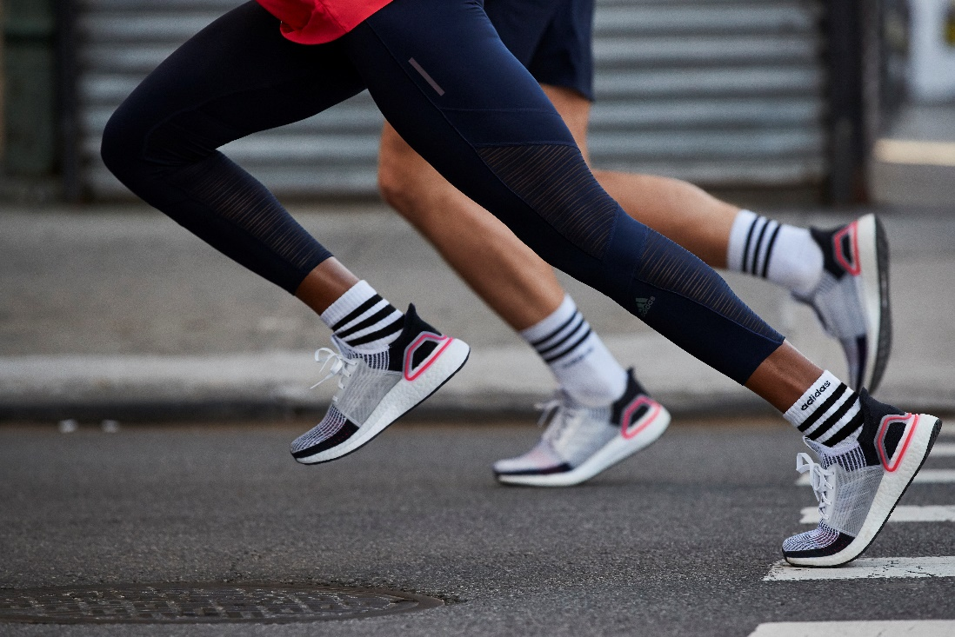

Herzogenaurach, December 11: adidas Running today unveils the adidas Ultraboost 19, an entirely reimagined and redesigned version of the brand’s iconic leading performance running shoe.

adidas designers and product developers worked with thousands of runners from around the world to create the new silhouette, in what was its most ambitious collaboration project ever.

The overwhelming feedback from runners was that running is changing, becoming younger and more democratic. With the emergence of city running clubs and fun runs, running is now a sociable sport rather than just something people do on their own.

Runners made it clear they wanted a simpler product with fewer pieces but equally high performance. To reflect that, the original adidas Ultraboost was deconstructed and reconstructed from 17 pieces to focus on four key components – Optimized BOOST, Torsion Spring, Primeknit 360 and 3D Heel Frame.

- Optimized BOOST – with 20% more BOOST in the midsole compared to the first-generation adidas Ultraboost, this updated technology brings even more energy return
- Torsion Spring – a lightweight construction for enhanced support on landing and a snappy transition to propel runners forward
- Primeknit 360 – feels like a second skin, combining pure comfort with lightweight performance
- Updated 3D Heel Frame – a stripped-back design cradles the heel, bringing the perfect mix of adaptability and support

Sam Handy, Vice President Design, adidas Running, said: “In creating the adidas Ultraboost 19, we tore up the rule book. We challenged the status quo of what a running shoe should be and how it should be created. We enlisted runners from all over our network to be a part of this process, with one goal in mind – to create the most responsive, performance-driven version of the adidas Ultraboost possible. On this journey, we literally tore apart the old model and discovered new testing, manufacturing and coloring methods to really challenge ourselves to reach our ambition.”

To celebrate the new silhouette, adidas Running is launching a new marketing campaign called Recode Running. Kicking off with a trailer featuring prominent LA and NY adidas Runners, including Adam Francique, Kwasi Kessie, Shiara Robison, Tia Hrubala and Bayano Kamani, this blockbuster campaign champions the culture and creativity of ‘new running’ and its power to transform.

The adidas Ultraboost 19 will initially launch in a limited-release Laser Red colorway, with further limited-edition drops to follow in the lead-up to the global inline launch on February 21, 2019.

To find out more, please visit: www.adidas.com/running_ultraboost. Follow the conversation on Instagram, Facebook and Twitter and using #ULTRABOOST and @adidasrunning.
END

