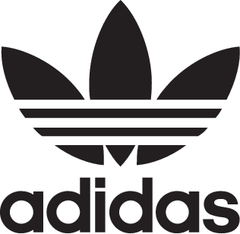

adidas + KANYE WEST announce the YEEZY POWERPHASE Grey

DECEMBER 2017 – adidas + KANYE WEST announce the YEEZY POWERPHASE Grey. It will be available on December 9, 2017 with a retail price of 120$/€.

The YEEZY POWERPHASE Grey features a soft grey leather upper, a die-cut EVA midsole, and a high abrasion rubber outsole. The quarter panel carries the CALABASAS logo marque.

The release will be available on adidas.com/YEEZY, at select adidas retail and partner locations, and on YEEZY.SUPPLY​​. A full list of adidas retail and partner locations can be found at adidas.com/YEEZY. Reservations for the YEEZY POWERPHASE Grey will be offered at select adidas retail locations prior to release day through the adidas Confirmed App.

www.adidas.com/YEEZY

YEEZY.SUPPLY

#adidasOriginals

@adidasOriginals

