EMBARGOED UNTIL 15 MAY, 10AM CET

adidas Football Reveals New Juventus Home Kit for 2018/19 Season

- Jersey includes design detail inspired by iconic Juventus kits of the past -
- Kit features a unique striping composition and new collar construction -

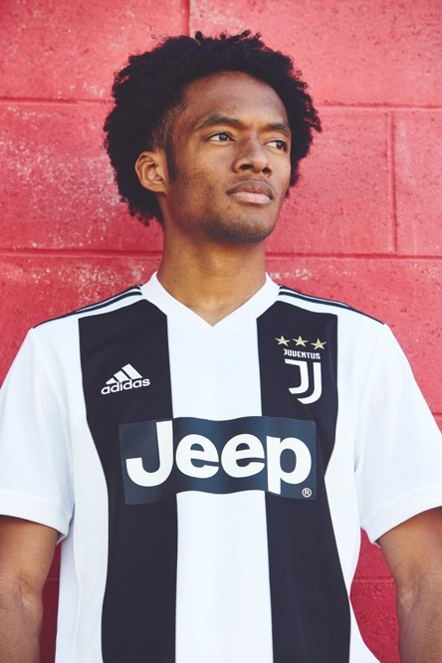

Herzogenaurach, 15 May – On the back of winning their seventh consecutive Italian league title, Juventus have today revealed their new adidas Football home kit for the 2018/19 season. The club continues to reinvent itself while honouring the past, with the latest jersey featuring a unique new striping composition while keeping the traditional black and white colours.

The new striping consists of two vertical stripes on the front with just one on the back; a bold and simple new design, offering a more contemporary look for a football style icon. The jersey also features the club’s modern new logo and the new adidas authentic collar construction.

The new kit continues the club’s redesigned identity: ‘Black and White and More’. This new philosophy is running through everything the club does, highlighting its innovative and uncompromising drive forward.

Francesca Venturini, Designer at adidas Football commented: “Juventus isn’t just one of the most ambitious clubs in the world from a football perspective, but also in terms of having a bold and forward-thinking approach to design. The redesigned identity of ‘Black and White and More’ guides all of our work with Juventus and allows us to innovate with modern interpretations of a historic club. This new home jersey is a great example of that.”

The kit will be seen on pitch for the first time in their final game of the 2018 season. It’s available to purchase in the Juventus online store, in adidas global retail stores, the adidas online shop www.adidas.com/football​.

For further information please visit adidas.com/football or follow @adidasfootball on instagram or twitter to join the conversation.

- END -

For further media information please visit http://news.adidas.com/GLOBAL/PERFORMANCE/FOOTBALL or contact:

Stuart Gower
Global PR Manager, adidas Football
Email: Stuart.Gower@adidas.com
Tel: +4917/036/225/82

Notes to editors:
About adidas Football
adidas is the global leader in football. It is the official sponsor / official supplier partner of the most important football tournaments in the world, such as the FIFA World Cup™, the FIFA Confederations Cup, the UEFA Champions League, the UEFA Europa League and the UEFA European Championships. adidas also sponsors some of the world’s top clubs including Manchester United, Real Madrid, FC Bayern Munich, Juventus and AC Milan. Some of the world’s best players also on the adidas roster are Leo Messi, Paul Pogba, Gareth Bale, Karim Benzema, Roberto Firmino, Thomas Müller, Luis Suárez, James Rodríguez, Diego Costa, Mesut Özil, Renato Sanches and Julian Draxler.

