**FOR IMMEDIATE RELEASE**

November 5th, 2018

**adidas Originals Broke Down Barriers For All at ComplexCon**

* ***The Three Stripes Brand Delivers First Fully Democratic Augmented Reality Product Drop***
* ***Pusha T, Pharrell Williams and Snoop Dogg Amongst Lineup of Esteemed Creators at Two Day Streetwear Convention***
* ***King Push Meets with Sound Lab Grant Finalists and Declares Final Five in Running for adidas Sound Labs Grant***
* ***Brand Launches @adidasLA and Celebrates 25th Anniversary of Doggystyle with Snoop Dogg and VIP Records***
* ***Global Creative Community Debuts Exclusive P.O.D. System Sneakers***

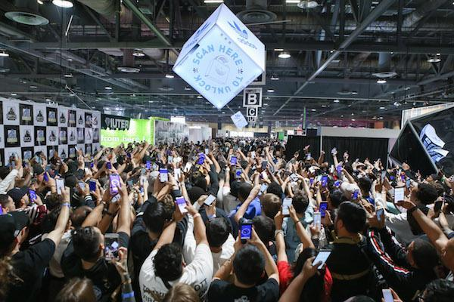

**(Long Beach, CA)**—In an ambitious response to serve everyone at ComplexCon, **adidas Originals** returns with a lineup of curated experiences driven by crucial attendee desires and insights. Aimed at breaking down barriers between fans and creativity, cultural icons, and exclusive product, the focal point of the brand’s presence this year was the launch of its groundbreaking augmented reality shopping platform that was described as “c*omplete and utter domination of impact and influence*” by Complex CEO Rich Antoinelle.

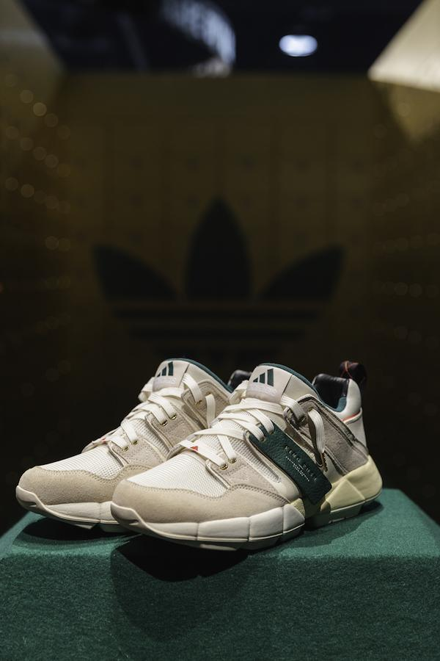 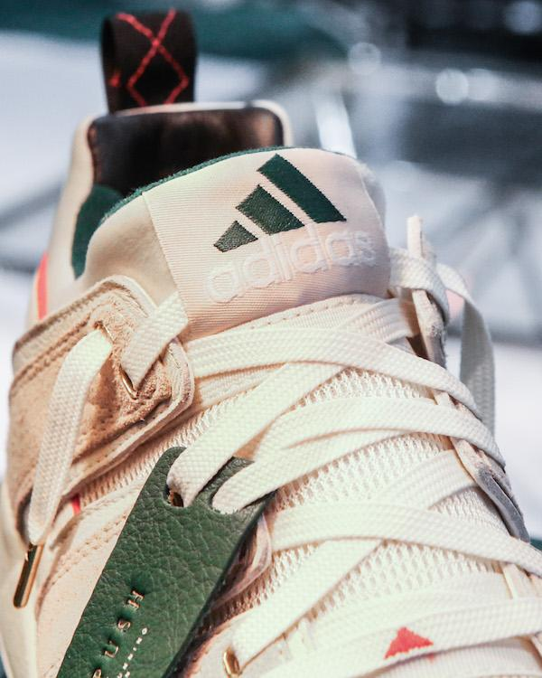

As part of the main event, the brand joined forces with creative partner Pusha T to present a journey through three connected environments, reimagining a retro bank vault and penthouse office, to unveil a limited edition EQT Cushion 2 collaboration. Answering the popular demand for more cultural experiences, the mogul sat with 12 aspiring artists from Los Angeles for an opportunity at the adidas Originals **Sound Labs Grant** for musical development. Only five musicians made the cut after two days of listening sessions and now local LA semi-finalists Sareal, Lorine Chia, Ice Cold Bishop, Indiigo and Rugby Wild will continue the application process for the grant that will result in a winner in the first days of 2019.

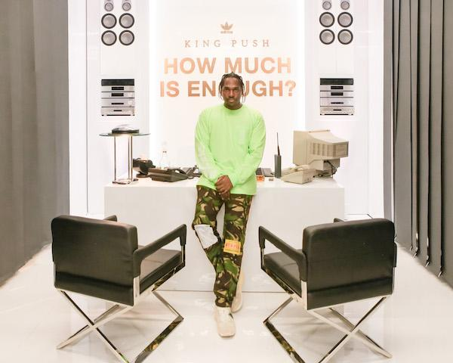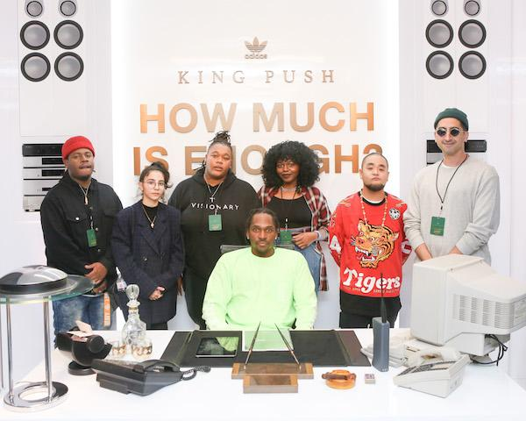 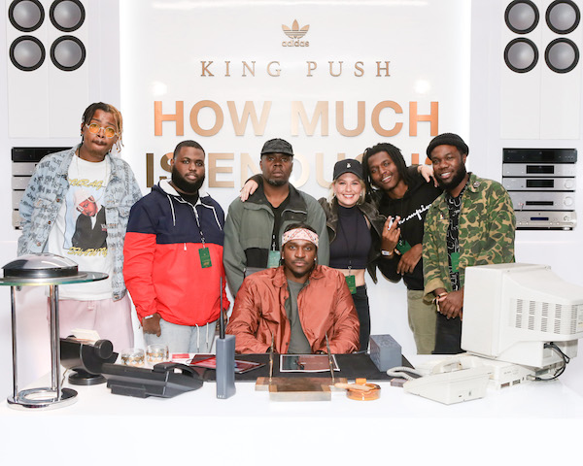

King Push was joined by adidas Originals partner **Pharrell Williams**, who released pairs of the elusive adidas Originals N.E.R.D HU NMD and 50 pairs of never-seen-before PW HU P.O.D.

System exclusive for the conference. Winners of the *Friends and Family*  HU P.O.D. System pairs got to meet Pharrell as a special treat from the icon and adidas Originals.

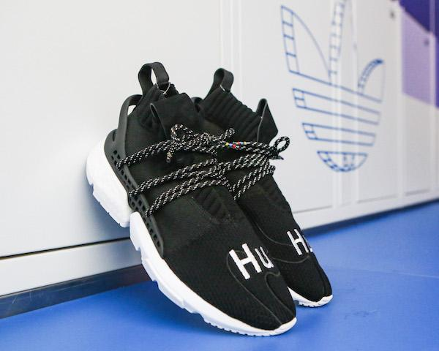 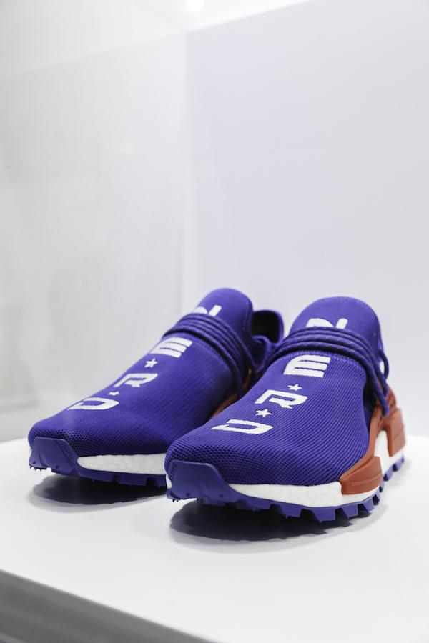

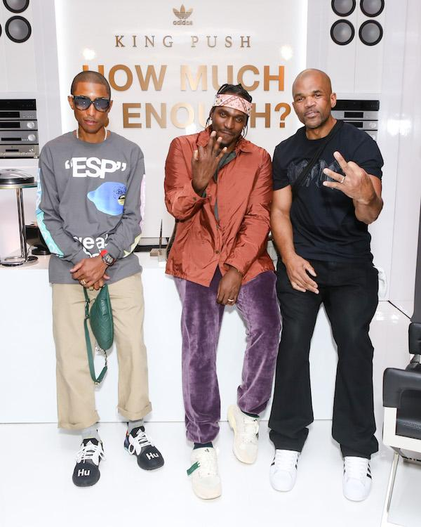

Over the weekend adidas Originals also took time to celebrate the launch of its new Los Angeles-focused social identity @adidasLA alongside rap legend and creative ambassador Snoop Dogg. Coinciding with the 25th anniversary of *Doggystyle,* the brand partnered with Snoop and LA’s World Famous VIP Records for a special pop-up experience. Snoop himself made a special appearance and signed 25 pairs of adidas Originals P.O.D. System sneakers that had been customized by artist LA artist Gregory Siffs.

Amongst the list of creators both iconic and emerging, adidas Originals also teamed up with New York creative Kerwin Frost who brought his infamous wit to report live on the grounds on behalf of the brand.

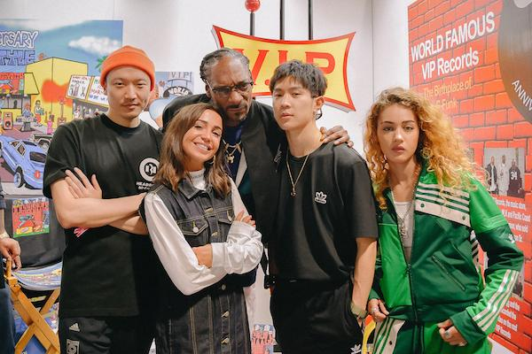

At the conference, the brand debuted an exclusive run of the P.O.D. System designed by members of a global creative community; Beija Velez, Victor Ma, DJ Soulscape and Carlotta Constant. Earlier this year, the group designed their own P.O.D. System during MakerLab workshops and since then have been involved in creative sessions with the Originals design team to put the styles into production. During ComplexCon the community shared their design experience with Kerwin and global brand ambassadors Pharrell, Pusha T and Snoop Dogg. The shoes will be available in 2019.

In a display of the three-stripe brand’s DNA celebrating culture, creativity and community, adidas Originals delivered the ultimate experience at this year’s ComplexCon, bringing together an esteemed group of creators and debuting the future of democratic commerce. [www.adidas.com/originals](http://www.adidas.com/originals)

@adidasLA

@adidasOriginals

**For further enquiries, please contact:**

Candice Han

[candice@pitchblend.com](mailto:candice@pitchblend.com)

Paige Bradford

[paige@pitchblend.com](mailto:paige@pitchblend.com)