FOR IMMEDIATE RELEASE
November 5th, 2018

adidas Originals By Pharrell Williams Reveal
SOLARHU Capsule Collection

- Pharrell reimagines traditional weaving patterns through a new sneaker and apparel collection
- New footwear and apparel inspired by East Africa’s legacy of long distance running
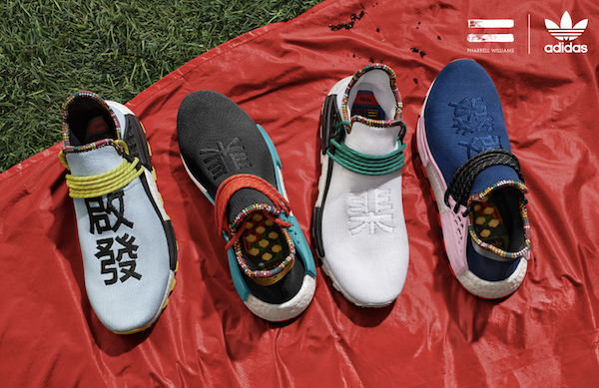

(Herzogenaurach, Germany)- adidas Originals and Pharrell Williams build upon their collaborative Hu series with a continuation of the SOLARHU story. Taking inspiration from the fearless colors, bold patterns, and stylistic flair of East Africa, Pharrell Williams continues his experimentation with prints and textures. Reiterating the shared belief that, through sport, we all have the power to transform lives, the collection draws on the tradition of long distance running that has a rich heritage in the region.

Revisiting his now iconic Hu NMD, Pharrell plays with the established aesthetic markers of the SOLARHU collaboration. Expressed in four bold colourways, Power Blue, Clear Blue, Black, and White, each sneaker in the collection features a printed collar, designed to evoke traditional East African weaving techniques in a medley of colours. Continuing the motif of motivation through language, each pair is emblazoned with the words ‘Empower’ and ‘Inspire’ embroidered in Chinese lettering across a primeknit upper.

Featuring prominent patterned detailing, the apparel offering stays true to SOLARHU’s East African inspiration. All pieces are presented in powerful textures and clashing colorways, whilst tops and jackets feature bold chest and back graphics, an homage to the numbering mechanisms found on long distance runners’ jerseys.

The adidas Originals by Pharrell Williams SOLARHU NMD capsule collection is available November 10th at adidas Originals flagship stores, select retailers and online.

###

For further enquiries, please contact:

Candice Han
candice@pitchblend.com

Paige Bradford
paige@pitchblend.com

