FOR IMMEDIATE RELEASE
October 8th, 2018
adidas Originals Releases Second Dragon Ball Z Installment
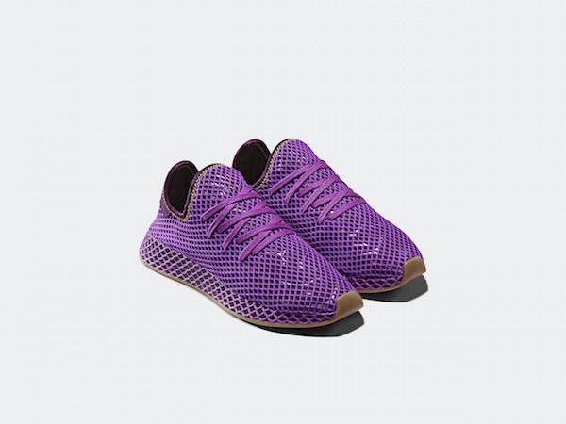 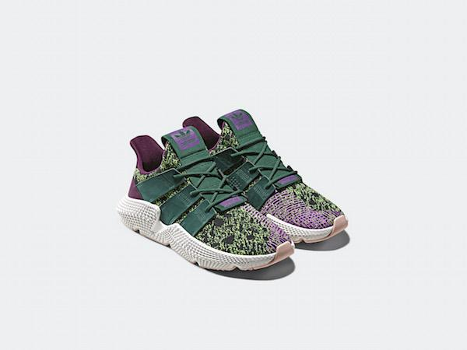

DOWNLOAD PRODUCT IMAGERY HERE
OCTOBER 2018—adidas Originals presents the second installment of its collaboration with iconic Japanese anime series Dragon Ball Z this week, this time using the Deerupt and Prophere silhouettes to celebrate another iconic showdown from the franchise’s history – Gohan vs. Cell.

Known as the true finale to the Cell saga in the Dragon Ball Z canon, Gohan and Cell’s battle spanned over 11 episodes in the television series and culminated in Gohan’s long-hinted hidden power when he became the first to achieve Super Saiyan 2 form. Each of the two shoes in the release channels the distinctive identity of these two characters in a tribute to this renowned saga.

First up, the Deerupt silhouette is presented in a tonal purple colorway in reference to Gohan’s distinctive battle suit, while reflective flash graphics on the base material beneath the Deerupt’s webbing mesh overlay pay homage to the fighter’s transformation into Super Saiyan 2 form.

Finishing touches include a heel patch logo which pays homage to Gohan’s mentor, Picollo, while Kanji detailing on the heel webbing denotes Gohan’s own name. A Dragon Ball can be found hidden beneath the heel patch, while collaborative adidas x Dragon Ball Z logos can be found on the sockliner.

Next up, the Deerupt model pays tribute to Gohan’s nemesis, Cell, assuming the distinctive green colorway of his exoskeleton, contrasted with his purple wings. A hidden Dragon Ball can be found on the tongue, whilst Cell’s name can be found printed on the tongue’s reverse. Collaborative adidas x Dragon Ball Z sockliners complete the picture, creating the perfect tribute to one of the Dragon Ball franchise’s most infamous villains.

Releasing worldwide on October 27th, both shoes in the release are presented in special collaborative packaging with an individual Dragon Ball printed on the box, combining with the other boxes in the 7-shoe release to create a single cumulative back cover.

# # #

About adidas Originals
Inspired by the rich sporting heritage of adidas – one of the world’s leading sports brands and a global designer and developer of athletic footwear and apparel ­­– adidas Originals is a lifestyle brand founded in 2001. With the adidas archive at its foundation, adidas Originals continues to evolve the brand’s legacy through its commitment to product innovation and its ability to filter the creativity and courage found on courts and sporting arenas through the lens of contemporary youth culture. Marked by the iconic Trefoil logo that was first used in 1972 and championed by those that continue to shape and define creative culture, adidas Originals continues to lead the way as the pioneering sportswear brand for the street.

For general enquiries, please contact:
Candice Han
candice@pitchblend.com

Paige Bradford
paige@pitchblend.com

