adidas Originals Reveals Superstar Boot W

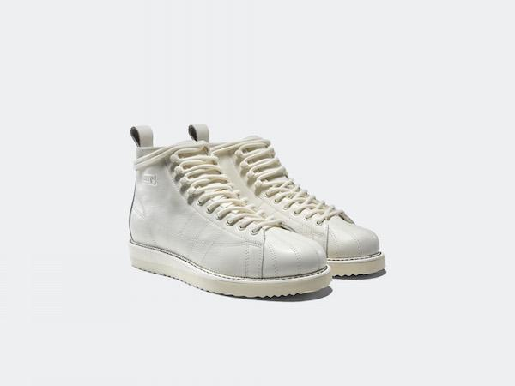

(Portland, OR)—This season, adidas Originals transforms one of its most iconic footwear silhouettes into a striking new form, exclusively for women, creating the Superstar Boot model.

Inspired by classic footwear design, the Superstar Combat Boot interprets the blueprint of the original Superstar model into a rugged, high-top design. Constructed from a premium pebbled leather, the shoe’s minimalist design is accented by embossed branding details and 3-stripes mark stitching, while the shoe’s iconic shell-toe is reproduced in stitched leather.
Finishing touches include a combination of eyelet and lug lacing system and a leather heel-pull, while the shoe is placed atop a durable rubber sole unit. Offered in tonal white colorway, also coming in black and seasonal colors, the Superstar Boot is a perfect take on a classic adidas model for the winter time or simply a styling piece for the months ahead.

###

For general enquiries, please contact:
Candice Han
candice@pitchblend.com

Paige Bradford
paige@pitchblend.com

