adidas Originals revamps Yung 96 Silhouette For Fall

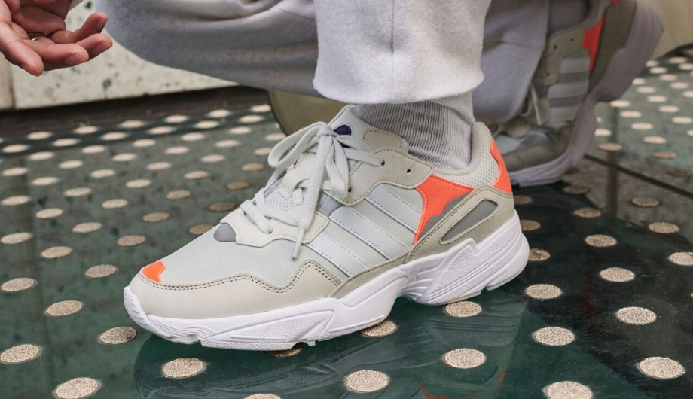

SEPTEMBER 2018—adidas Originals presents its new Yung 96 silhouette in a trio of new colorways this week, rendering its referential design in three colorways that bring the shoe’s proud ‘90s influences to the fore.

For its latest outing, the Yung 96 shoe assumes a classic durable mesh upper, reinforced with nubuck overlays and a mud guard, while reflective underlays add some subtle pop to the shoe’s design. This is then countered with the shoe’s aggressive midsole tooling, rounding off the Yung 96’s referential design language. Finishing touches include branding details on the tongue and heel, as well as an authentic Torsion™ bar in the midsole as a tribute to classic ‘90s adidas footwear design.

Stepping out in Black/Yellow, White/Orange and Grey/Green colorways, the latest release for the Yung 96 model puts the shoe’s distinctive archival aesthetic into its most natural form yet.

The new Yung 96 colorways will be available September 20th via select adidas retailers and www.adidas.com.

Download product imagery here.
# # #

About adidas Originals
Inspired by the rich sporting heritage of adidas – one of the world’s leading sports brands and a global designer and developer of athletic footwear and apparel ­­– adidas Originals is a lifestyle brand founded in 2001. With the adidas archive at its foundation, adidas Originals continues to evolve the brand’s legacy through its commitment to product innovation and its ability to filter the creativity and courage found on courts and sporting arenas through the lens of contemporary youth culture. Marked by the iconic Trefoil logo that was first used in 1972 and championed by those that continue to shape and define creative culture, adidas Originals continues to lead the way as the pioneering sportswear brand for the street.

# # #

For general enquiries, please contact:
Candice Han
candice@pitchblend.com

Paige Bradford
paige@pitchblend.com

