Embargo: 15th August 2018, 10am (CET)
adidas Unveils 2018 US Open Barricade Code Collection

- Inspired by the iconic adidas Barricade franchise –
- Set to be worn on court by athletes including Dominic Thiem and Garbine Muguruza -
- Offering ultimate craftmanship with innovative and performance focused materials -

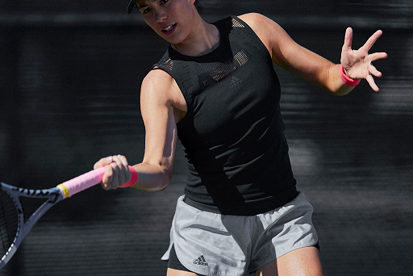

Herzogenaurach, Germany 15th August 2018: adidas unveils the outfits set to be worn on the courts of Flushing Meadows, with its US Open collection that has been inspired by the sport’s greatest shoe franchise – the Barricade. Celebrating the ultimate technical and performance footwear and apparel in tennis, the US Open Barricade collection features premium materials, innovation and proven craftsmanship to enable players to bring their best game on court. The US Open Barricade collection will be worn on court by leading players including Dominic Thiem, Sascha Zverev, Garbine Muguruza, Angelique Kerber and Jelena Ostapenko.

The US Open Barricade collection has been designed in the signature red, black and white colourstory that the Barricade franchise is famed for. Taking further inspiration from the franchise, the collection features strong silhouettes to ensure the player demands respect on court.

The men’s collection will be worn at the US Open by players including Dominic Thiem, Sascha Zverev and Jo-Wilfried Tsonga. The collection includes the Barricade polo in a Climalite jacquard material and rib finish to keep players dry and cool under the late summer sun in New York. Available in the iconic black and white colorway, the polo also features a zip placket that adds a unique finish. Dominic Thiem, Jo-Wilfried Tsonga and Thomas Berdych will pair the polo with the Barricade shorts, which feature a bonded seam design and ergonomic construction for improved freedom of movement – available in black, red and white. The apparel will be worn with the Barricade Boost 2018 – offering the ultimate in stability and performance. Sascha Zverev and Lucas Pouille will wear the Barricade Tee, made from a Climalite jersey material and featuring a contrast colour rib neckline and bonded seam at the hem, as well as the Barricade shorts.

The women’s collection continues the powerful aesthetic with the Barrciade Code tank, which features a secure fit and brings a strong style to the courts. Incorporating the premium materials and craftmanship the Barrciade Franchise is known for, the tank is made from breathable engineered mesh fabric and Climacool technology to help athletes battle heat. Former Roland Garros and Wimbledon champion Garbine Muguruza will debut the tank with the Barricade short.

Caroline Hess, Design Director Tennis Apparel at adidas explains: “This collection offered an exciting design challenge as we reimagined the iconic Barricade shoe and applied its features to every element of the design process – sticking to the signature colour palette and creating strong silhouettes, as well as ensuring every feature provided additional technical benefits to aid performance.”

”Dominic Thiem comments: “I’ve had my most successful season so far to date and my Barricade shoes have been there all the way – providing the support I need to push for every single point. The shoes are so iconic it’s exciting to play in a collection that is inspired by them – I know it will make a strong impact on court and seeing the familiar red, black and white will provide me extra confidence to perform at my best.”

The 2018 adidas US Open Barricade collection will be available online from 15th August at www.adidas.com/tennis.

ENDS

For further media information please contact:
Lindsey Rossell
lindsey.rossell@hkstrategies.com
+44 (0) 207 413 3163

Notes to editors:

About adidas Tennis
adidas Tennis is represented by top players such as Angelique Kerber, Jelena Ostapenko, Kristina Mladenovic, Garbiñe Muguruza, Caroline Wozniacki, Tomas Berdych, Lucas Pouille, Dominic Thiem, Jo-Wilfried Tsonga and Sascha Zverev. For more information on adidas Tennis, please visit www.adidas.com/tennis. For additional images please visit our media news room on news.adidas.com and follow us on Twitter or on Instagram under @adidasTennis.

About adidas
The adidas Group is a global leader in the sporting goods industry, offering a broad portfolio of footwear, apparel and hardware for sport and lifestyle around the core brands adidas and Reebok. Headquartered in Herzogenaurach, Germany, the Group employs more than 56,888 people across the globe and generated sales of around € 21.2 billion in 2017.

