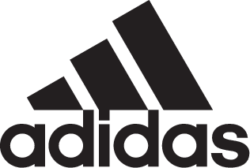

ADIDAS SOCCER REVEALS PREDATOR ACCELERATOR ELECTRICITY

- New Predator Accelerator Electricity celebrates the iconic release from adidas in 1999 -
- Released during this year’s 2018 FIFA World Cup™ -
- Range includes Stadium and Street versions -

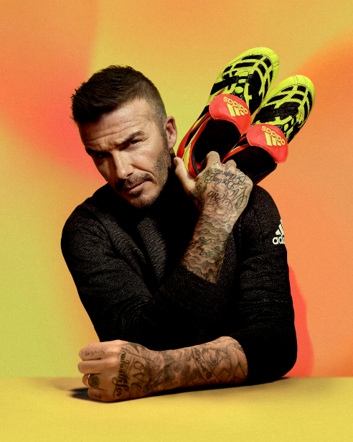

Portland, Ore., July 3, 2018 – adidas Soccer today reissued one of the most iconic cleats in the history of the brand, the Predator Accelerator. Released in time for the 2018 FIFA World Cup™, the new Predator Accelerator comes in a unique ‘Electricity’ colorway inspired by the original 1999 cleat.

The new collection will be available from today and can be purchased via adidas.com and in adidas stores.

The Predator Accelerator Electricity comes in the rare color of electric yellow, with the iconic fold-over tongue in red with the three stripes overlapping the cleat in classic black. The rare colorway also aligns with the color of the inline Predator that will be worn at the FIFA World Cup™ continuing to tell a true holistic story.

The first release of this iconic cleat came in 1999 when only 999 pairs were made available. This time adidas take inspiration from the past by releasing just 1999 pairs. The Predator Accelerator Electricity comes in both ‘Stadium’ cleat and ‘Street’ shoe versions.

For more information visit http://www.adidas.com/us/soccer and join the conversation on Twitter​ and Instagram​ with #HereToCreate.

- END -

For further media information please visit http://news.adidas.com/US/home/SOCCER or contact:

Cristina Maillo Belda
PR Manager, adidas Soccer
Email: Cristina.maillobelda@external.adidas.com
Tel: 503.915.9129

About adidas Soccer
adidas is the global leader in soccer. It is the official sponsor / official supplier partner of the most important soccer tournaments in the world, such as the FIFA World Cup™, the FIFA Confederations Cup, the UEFA Champions League, the UEFA Europa League, the UEFA European Championships and Major League Soccer. adidas also sponsors some of the world’s top clubs including Manchester United, Real Madrid, FC Bayern Munich and Juventus. Some of the world’s best players also on the adidas roster are Leo Messi, Paul Pogba, Gareth Bale, Karim Benzema, Roberto Firmino, Thomas Müller, Luis Suárez, James Rodríguez, Diego Costa, Mesut Özil, Renato Sanches and Julian Draxler.

