adidas x Wanderlust FW18 Co-Branded Collection: Inspired by the beauty of mother nature

- Find new ways to move in forest green shades and sunset hues -

- Protect the planet in yoga and training apparel built from recycled materials -

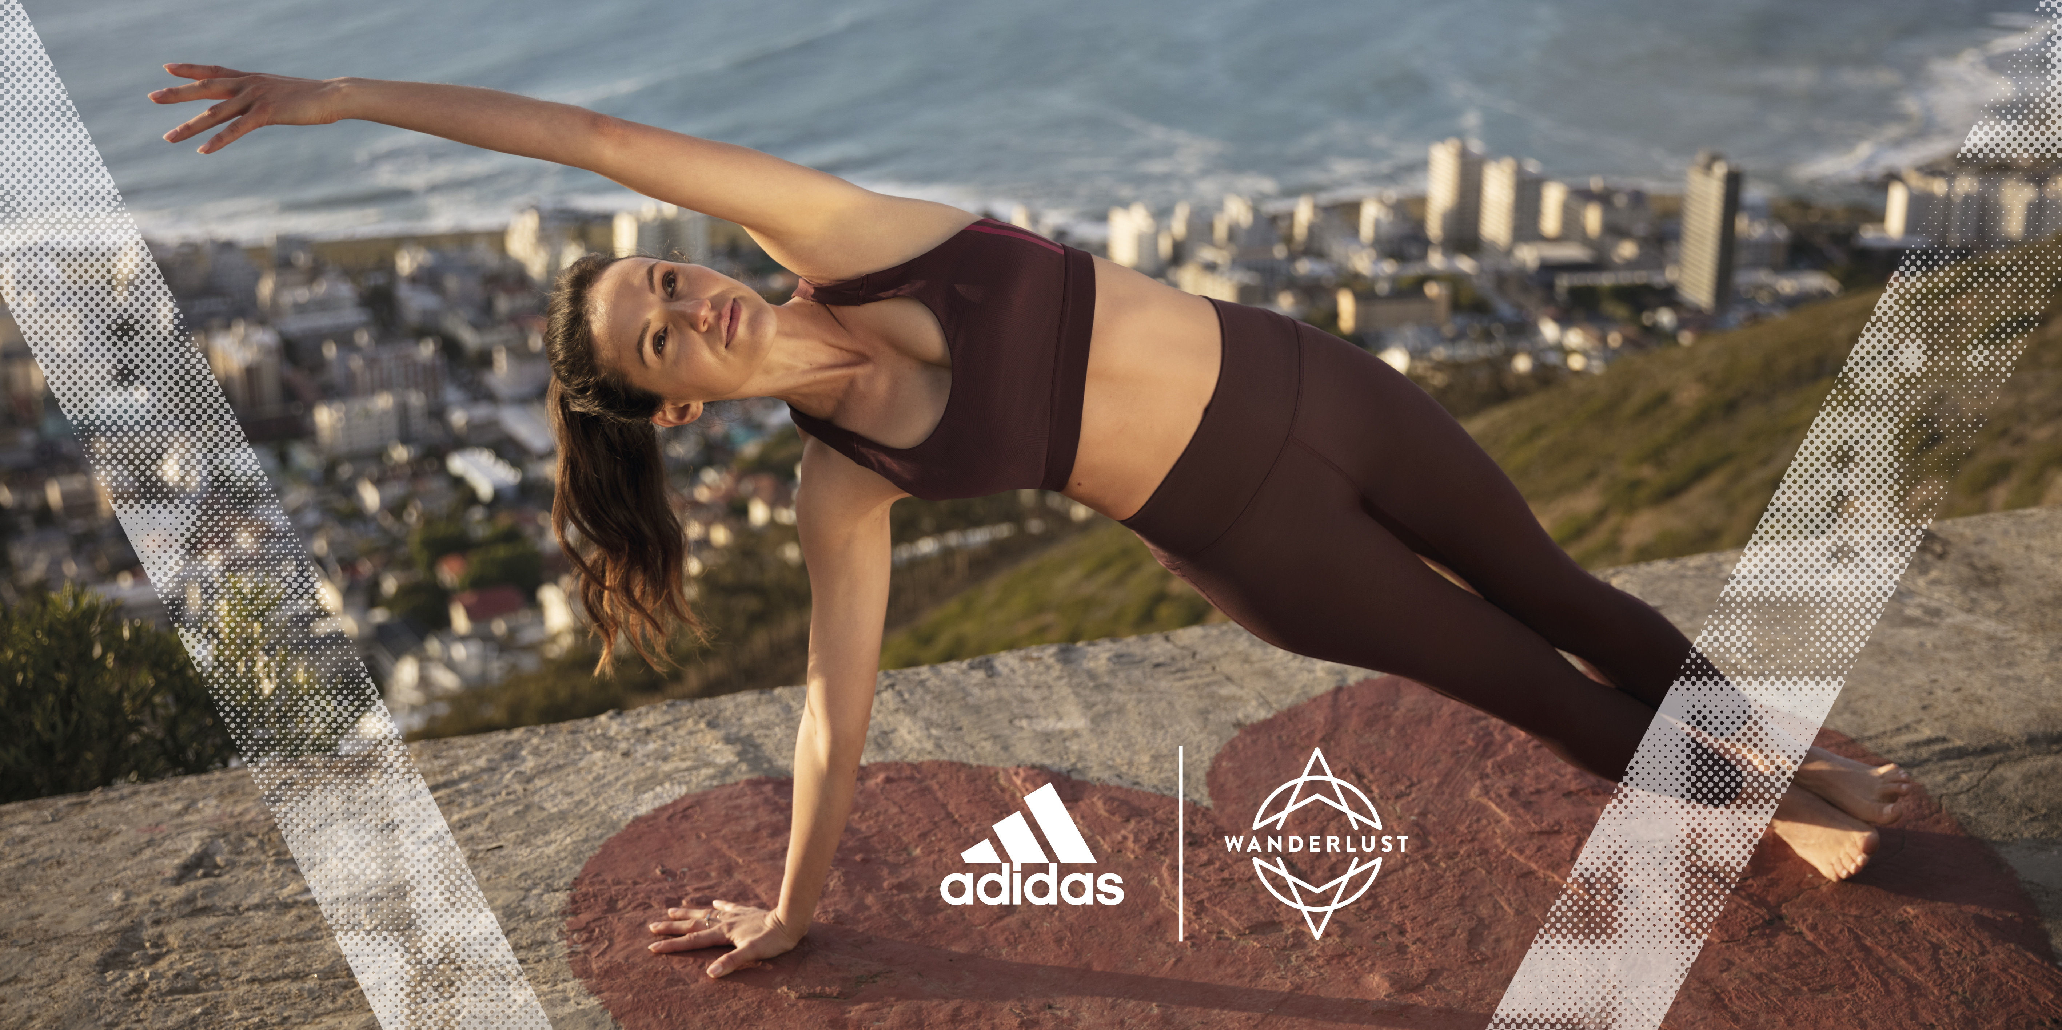
Herzogenaurach, June 21, 2018: Today adidas and Wanderlust unveil the Fall/Winter 2018 Collection: inspired by the beauty of mother nature, designed for city women. Combining adidas’ unparalleled performance technology with Wanderlust’s expertise in mindful experiences, the collection encourages women everywhere to channel the power and strength of community.
Featuring adidas x Wanderlust ambassadors Chelsey Korus, Adriene Mishler, Clio Pajczer and Angelique Fredericks, the collection’s campaign celebrates the connection between ourselves and our surroundings. Comprised of performance bras, tights and seasonal layers, the yoga, running and training pieces are perfect for Wanderlust’s 108 events and active, urban living. Built with recycled fabrics to protect the planet, the capsule manifests itself in two, unique color palettes reminiscent of lush forest greenery and warm summer sunsets.

Alison Stewart, Senior Director adidas Women’s, says:
“adidas and Wanderlust want to help women embed more sport and mindful living into their every day. That’s why together with Wanderlust we have created a range of apparel with the performance, versatility and style to transition across yoga, sport and life moments, in the city and beyond.”

Sean Hoess, CEO of Wanderlust comments:
“This season, Wanderlust has been inspired by the beauty and fragility of Mother Nature. We’ve channelled that inspiration into the pieces in this collection, both aesthetically, and by working with adidas to use as many recycled materials in the line as possible.”

THE FW18 COLLECTION
Experience feminine, simple and modern athletic apparel made for movement. With an assortment of soft, brushed fabrics and warm quilts, master new moves in versatile, cozy layers. A cool and warm colorway of off-beat neutrals celebrates the natural environment, and each garment features a distinctive adidas x Wanderlust logo.
The sweat-wicking All Me Wanderlust Bra, features internal power-mesh, a beautifully playful strap design and padding for extra comfort. Constructed with recycled polyester, it combines a love of nature with organic movement. The matching Believe This High Rise Wanderlust Tight ensures zero distractions and ultimate freedom of movement thanks to a high-waist design that gives you the confidence to stand at the front of class. Take a walk and be inspired by your surroundings in the Wanderlust Long Onesie, a loose fit, drop neck and tie waistband one piece. Perfect for layering over any bra and tight, wear it on your way to and from yoga practice.

Mindfulness expert and collection ambassador Adriene Mishler, comments:
“The pieces in the adidas x Wanderlust collection allow me to be a superhero one minute and a cool and confident girl on the sidewalk the next. I love the prints and patterns because they offer a balance between the soft and beautiful side of nature combined with its boldness and power. Simple yet magnificent, like a good sunset.”

The flattering Believe This Highrise 7/8 Wanderlust Tight, is designed in flexible, soft fabric that moves with you through any pose. Feel supported in downward dog, warrior pose and everything beyond in the racerback Don’t Rest Wanderlust Bra. The bra features supportive technology, a ventilation mesh panel and anti-bounce straps. When it’s time to relax and restore, it’s easy to keep warm in the Quilted Wanderlust Cover Up, a loose fit jacket that layers over the top.

Wanderlust instructor and collection ambassador Chelsey Korus, says:
“For yoga, I love anything high-waisted. It seems minor, but functional clothing is key when doing the yoga I specialize in. You want to feel confident that your clothes will stay where they should and not add any unnecessary distraction to your movement.”

The adidas x Wanderlust Collection is available now at adidas.com, wanderlust.com, select adidas stores and retailers including SIX:02, Macy’s and Nordstrom as well as the Wanderlust Hollywood Studio and all Wanderlust events. The collection ranges from $45 for the All Me Wanderlust Bra to $80 for the Wanderlust Onesie. Tickets for Wanderlust festivals and city events across the world are available at Wanderlust.com.
- END -

Note to editors:

About the adidas Group
adidas is a global leader in the sporting goods industry. A designer and developer of athletic and lifestyle footwear, apparel and accessories, adidas has the mission to be the best sports brand in the world. Headquartered in Herzogenaurach, Germany and Portland, Ore., adidas employs more than 60,000 people across the globe and generated sales of € 19 billion in 2016.
www.facebook.com/adidaswomen
http://instagram.com/adidaswomen
https://www.adidas.co.uk/women

About Wanderlust:
Wanderlust Holdings, LLC is a global yoga lifestyle company founded in 2009. Our mission is to help you find your true north—to live a healthy and inspired life. Wanderlust’s events encompass Wanderlust Festival, the largest multi-day yoga and music festivals in the world, Wanderlust 108, a one-day “mindful triathlon” taking place in urban parks across the world, and Wellspring, a first-of-its-kind wellness gathering featuring the world’s leading innovators, teachers and socially-conscious companies in Palm Spring, CA. In 2012, we opened the first Wanderlust Yoga studio, a re-imagination of the yoga studio experience and began offering Wanderlust Teacher Training, a yoga teacher-training program inspired by the Wanderlust festival experience. In 2015, we launched Wanderlust TV, a media platform connecting viewers with inspirational teachers and wellness experts and Wanderlust Hollywood, a 10,000 square foot center in Los Angeles, CA offering yoga and meditation classes, a world-class organic restaurant, and a full-featured performance venue. In 2018, we earned B Corporation Certification, meeting rigorous standards for of social and environmental performance, ethics, accountability, and transparency in business.
https://www.facebook.com/wanderlust
https://www.instagram.com/wanderlustfest
https://www.wanderlust.com

