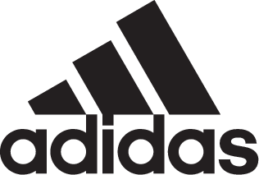

ADIDAS CELEBRATES SOCCER IN LOS ANGELES;
CROWNS MELVYN OWEN PEREZ CORTEZ LA TANGO MVP

- Held at The Base in downtown LA, the Energy Mode event celebrated adidas Soccer’s latest footwear drop X18, the fastest and lightless laceless boot in the market –
- Perez Cortez to travel to Moscow for the Global Tango League during the 2018 FIFA World Cup™ Final week -
- In true Stadium to Street form, the event featured LAFC players Lee Nguyen and Latif Blessing as well as a live performance from rapper Rich The Kid -

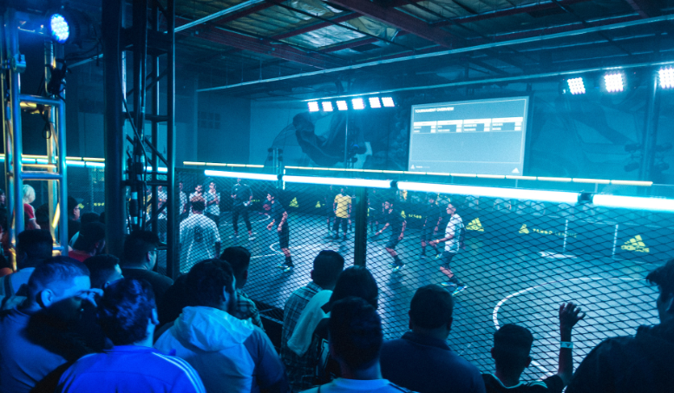

LOS ANGELES, June 13, 2018 – With only one day to go in the 2018 FIFA World Cup™ countdown, adidas Soccer kicked off the festivities with their first Energy Mode X18 event and the celebration of their X18 footwear, the fastest and lightless cleat in the market. Located at The Base in downtown LA, the event is the first of two activations taking place in the U.S. this week, with its second edition happening in Brooklyn, NY on Sunday, June 17.

Meeting at the intersection of sport and culture, and staying true to adidas Soccer’s stadium to street mantra, guests were treated to appearances from LAFC players Lee Nguyen and Latif Blessing as well as a live performance from American rapper Rich the Kid.

As part of the event, Melvyn Owen Perez Cortez was crowned Tango MVP of Los Angeles and sent off to Moscow, Russia to partake in the global Tango League final that will take place during the last week of the tournament. The 19-year old player will be joined by the yet-to-be crowned MVP of NY as they compete against Tango MVPs from all around the world to earn a spot in the Tango Squad F.C. managed by World Cup champion Xabi Alonso.

LA Tango MVP: Melvyn Owen Perez Cortez
Date of Birth: Oct. 01, 1991
Hometown: Los Angeles
Social: @M.Perez1001

Follow the Tango MVPs’ journey and join the conversation on Twitter​ and Instagram​ with #HereToCreate, #TangoLeague and #X18.

- END -

For further media information please visit http://news.adidas.com/US/home/SOCCER or contact:

Cristina Maillo Belda
PR Manager, adidas Soccer
Email: Cristina.maillobelda@external.adidas.com
Tel: 503.915.9129

- END –

About adidas Soccer
adidas is the global leader in soccer. It is the official sponsor / official supplier partner of the most important soccer tournaments in the world, such as the FIFA World Cup™, the FIFA Confederations Cup, the UEFA Champions League, the UEFA Europa League, the UEFA European Championships and Major League Soccer. adidas also sponsors some of the world’s top clubs including Manchester United, Real Madrid, FC Bayern Munich and Juventus. Some of the world’s best players also on the adidas roster are Leo Messi, Paul Pogba, Gareth Bale, Karim Benzema, Roberto Firmino, Thomas Müller, Luis Suárez, James Rodríguez, Diego Costa, Mesut Özil, Renato Sanches and Julian Draxler.

About Tango League
The Tango League is a league that champions standout players both on and off the field. Individuals from all over the world can show that they are the best street soccer player in their city through Tango League events. Perform on the field, aim to be the MVP and grow your social following for a chance to win. Please read the Tango League Terms and Conditions via this link.

