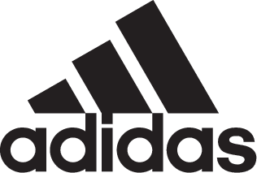

ADIDAS SOCCER REVEALS SIGNING OF PAULO DYBALA

- adidas Soccer welcomes Dybala to the three stripes family -
- Dybala will wear GLITCH skin at the 2018 FIFA World Cup™ –

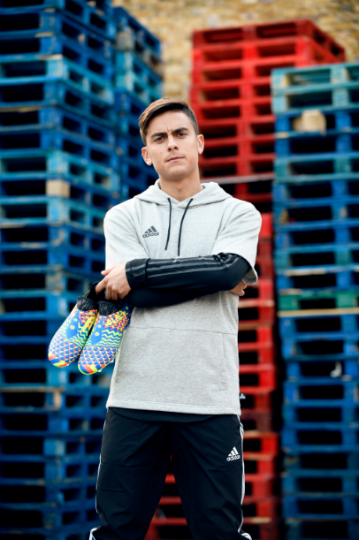

Portland, Ore., June 12, 2018 – adidas Soccer has revealed today the signing of Argentina and Juventus forward Paulo Dybala. The signing comes with Dybala fresh off leading Juventus to the Serie A title, scoring 22 goals and assisting five.

One of the world’s most exciting and creative players will be seen on the field wearing the unique GLITCH skin during this summer’s 2018 FIFA World Cup™. GLITCH comes in two parts, an inner shoe and outer skin. The outer skin can be removed and replaced so players can change their look based on their preference, while maintaining an inner shoe that has a comfortable and supportive fit that suits them. Dybala will also be featuring in GLITCH at the start of the new 18/19 season.

Claus-Peter Mayer, VP Global Sports Marketing at adidas Soccer said “We’re delighted to sign one of the brightest young talents in world football right now. Paulo Dybala is one of the most creative players in the game and it’s these attributes that make him the perfect player to join team adidas. We can’t wait to see Paulo make his mark on the FIFA World Cup.”

Dybala speaking on his signing has said “I’m delighted to be part of the adidas family, joining the leading sports brand pushing the boundaries of creativity on and off the pitch. I’m excited to see what the future holds and what we’re able to create together”.

GLITCH is solely sold via the GLITCH app, but it’s yet to become available in the U.S. The app can be downloaded via the App Store (iOS) and Google Play Store (Android).

For more information visit http://www.adidas.com/us/soccer and join the conversation on Twitter​ and Instagram​ with #HereToCreate.

- END -

For further media information please visit http://news.adidas.com/US/home/SOCCER or contact:

Cristina Maillo Belda
PR Manager, adidas Soccer
Email: Cristina.maillobelda@external.adidas.com
Tel: 503.915.9129

About adidas Soccer
adidas is the global leader in soccer. It is the official sponsor / official supplier partner of the most important soccer tournaments in the world, such as the FIFA World Cup™, the FIFA Confederations Cup, the UEFA Champions League, the UEFA Europa League, the UEFA European Championships and Major League Soccer. adidas also sponsors some of the world’s top clubs including Manchester United, Real Madrid, FC Bayern Munich and Juventus. Some of the world’s best players also on the adidas roster are Leo Messi, Paul Pogba, Gareth Bale, Karim Benzema, Roberto Firmino, Thomas Müller, Luis Suárez, James Rodríguez, Diego Costa, Mesut Özil, Renato Sanches and Julian Draxler.

