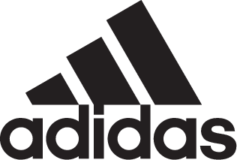

ADIDAS SOCCER REVEALS NEW PRIMEKNIT VERSION OF GERMANY HOME KIT

- New kit is designed to be worn by fans during the World Cup -
- Primeknit material used to improve wearability and comfort as lifestyle apparel –
- Jersey features the same design as the performance kit -

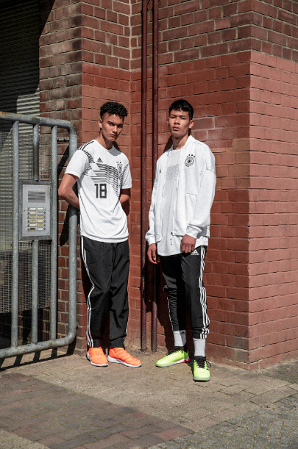

Portland, Ore., June 1, 2018 – adidas Soccer has today released a lifestyle version of the 2018 FIFA World Cup home kit for Germany, crafted from the brand’s innovative Primeknit material. The kit follows the same design inspiration as the performance jersey and is a modern interpretation of one of the country’s most famous jerseys worldwide, the iconic 1990 shirt.

Available now at select retailers, the jersey will be available on adidas.com next week.

The shirt builds on this classic design with an improved and reworked performance silhouette featuring dropped shoulder cut lines. The new lifestyle version is constructed using Primeknit material – crucial for comfort, fit and feel – and the words “Die Mannschaft” appear on the reverse of the neck, with a heat applied DFC crest and adidas logo.

Using a completely new manufacturing method for soccer jerseys, the name and numbering is fully engineered and knitted into the jersey, resulting in no extra trims and a unique new look. The Primeknit material features several different textures, including a mesh structure around the name and numbering, as well as on the upper back for ventilation and moisture management.

There are a limited number of the jerseys available, each one has its number on the bottom right signifying its run number.

For more information visit http://www.adidas.com/us/soccer and join the conversation on Twitter​ and Instagram​ with #HereToCreate.

- END -

For further media information please visit http://news.adidas.com/US/home/SOCCER or contact:

Cristina Maillo Belda
PR Manager, adidas Soccer
Email: Cristina.maillobelda@external.adidas.com
Tel: 503.915.9129

About adidas Soccer
adidas is the global leader in soccer. It is the official sponsor / official supplier partner of the most important soccer tournaments in the world, such as the FIFA World Cup™, the FIFA Confederations Cup, the UEFA Champions League, the UEFA Europa League, the UEFA European Championships and Major League Soccer. adidas also sponsors some of the world’s top clubs including Manchester United, Real Madrid, FC Bayern Munich, Juventus and AC Milan. Some of the world’s best players also on the adidas roster are Leo Messi, Paul Pogba, Gareth Bale, Karim Benzema, Roberto Firmino, Thomas Müller, Luis Suárez, James Rodríguez, Diego Costa, Mesut Özil, Renato Sanches and Julian Draxler.

