‘RUN FOR THE OCEANS’ GROWS IN 2018 –
ADIDAS X PARLEY ANNOUNCE EXPANDED GLOBAL CAMPAIGN TO HARNESS THE POWER OF SPORT AND CONTINUE FIGHT AGAINST THE THREAT OF MARINE PLASTIC POLLUTION
For every km completed, adidas will donate $1 to the Parley Ocean Plastic Program (up to $1 MM)

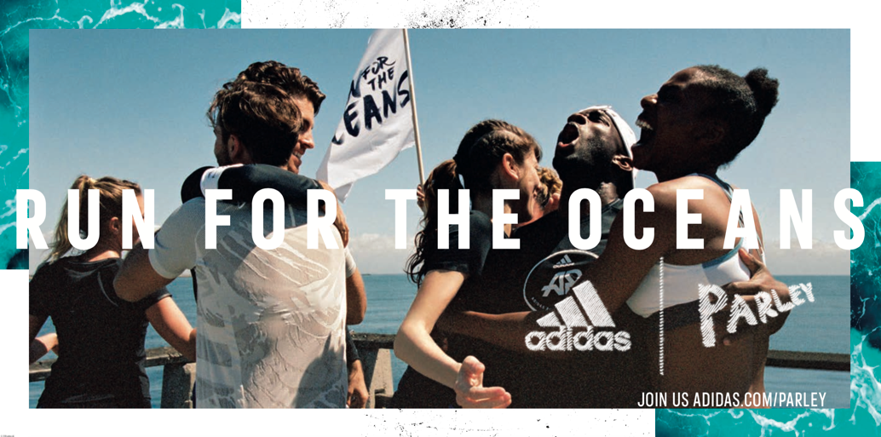

- adidas and Parley for the Oceans are calling on their global communities to unite for the second consecutive year in one movement against marine plastic pollution
- adidas and Parley will host over 12 major running events across six key cities globally, including Los Angeles on June 8th and New York on June 27th, plus weekly running activities with 50 adidas Runners communities worldwide
- For every km completed and logged from June 8th through July 8th, adidas will contribute $1 dollar to the Parley Ocean Plastic Program (up to $1 million)
- 20 world-renowned cross-category adidas athletes join the Parley Ocean Squad to increase awareness for the cause, including Shaunae Miller, Tori Bowie and Wayde Van Niekerk
- Sign up on adidas.com/parley and follow #adidasParley, #RunForTheOceans

Portland, Ore., May 31st 2018 – adidas and Parley for the Oceans today announced the return of Run For The Oceans, a global running movement that uses the power of sport to raise awareness for the threat of marine plastic pollution.

For the second year in a row, through this worldwide initiative, adidas and Parley call on their global communities between June 8 and July 8 to take action and protect the oceans that are increasingly endangered due to man-made issues including pollution, waste and growing consumption. Since 2015, the partners have been working together to educate people on the issue, but also showcasing creative solutions such as the use of Parley Ocean Plastic™ for the making of adidas x Parley products.

Andre Maestrini, General Manager, adidas Sports Business Units said: “At adidas, we believe that sport has the power to change lives and the Run For The Oceans movement truly reflects this. We have created a unique global platform that gives everyone the opportunity to impact their lives by joining a collective running movement that fights marine plastic pollution. Seeing the adidas family unite for a shared purpose is what makes the campaign so powerful.”

Taking the initiative to the next level for 2018, adidas will match every kilometer run with $1 dollar– for the first one million kilometers – to support the Parley Ocean Plastic Program, focusing specifically on the Parley Ocean School initiative, which educates and empowers the next generation of Ocean Guardians through immersive experiences in the environment we are fighting to protect. With in-school and water sports activities, the program introduces youth to the underwater world, teaching them about the impacts of marine plastic pollution and giving them the tools and inspiration to protect their future with Parley AIR.

Cyrill Gutsch, Founder of Parley for the Oceans said: "Every second breath we take is created by the Oceans. Still, we are killing its life in rapid speed. We are hosting Run for the Oceans with adidas to step out of our routine, to take a deep breath and to reflect on how important the sea is for every one of us. And to show that millions of little steps can make a huge difference for our movement."

To get involved, adidas and Parley are hosting a series of physical runs in several key cities worldwide including LA, New York, Paris, Berlin, London, Barcelona, Milan and Shanghai, and are mobilizing the global adidas Runners network to organize weekly running initiatives in 50 adidas Runners communities worldwide.

On Friday, June 8 in Temescal Park, Los Angeles, adidas x Parley will bring their communities of runners, ocean ambassadors, environmentalists and influencers together to inspire collective action and affect positive change for our oceans. The group will together log miles through the park, have the opportunity to learn more about ocean pollution, and witness a live performance from a surprise musical guest. The community in New York City will also show their support on Wednesday, June 27 at Pier 26.

Runners around the world can also sign up and track their runs on the digital platforms of Runtastic and Joyrun (in China) to contribute and help reach one million kilometers, joining adidas ambassadors Shaunae Miller, Tori Bowie and Wayde Van Niekerk among other high-profile athletes in their efforts to spread the message.

Inspired by the fragility of the oceans, adidas Running will reveal limited-release UltraBOOST Parley and UltraBOOST X shoes, fusing performance-oriented footwear technology with progressive eco-innovation. The high-performance, high-purpose products prove adidas’ and Parley’s commitment to tackle the major threats one step at a time. Featuring an energy‐return BOOST™ midsole and 95% Parley Ocean Plastic™ Primeknit upper, each pair prevents approx. 11 plastic bottles from the possibility of entering our oceans. Available in a chalk pearl colorway, the silhouettes are available online beginning June 8 and in stores worldwide from June 27. (MSRP: $200.)

People everywhere can join the movement by downloading Runtastic/Joyrun to track each step between June 8 and July 8. To find out more about the Run For The Oceans and sign up, visit: adidas.com/Parley.
Follow the conversation at @adidasrunning on Instagram, Facebook and Twitter and using #RunForTheOceans, #adidasParley, #UltraBOOST.

END
For questions or more information please contact:
Laura Baum | Global Senior PR/Social Manager – Running | Laura.Baum@adidas.com
Michelle Keitel I PR/Social Manager – Running I Michelle.Keitel@adidas.com |

NOTES TO EDITORS:
ABOUT ADIDAS & PARLEY
In April 2015, adidas announced a partnership with Parley for the Oceans, an organisation that raises awareness about the beauty and fragility of the oceans. As a founding member, adidas supports Parley for the Oceans in its education and communication efforts, as well as its comprehensive Parley Ocean Plastic Program and Parley AIR Strategy (Avoid, Intercept, Redesign) that intends to end plastic pollution of the oceans.
For more information, please visit: adidas.com/parley

