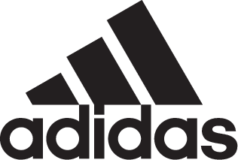

ADIDAS SOCCER REVEALS NEW ENERGY MODE EDITION OF THE COPA18

- New Energy Mode Copa18 arrives in striking red and yellow colorway -
- Copa18 also available in a cage version -

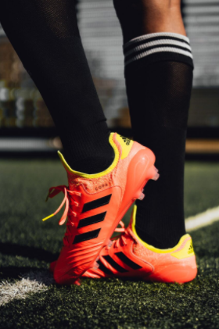

Portland, Ore., May 28, 2018 – adidas Soccer has today released the new Energy Mode Copa18. Originally launched in the late ‘70s with the Mundial, the Copa franchise has outclassed oppositions all over the world for the last 38 years.

The Energy Mode Copa 18 is available from today at adidas.com and adidas retail stores.

The Energy Mode Copa18 arrives in a bold red and yellow colorway and benefits from the most advanced performance materials, combining a Leather Embossed Vamp and innovative Sock Construction System. It features a premium K-leather upper and X-Ray Vamp Cage to deliver close control by reducing slippage. A Compression Fold-Over Tongue provides improved supportive fit and stability.

The Comfort Internal Construction features foam pads and the new Ortholite Sockliner offers an enhanced cushioning experience for unmatched comfort.

Energy Mode COPA18 is also available in a cage shoe and features the same fold-over tongue, compression sock construction and premium K-leather upper as the on-field cleat. A Boost™ midsole, EVA strip and rubber outsole provides the tools required to dominate the cage.

For more information visit http://www.adidas.com/us/soccer and join the conversation on Twitter​ and Instagram​ with #HereToCreate.

- END -

For further media information please visit http://news.adidas.com/US/home/SOCCER or contact:

Cristina Maillo Belda
PR Manager, adidas Soccer
Email: Cristina.maillobelda@external.adidas.com
Tel: 503.915.9129

About adidas Soccer
adidas is the global leader in soccer. It is the official sponsor / official supplier partner of the most important soccer tournaments in the world, such as the FIFA World Cup™, the FIFA Confederations Cup, the UEFA Champions League, the UEFA Europa League, the UEFA European Championships and Major League Soccer. adidas also sponsors some of the world’s top clubs including Manchester United, Real Madrid, FC Bayern Munich, Juventus and AC Milan. Some of the world’s best players also on the adidas roster are Leo Messi, Paul Pogba, Gareth Bale, Karim Benzema, Roberto Firmino, Thomas Müller, Luis Suárez, James Rodríguez, Diego Costa, Mesut Özil, Renato Sanches and Julian Draxler.

